UNIFORM SPECIFICATION – FOR FIRST YEARS

Food Production & Bakery Practical:
- Chef coat :
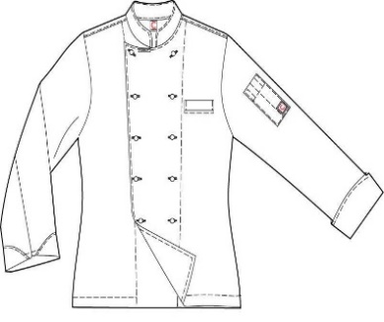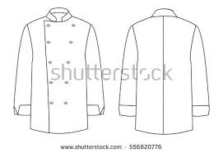
Colour – white, Material : Drill, sanforized, Tailoring : With overlap in front. Deep narrow pocket in front and on one sleeve. Refer sketch.
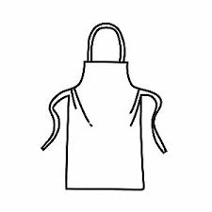
- Black Pants
- Apron – White Drill Material.
Sanforized.
- Scarf: Triangular –Red and White
Checked 90 cms × 60 cms × 60 cms.

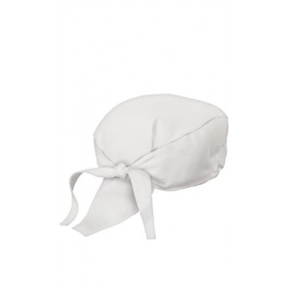
- Chef cap
- Black socks.
- Black Safety shoes
- Kitchen cloth – white cotton, 2 nos
- Kitchen Cleaing cloth – Green &
White Checked Cotton 2 nos

- Tool kit

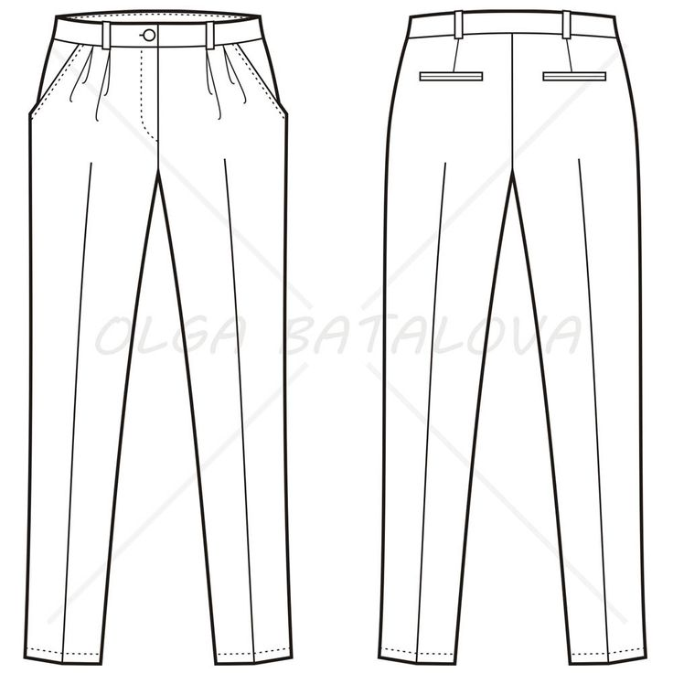
F&B Service Practical:
- Pants: Black Suiting.
Formal. Straight cut with a
Pleat on either side. Side
pockets and back pockets

- Waist Coat: Suiting
Material, Black

- White full sleeved shirt
- Black bow tie
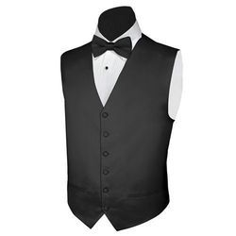
- Waiter’s cloth – 2 nos
- Serviettes – Damask white 45 cms *
45 cms – 4 nos.

- Black socks
- Black Oxford Shoes ( Boys) Closed
shoes – not more than 2 inch heel(
Girls)

- Bottle Opener
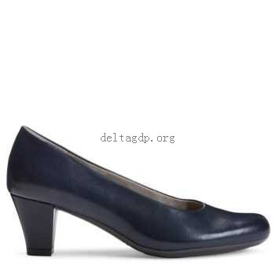
- Lighter
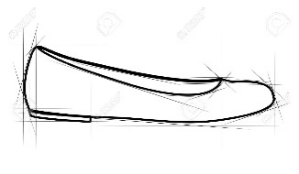
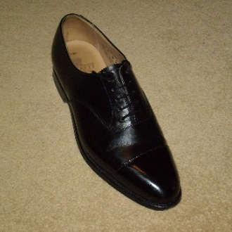

Front Office Practical :
Black pants , White full sleeved shirt, Black oxford shoes, Black socks. (as for F& B Service), Black Tie.
Accommodation Operation Practical: Black pants , White half sleeved shirt ( suiting material) with chinese collar, Black oxford shoes ( , Black socks, Apron with a pocket (12 inches wide, 6 inches high) in front ,
** Dusters (blue and white check) 2 nos
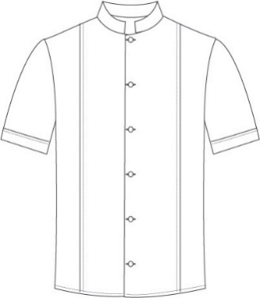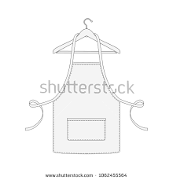
** Issued from the Institute
Students are expected to be in their respective uniforms during class hours.
Girls: have the option of wearing knee length formal black skirt (A-line) with black stockings instead of pants for F & B Service Practical. Closed shoes with not more than 2 inch heel.
Girls also will be required to buy a saree at a later date.
**************

