- Food Production & Bakery Practical: Chef Coat, black pants, apron, scarf, chef cap , safety antiskid shoes (black) and black socks, tool kit.
** Kitchen cloth ( 2 nos) , cleaning cloth ( 1 no) - provided at the institute on payment.
Chef coat :
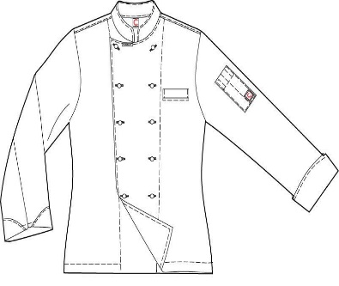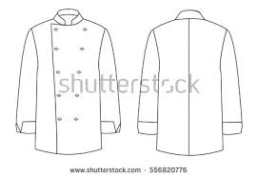
Colour – white, Material : Drill, sanforized, Tailoring : With overlap in front. Deep narrow pocket in front and on one sleeve. Refer sketch.

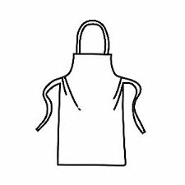
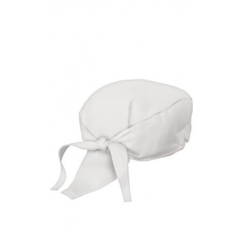
Apron: White, Drill sanforized, knee length
Scarf: Triangular Blue and white checks 90 cms × 60 cms × 60 cms
- F&B Service Practical: Black pants , White full sleeved shirt, Bow Tie, Waist Coat, Waiter’s cloth (2 nos), Serviettes (4 nos), Black oxford shoes, Black socks. Bottle opener, lighter

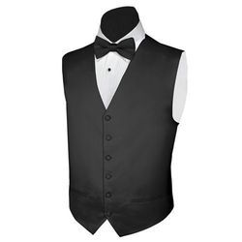
Waist Coat:

Pants: Black Suiting. Formal. Straight cut with a pleat on either side. Side pockets and back pockets
- Front Office Practical : Black pants , White full sleeved shirt, Black Tie, Black oxford shoes, Black socks.

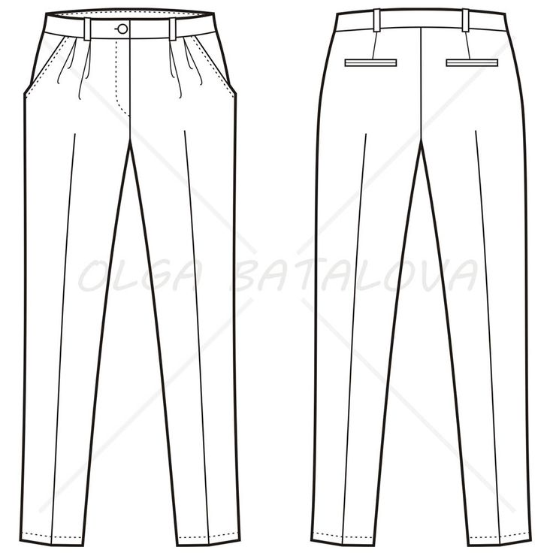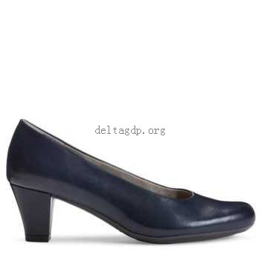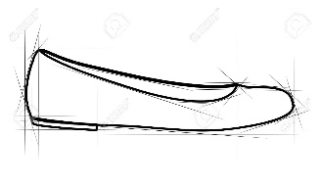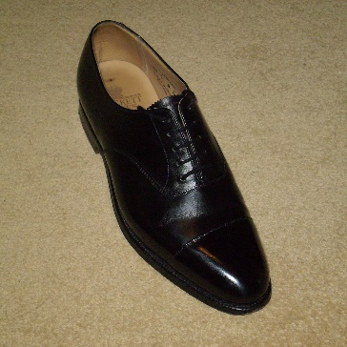

- Accommodation Operation Practical: Black pants , White half sleeved shirt ( suiting material), Black oxford shoes, Black socks, Apron with a pocket (12 inches wide, 6 inches high) in front ,
** Dusters (blue and white check) - 2 nos. Provided at the institute on payment
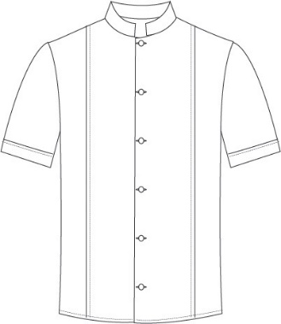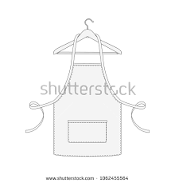
** Issued from the Institute on payment.
Students are expected to be in their respective uniforms during class hours.
Girls: have the option of wearing knee length formal black skirt (A-line) with black stockings instead of pants for F & B Service Practical. Closed shoes with not more than 2 inch heel.
Girls also will be required to buy a saree at a later date.

******************

