NUTRITION

Ist SEMESTER, B.Sc H& HA
ASSISTANT LECTURER (ON CONTRACT) IHMCT, Kovalam
Name of student : Batch :
BHM 16-NUTRITION
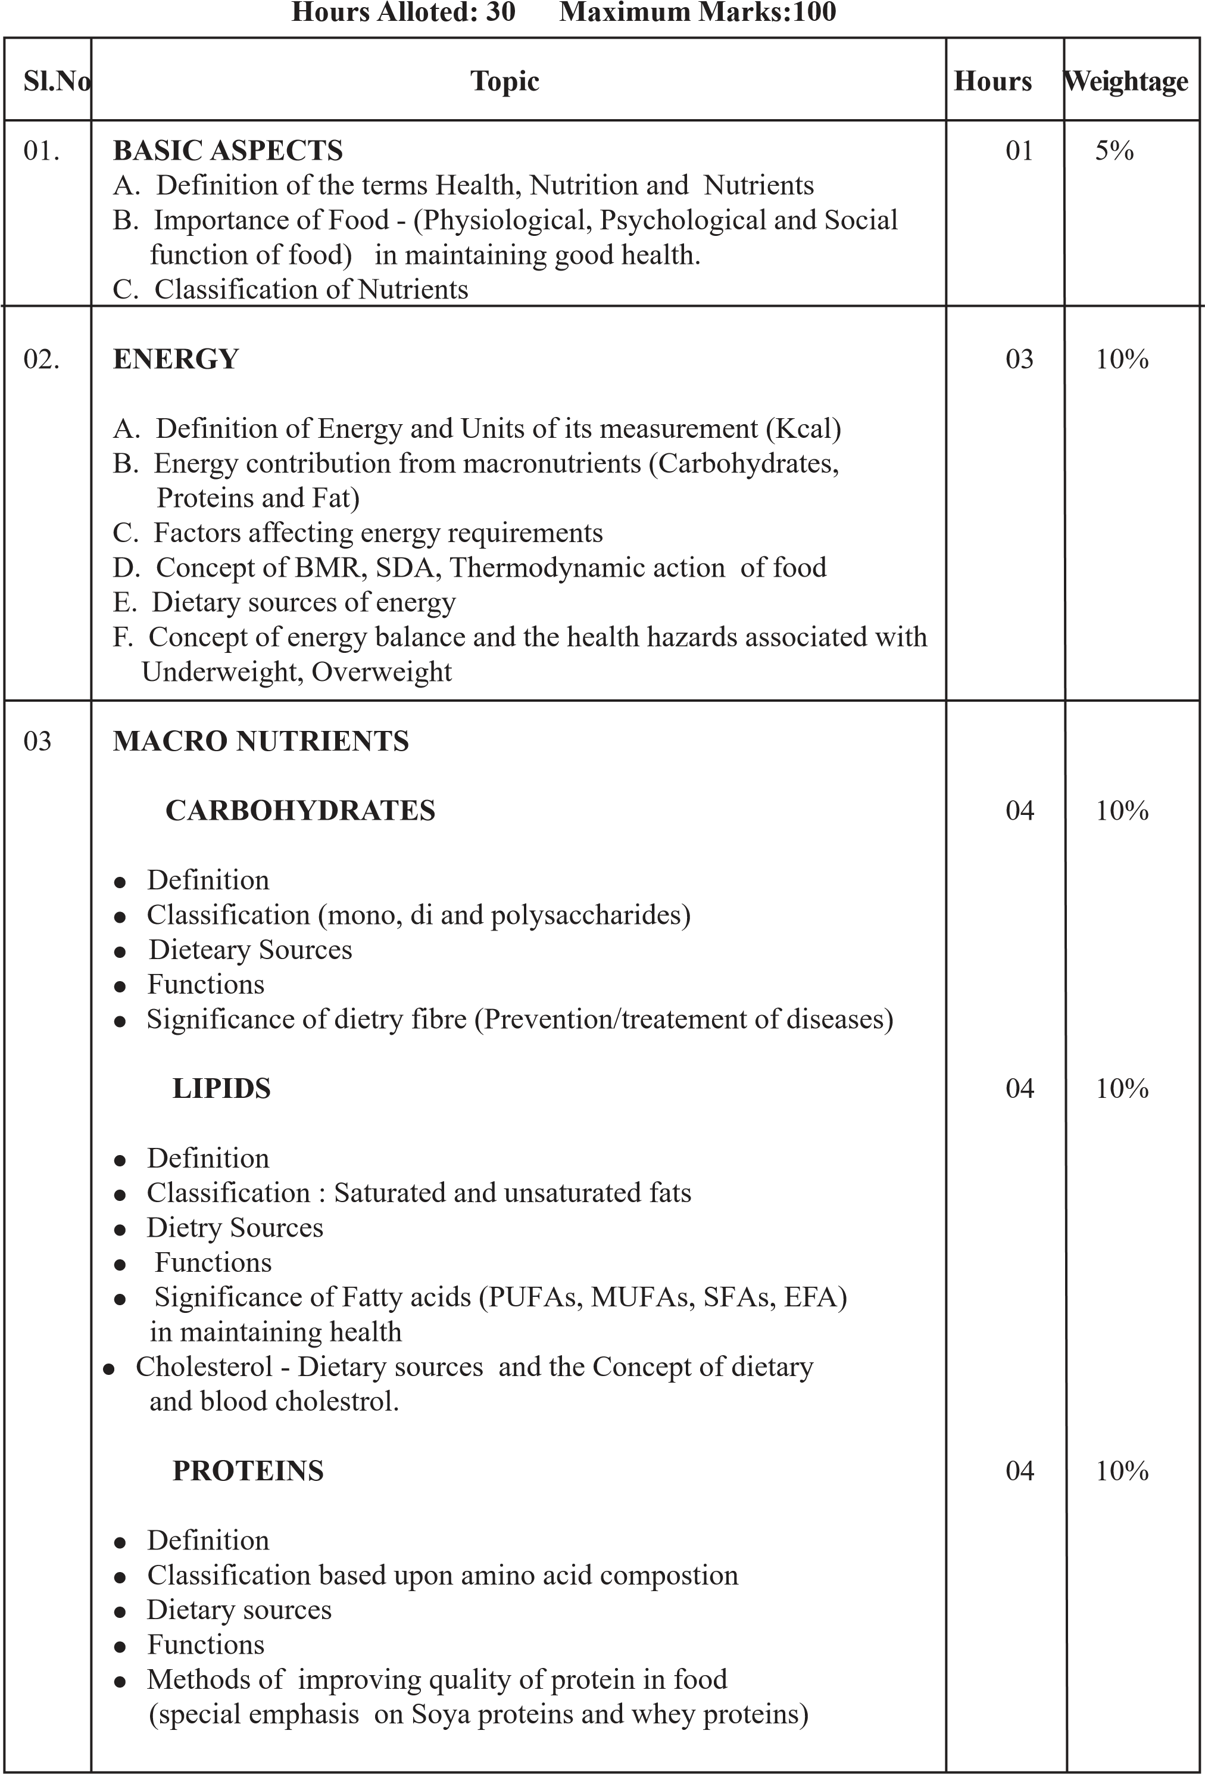

04. MACRO NUTRIENTS 05 15% A.VITAMINS
 Definition and Classification (water and fats soluble vitamins)  Food Sources, function and significance of :
  1. Fat soluble vitamins (Vitamin A,D,E,K)
  2.Water soluble vitamins(Vitamin C, Thiamine, Riobolfavin, Niacin, Cyanocobalamin Folic acid)

B.MINERALS
 Definition and Classification (major and minor) 03 10%
 Food Sources , functions and significance of:
Calcium, Iron, Sodium, Iodine & Flourine
05 WATER 01 5%
 Definition
 Dietary Sources (visible, invisible)
 Functions of water
 Role of water in maintaining health (Water balance)

06 BALANCE DIET 01 5%
 Definition
 Importance of balance diet
 RDA for various nutrients - age, gender, physiological state

07 MENU PLANNING 02 10%
 Planning of nutritionally balanced meals based upon the three food group system
 Factors affecting meal planning
 Critical evaluation of few meals served at the institutes/ Hotels based on the principle of meal planning.  Calculation of nutritive value of dishes/meals.
08. MASS FOOD PRODUCTION 01 5%
 Effect of cooking on nutitive value of food(QFP)

09 NEWER TRENDS IN FOOD SERVICE INDUSTRY IN RELEVANCE TO NUTRITION AND HEALTH
 Need for introducing nutritionally balanced and health specific meals
 Critical evaluation of fast foods
 New products being launched in the market (nutritional evaluation)
Total 30 100%
01.Basic Aspects
Health
It is the complete state of physical, mental, social and spiritual well being and merely the absence of any disease or infirmity.
Nutrition:- is the process by which the food is ingested, digested and absorbed by the body for its growth maintenance and energy purpose.
Nutrients :- are the chemical components which are present in food needed by the body in appropriate amounts in order to grow and maintain the normal health. CHO,proteins & fats are egs.
Importance of food in maintaining good health.

(1) Physiological functions:-
Body building
Provide energy
To regulate the activities of the body(includes beating of heart,clotting of blood, removal of waste products from the body)

(2) Social functions of food
Food has always been a central part of our social existence, For eg: special foods are distributed in religious functions.

(3)Psychological functions
In addition to satify the physical and social needs foods must satisfy some psychological needs also. Sharing of food is a token of friendship & acceptance. In friendly gathering we try unfamililar foods and enlarge our food experience.
-1-

02. ENERGY

Energy :-is defined as the ability to do work. Energy is released by the metabolism of food.
Unit of energy:- Kilocalrie (Kcal)
Calorie:- A kilocalorie is defined as the amount of heat required to raise the temperature of 1 kg of water through 1⁰C.
Energy contribution from macronutrients
The energy contributing nutrients are the macronutrients; CHO, proteins, & fats.
1g CHO give = 4kcal
1g protein give = 4 kcal
1g fat give = 9kcal
Factors affecting energy requirements
The WHO, FAO, committee defined energy requirements as the energy intake that is considered adequate to meet the energy needs of the average healthy person in a specified age/ sex category.
The energy requirements of the individuals are influenced by the following factos;
Age, sex, body size & composition, physical activity, climate & Physidogical conditions
(pregnancy & lactation)
- Age:- the enrgy requirements of infants ranged from 120 to 112 kcal per kg of body weight. As the age increases the energy requirements will decrease. The energy requirement of adults is defined in terms of refernce man and reference woman.
Reference man:- he is between 20-29 years of age with 65kg, healthy and physically fit for active work, doing 8 hrs moderate active work, 8hrs in bed, 8hrs light activity.
Reference woman :- she is also between 20-29 years of age with 55 kg, healthy and physically fit for active work, doing moderate active work, 8hrs light activity.

The recommended energy intake of reference man is - 3000kcal/day The recommended energy intake of reference woman is -2200kcal/day
The energy requirement decreases as the age advances (old age).
- Sex:- men requires more energy than women.
- Body size & composition :- Obese person requires less energy than persons with ideal body weight.
- Physical activity :- The energy requirement for different type of physical activity varies.
Sedentary work eg : office work
Moderate work eg: teaching, students
Heavy work eg:agricultural laborers, stone breakers
(5)Climate :- energy requirement varies according to the climatic condition.
(6) Physiological conditions :- means pregnancy & lactation in that energy requirement increases.

BMR (Basal Metabolic Rate)
The BMR is defined as the rate of energy metabolism of a subject at complete physical and mental rest and having normal body temperature & in the post absorptive state (12 hrs after the last meal).
Basal metabolism is usually determined using “Benedict Roth Apparatus”.

RMR (Resting Metabolic Rate)
The RMR is the energy required to maintain life. The subject is awake & non fasting. It is approximately about 3% higher than BMR.
FACTERS AFFECTING BMR.
- Age:- the BMR is higher in infants and young children than in adults.
- Sex:- In males BMR is high than women.
- Body Size :- a tall thin person has more body surface area & higher BMR than obese person.
- Physical activity:- increased physical activity increased BMR.
- Fever:-12% fever rise in temperature per⁰C.
- Sleep:-BMR in sleep is about 5% less.
-4-
(6)Under nutrition/starvation :- causes a reduction of BMR about 10-20%.
(7) Fear/nervous tension:-BMR increases.

SDA (SPECIFIC DYNAMIC ACTION/THERMOGENIC EFFECT OF FOOD (TEF)
SDA refers to the increased heat production following the intake of food.
The values for SDA are; for proteins 30%, for lipids 5% & CHO 10-15%. This means that out of every 100gms of proteins consumed, the energy available for doing work is 30% less than the calculated value.

Dietary sources of energy
Richest source | Moderate source | Fair source | Poor source.
Fatty foods, fats and | Cereals and cereal | Fruits,starchy, | Leafy & fibrous
oils, ghee, butter, sugar & | products, meat and meat | vegetables, milk | vegs.,
jaggary, sweets, bakery pdts. | products, pulses and dals, fish, roots & tubers | and milk pdts. | mushroom

Energy Balance
Energy Balance is achieved when input (that is dietary energy intake) is equal to output (that is total energy expenditure). The energy required for growth in childhood and pregnancy and the energy required for milk production during lactation is also accounted in energy output. When energy balance is maintained over a prolonged period an individual is considered to be in steady state.
Both lower and higher intakes are associated with health hazards. Too much deviation on either side from the appropriate range of body weight increases the risk of health problems. Overweight is the result of positive energy balance (energy intake is more, expenditure is less). Underweight results when the energy balance is negative (energy intake is less, expenditure is more).
Body Mass Index (BMI) is defined as weight in Kilo grams divided by height in meter square (m²) is now used to classify underweight and overweight. WHO (1998) classify undeweight and overweight. WHO (1998) classification of underweight, and obesity in adults according to BMI is given below.
Classification
BMI (kg/m
²
)
Underweight
<
18.5
18.5 - 24.9
Normal range
25-29.9
Overweight
Obesity
≥
30
30-34.9
Class I
35-39.9
Class II
Class III
≥
40

******
-6-

03.Macronuteients Carbohydrates
Definition:-these are energy yielding nuteints widely distributed in plants. These are the single most abundant source of dietary energy comprising 50-70% of the total energy intake. The carbohydrate composed of carbon, hydrogen and oxygen.

Classification
(1)Monsaccharide :- consist of a single unit of sugar, Also known as simple sugar. Eg:- glucose, fructose
(2)Oligosaccharides:-each molecule contain 2-9 monosaccharide units.
Contains (i) disaccharides - maltose, lactose, sucrose (ii) trisaccharides-raffinose.
(iii) tetrasaccharides - stachyose.
(3) Polysaccharides :- these are higher molecular weight polymers.
Polysaccharides
Homopolysaccharides Heteropolysaccharides
(signle monosaccharide Unit) (contain different types of monosaccharide
Eg:- starch Units)

DIETERY SOURCES OF CHO
 | Dietary sources
Richest source | Moderate source | Fair source
(contains more than 60% CHO) | (contains 30-35% CHO) | (contain below 30 % CHO)
Eg:-cereals, millets and | Eg:- pulses & dals | Eg:-fruits, leafy veg.
its processed products, | Nuts & oil seeds
rots & tubers, sugar & jaggary & honey. | Starchy vegetables.

DIETARY FIBRE:-
It is defined as the components of plant cell walls that are indigestible in the human small intestine.
Dietary fibre is the edible part of plants resistant to digestion and absorption in the human small intestine with complete or partial fermentation in the large intestine. Dietary fibre includes polysaccharides, oligosaccharides, lignin etc.

Classification
 | Based on solubility
 | Insoluble dietary fibre |  | Soluble dietary fibre
 | Eg:- Cellulose |  | Eg:-pectin
 | Hemicelluloses Lignin |  | Gums
Based on plant cell wall
Plant cell wall constitutents |  | Non-plant cell wall constituents
Eg:-Cellulose  Hemicelluloses Lignin, pectin. |  | Eg:-Gums

Effects of dietary fibre
- Providing satiely value (that is it will reduce the meal size and food intake).
- It holds water so that stools are soft, bulky and helps to prevent constipation.
- Helps to reduce blood glucose level and hence effects on diabetics.
- Helps to prevent colon cancer.
- Helps to prevent coronary heart diseases.
- Fibres bind bile acids and cholesterol and helps to carry these out of the body.
- Helps in the elimination of intestinal wastes.
Health benefits of dietary fibre.

Dietary fibre and colon cancer
The relationship between colon cancer and dietary fibre remains complex. Consumption of vegetables and fruits will decrease the effect of colon cancer. Some of the fruits and vegetables contain anticarcinogenic compounds also.
Fibre increases stool bulk results in the dilution of of carcinogents. Fibre binds carcinogents.

Functions of carbohydrates
- Source of energy :- glucose is a major source of energy for all the body cells. One gram CHO provides 4 Kcal. Sole source of energy for brain, cardiac muscles & nerve cells.
- Protein sparing effect :- presence of sufficient CHO to meet energy demand prevents the channelling of too much protein for this purpose. This protein sparing action allows the major portion of protein to be used for its basic structural purpose of tissue building.
- Excretion of toxins:- glucose combines chemical and bacterial toxins and there by helps in their excretion.
- Act as precursors:- to nucleic acid, nertve tissue, etc.
- Overall positive health:- carbohydrates including non-starch polysaccharides are beneficial for gastrointestinal tract and thus have a positive effect on the overall health.

******
-8-

LIPIDS

Dietary sources
 | Dietary sources
Richest source | Moderate source | Fair source
All cooking oils | Eg:- | Eg:- pulses
Eg:-palm oil | Nuts & oil seeds,
Coconut oil | Ground nut, cashew nut,pista milk, meat, egg, fish.
Significance of fatty acids (PUFA, MUFA, SFA, EFA) in maintaining health.
Fatty acids are included in the group of derived lipids. It is the most common component of lipids in the body. FA are classified into two types saturated fatty acids and unsaturated fatty acids.
SFA (SATURATED FATTY ACIDS) :- no double bond present. SFA are found mostly in animal fats as white like solid at room temperature. Red meats are rich in SFA. Other sources of saturated fats are milk fat, butter, ghee, coconut oil, hydrogenated fats etc. These saturated fats in the diet also give rise to high LDL, thus leading to atherosclerosis. The energy provided from saturated fat should always be less than 10% of the total calories. The decreased consumption of 1% SFA will leads to decrease in blood cholesterol level to 3mg/dl.
Foods rich in SFA
Milk fat, ghee, Vanaspathy coconut oil, mutton. etc.
USFA (unsaturated fatty acids):- having double bond.
Two types:
(1). MUFA(mono unsaturaqted fatty acids):- having single double bond (2). PUFA (Poly unsaturated fatty acids):- having two or more double bond.
MUFA:- These are liquid at room temperature. MUFA is an excellent fat, it reduces bad cholesterol (LDL) increase good cholesterol (HDL). Thus preventing atherosclerosis.
Oils high in MUFA
Olice oil, rape seed oil.

-9-
PUFA:- liquid at room temperature.
Dietary PUFA are of two types.
b₃ b₃
The ratio of b₃ and b₆ between 5-10 is considered as healthy. This can be obtained by a mixture of oils; that is combination of corn+sun flowers oil= gives ratio between 5-10. This is not atherogenic. Hence healthy to heart.
Rich sources of PUFA
b₃ | b₆
Olive oil, | Sunflower
fish oil, | Oil, corn oil
Soya bean | & sesame
oil | oil
EFA(ESSENTIL FATTY ACIDS): - are essential for health but it is not produced in our body it must be supplied in the diet from plant sources.
Eg:- linoleic acid, Ienolenic acid
 | Dietary sourc | es
Richest source | Dietary source | Fair source | Poor source
Eg: Sunflower oil, soya | Eg:- | Eg:- egg | Coconut oil
bean oil | Pea nut, rice bran oil | Yolk

Cholesterol
Cholerol is widely disributed in the animal tissues.
Dietary sources of cholestrol
Whole egg | → 300mg/ 100gm
Egg yolk | → 1330mg/100gm
Liver | → 300-600mg/100gm
Butter | → 280mg/100gm
Ghee | → 310mg/100gm
Meat & fish | → 40-200mg/100gm
Whole milk | → 10mg/100gm
Blood cholesterol level less than 200 mg/dl → is desirable.

200-239mg/dl → borderline Greater than 240mg → high

-10-
Functions of Cholestrol
- Cholesterol is a component of cell membrane
- It is a poor conductor of electricity and help to insulate nerve fibres.
- Bile acids are derived from cholesterol.
- Bile salts are important for fat absorption
- Cholesterol helps in the synthesis of some hormones. Eg:-glucocorticoids, anthrogents & estrogen.
- Vitamin - D is synthesised from cholesterol
Blood lipids (cholesterol, triglyceride(TG), phospholipids) being insolute in blood, usually bounds to proteins and form complex particles called lipopoteins which vary in size, composition and density. There are 5 classes of lipoproteins in blood.
- Chylomicrones:- these are formed inside the intestine when a fatty meal is taken. 90% TG & 5% cholesterol.
- VLDL (very low density lipoprotein):- produced by liver, 60% TG & 10% cholesterol.
- LDL:-This is atherogenic, 10% TG, 45% cholesterol.
Normal range:- below 130mg/dl
- HDL:- good cholesterol, it decreases the risk of atherosclerosis.
3% TG & 20% cholesterol
Normal range:- 40-60mg/dl
Normal range:- 40-60 mg/dl
- IDL Cinter mediory density lipoprotein):- rich in cholesterol, 40% TG & 10% cholesterol. Cholesterol and heart disease
It is advisable that diets rich in cholesterol are to be consumed in limited amounts. Vegetables, cereals & pulses do not contain any cholesterol. Saturated fats raise cholesterol while unsaturated fats lower it. PUFA are required to remove extra cholesterol from the body. And they are termed as antiantherogenic. The b₃ fatty acids from the fish oils decrease the risk of coronary artery disease. High fibre content in the diet reduces cholesterol, lowers LDL & raises HDL.

******
-11-

PROTEINS
Proteins are made up of carbon, hydrogen, nitrogen and sulphur.
Amino acids are building blocks of proteins
Amino acids are linked to one another by peptide bonds.

CLASSIFICATION BASED ON AMINO ACID CONTENT
Nutritionally amino cids are classified on the basis of the body’s ability to synthesize them;
- Essential
- Non-essential
- Conditionally essential
Essential | Non essential | Conditionally essential
 Indispensible and not |  Dispensable and can be  |  Synethsised by using
synthesized in the body | synthesized in the body | other amino acids as presursors.
 Must be part of the diet |  Need not be present in food | Eg:- cystine synthesis other amino acids
 Eg:- methionine, tryptophan, valine, leucine etc. |  Eg:- alanine, proline | methionine and serine.

Dietary source
 | Dietary sources
Richest source | Moderate source | Fair source
Soya bean, soya chunks, | Eg:- skimmed milk | Eg:- milk,
nuts and oil seeds | powder, meat fish, | cereals and
 | liver | products.
Milk is a moderate source. even though it contains good quality protein.

Q & A
1) How come vegetarians ensure good quality protein ? Explain with examples?
Vegetarians usually have plant foods, sometimes consume milk(lactovegetarian) or egg(ovovegetarians) along with plant foods. Usually plant foods contain partially complete proteins; in other words limiting or lacking in one or more essential amino acids. Instead of having only one item of food, inclution of a variety of foods in the diet improves the quality of proteinby mutual supplementation of amino acids.
For example, in Kerala the break fast foods are either dosa, idly, appam, puttu etc.idly is a cereal(rice) & pulse (black gram) preparation in which rice is limiting in the essential amino acid lysine. Which is supplemented from black gram dal, while the dal is lacking in methionine which is mututally supplumented from rice. In this way quality of protein could be improved.

-12-
2) What do you mean by protein quality ? What are the methods of improving protein quality in food?
The protein quality tends the quality of food protein to promote growth. It is also termed as biological value of protein. A food protein contains all the essential amino acids are termed as complete protein, which is good quality and promote growth. Eg:-milk protein, egg protein, cereal and pulse mix protein. If there is a lack of one or two essential amino acids in the protein, then it is termed as partially complete protein, which promotes moderate grwoth and maintain body well. Eg:- plant protein while the lack of more essential amino acid, then the protein quality is poor. Which will not promote growth or maintain body.
Eg:- gelatine
The quality of protein can be improved by mixing cereals and pulses. Which helps in mututal supplementation of essential amino acids and improves quality. The proportion of mixing the type of ingredients to be mixed all will depend on the type of limiting amino acid. Inclusion of novel proteins and textured vegetable protein will improves the protein quality. Eg:- soya protein.

Soy protein
It is one of the natures wonderful nutritional gifts. Soyabean is other wise called miracle bean. Soya bean is good source of protein. It contain all the three macronutrients, as well as fibre, vitamins and minerals. Soya bean has more than two times the amount of most of the minerals, especially calcium and iron. It is also a GOOD SOURCE OF VIT-C & VIT-E

Health benefits
Cancer prevention
Cholesterol reduction
Consumption of soya protein selectively decreases bad cholesterol and maintain good cholesterol.
Soy protein exhibits less calcium leaching effects.
Soy food contains calcium, magnesium & phosphorous which help to prevent nerve disorders and strengthen the teeth.
Protein content in soya is three times more than any variety of dal.

Functions of proteins
Type | Function | eg
Storage | Stores oxygen in muscles | myoglobin
Information | Amount of blood sugar | insulin
Motion | Muscle protein | Actin/myocin
Structural | Hair, nail,teeth | Collagen, keratine
Transport | Oxygen in blood | Hemoglobin
Blood clotting | Blood clotting | Fibrinogen
-13-

Functions of Proteins
Body building
Maintaenance of tissues that are already built and replacement of regular loss
For water,acid, base balance
For milk formation
For energy
For antibodies and enzyme metabolism

******
-14-

04.Micronutrietns

A.Vitamins
Classification:- they are classified into two groups, on the basis of their solubility. They are fat soluble vitamins and water soluble vitamins.
Fat soluble vitamins are :- vit-A, D,E & K
Water soluble vitamins are:- vit-C, and B-complex vitamins
Vitamin Food Sources Function Defitiency
A(Retionol) LIver, Egg,Milk Growth and cell night blindnbess
(Carrots, Green Leafy development, vision xerosis conjectiva,
Vegetables as B caretene) keratomalacia-
blindness
D(Calciferol) Fish, liver, oils, egg, Needed for the Muscle weakness and salmon, sardine, and absorption of Ca softening of bones sunlight. and P, for bone and causing bone
teeth. pain(osteomalacia). In
children leads to deformation of skeleton (rickets)
E(Iocoferol) Vegetable oils, nuts It is a natural Haemolytic anaemia seeds and margarine antioxidant
K(Phylloquinone) Green leafy veg. Essential for normal Reproductive failure, Especially green blood clotting haemorrhage cabbage
C(Ascorbic acid) Citrus fruits, A natural antioxidant, Scurvy (spongy
strawberry, need to make bleeding gum), scaly vegetables collagen (a protein skin, slow healing of
essential for gums, wounds
teeth etc), helps in the absorption of iron.
Thiamine(B1) Pork, liver, fortified Help to obtain energy Beriberi breakfast cereals, prevents build up of nuts,yeast, bran toxic substances which
may damage heart and nervous system.
Riboflavin (vit-B2) Milk, Yoghurt, egg Needed to obtain Angular stomatitis, meat, poultry, fish energy from food & Chelosos, dry cracked helps int the lips. functioning of Vitamin-B6 &niacin
Niacin (B3) Poultry, pulses, Helps in maintaining Pellagra potatoes,yeast, fish healthy skin
& digestive system, needed to produce energy in cells.
Cyanocobalamine Meat, poultry, fish, Formation of DNA & Megaloblastic
(B 12) egg, dairy products RNA anaemia
Folic acid Green leafy Formation of DNA Megaloblastic
vegetables, pulses,nuts RNA & pr anaemia, loss of
sensation.
-15-

B.MINERALS
They are inorganic substances present in our body; they do not provide energy and cannot destroy during food preparation.
GENERAL FUNCTIONS OF MINERALS
Maintain acid base balance
Helps in muscle contraction
Control water balance
Clotting of blood
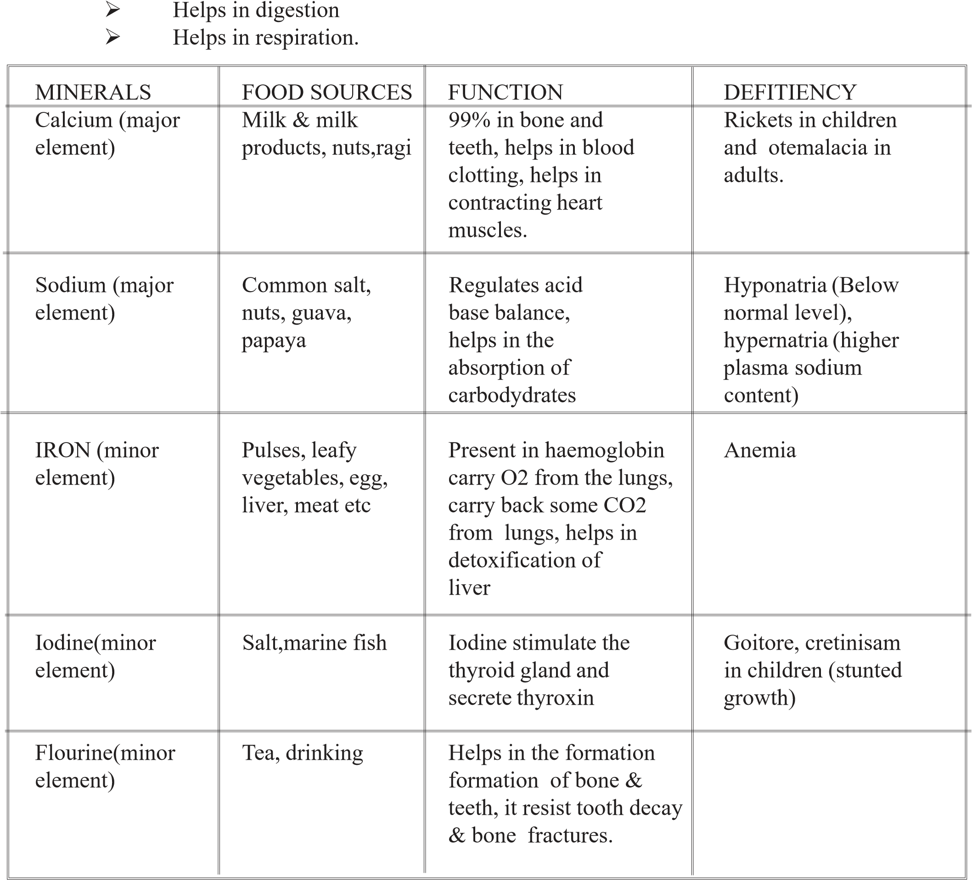

******
-16-

05.Water
Water is the medium through which all the cellular reactions occur. It functions in digestion, absorption, circulation and excretion. Water helps to manage electroytic balance in the body and plays a role in the maintenance of body temperature. Water influences the appearance texture and flavor of food.

Dietary sources
Visible
Invisible
Plain water Water present in food stuffs like,
Beverages (coffee, tea, soft drinks, rice, wheat, leafy vegetables, juices) soups Curry’s fruits etc.

Functions of water
- As a medium of solvent:- water is the medium of all cell fluids, including digestive juices, blood, urine etc. all the reactions in the body are regulated by water. Water is a solvent for digestion. Water carries nutrients to the cells & removes waste products.
- As lubricant:- water based fludis act as lubricants in various parts of the body.
- As a temperature regulator:- plays as important role in the distribution of heat throughout the body & also in the regulation of body temperature.
- Water as a source of dietary minerals:- except hydrogen and oxygen, water we drink contains some small amounts of calcium, magnesium, Zinc, copper etc.

Water Balance
In a normal individual the maintenance of water balance is achieved by adjusting water intake & output.
The amount of fluids that we consume as beverages, including water depends on climate conditions and habit. Foods are the second most important sources of water for the body. Most foods contain 50% water. Milk has the highest amount of water. Fruits and vegetables rank next to milk. While fats and oils do not contain any water. Some metabolism of foods also gives water.

-17-
1g starch yields → 0.6g of water
1g protein yields → 0.41g of water 1g fat yields → 1.07g of water.
The water is lost from the body by four routes,
- Kidneys
- Skin
- Lungs
- Intestine
Normal adult kidneys excrete about 1-2 liters of urine daily.
The water loss through skin is variable, it depend on the surface area of the body, climate, physical activity etc.
A small quantity of water is normally lost in faeces, but this can exceed 5L in diarrhoeal conditions.
The air expired from the lungs also contains water.
Daily water balance
Source | Input(ml) | Source | Output(ml)
Food | 800-1000 | Insensible loss | 800-1000
Oxidation of food | 300-400 | sweat | 200
As water | 1000-2000 | Faeces | 100-200
 |  | urine | 1000-2000
Total | 2100-3400 | Total | 2100-3400

-18-

06. BALANCED DIET
A balanced diet may be defined as one which contains various groups of food stuffs such as energy yielding foods( meat,fish egg, milknuts and and oil seeds, pulses, soybean etc.) and protective foods ( cereals, fat and oils, sugar, jiggery, roots and tubers etc.) body building foods (meat, fish, egg, milk, nuts and oil seeds, pulses, soybean etc.) and protective foods (vegetables, fruits, honey, nutsetc). in correct proportions. So that an individual is assured of obtaining minimum requirement of all nutrients.
The components of balanced diet will differ according to age, sex, physical activity, economic status etc.
The food habits and availability of foods also needs to be taken into consideration while planning balanced diets.

Factors to be considered while planning balanced diet
The meal must be adequate to meet the physiological, psychological & social requirements of the individual or the family.
Nutritional adequacy- means that diet must be adequate with respect to nutrients. The factors that affect nutrient requirement such as age, sex, occupation, etc should be taken into account.
Meal pattern should fulfill the family or individual needs. Meal pattern should provide variety.
To ensure this different food groups should be judiciously selected/chosen so as to meet the dietary requirements as well as to provide variety in terms of combinations of color, texture, taste, flavour and consistency.
Provide acceptable time gap between each meals.
Prefer easy methods of cooking that save time, energy, nutrients etc.
Make the best use of locally available, seasonal and culturally acceptable foods.
Religion, tradition and customs of food habits may be considered while selecting foods.
The economic condition of the family is important.
Minimize the use of spices and condiments. Avoid substances that provided empty calories Include raw foods also.
-19-

07. Menu planning
Menu is the list of dishes planned for preparation and forms an essential part of all activities in the food service establishment.
Menu planning is a skilled activity involving planning of balanced meals that are colourful, appetizing, and palatable and within the econiomic means of the individual concerned. It helps to determine quantities different foods accurately. It helps to avoid monotony in the menus.
While planning meals following points to be in mind:
Choose a variety of foods in appropriate amounts, according to the age, gender (male/Female), physiological status(pregnant, lactating, disease conditions) and physical activity (sedentary, moderate, heavy work).
Prefer fresh vegetables and fruits in plenty.
Include milk, eggs, meat and fish in the diet as per the requirement.
Use a combination of cereals (rice, wheat), pulses (green gram, Bengal gram, black gram etc.) and vegetable and greens. Include jaggery, sugar, and cooking oil in moderation to bridge the energy gap.
Adults should choose low fat protein rich foods such as lean meat, pulses, low fat milk and fish in the diet as per the requirement.
Develop healthy eating habits and exercise regularly.
Foods are conventionally grouped as:
1.Cereals, millets and uses.
2.Vegetables and fruits.
3.Milk, & milk products, egg, meat, and fish.
4.Oils and fats and nuts and oil seeds.
Foods are classified according to their functions into three groups
- Energy yielding foods.
- Body building foods.
- Protective foods.

-21-

Table below shows nutrients supplied by different foods

Group | Food items | Supply of major nutrients | Other nutrents
Energy rich Foods | Whole grain creats/ | Carbohydrates | Protein, fibre, minerals,
 | millets |  | B-complex vitamins
 | Vegitable iols/ | Fats | Fat soluble vitamins,
 | butter |  | essential fatty acids
 | Nuts and oilseeds | Carbohydrates and fats | proteins, vitamins,minerals
 | Sugars | Carbohydrates | Nil
Body building foods | Pulses, nuts and | Proteins | B-complex vitamins, fiber,
 | oil seeds |  | invisible fat
 | Milk and milk | Proteins | calcium, vit-A,
 | products |  | riboflavin, vit-B12
 | Meat, fish, | Proteins | Iron, iodine, fat, B-complex
 | poultry |  | vitamins
Protective foods | Green leafy  fruits, egg milk and | Vitamins & minerals | Antioxidents, fiber sugar
 | milk products | protein | Vitamins and minerals

Factors affecting meal planning
- Nutritional facts : Knowledge of food group and the nutrient in each group helps to select foods judiciously. So that a balance foods and nutrients can be met from the planned meal.
Eg: combination of creals and pulses helps sto improve protein quality. Mutual supple mentation of proteins, selection and inclusion of green leafy vegetables provides B-carotene, minerals, vitamins, antioxidants, and photochemical.
- Personal Preference: often people choose foods because they like certain flavours. We Indians enjoy spicy curry’s, use asafetida in south Indian preparations. While north Indians add gram masala.
- Habit: eg idli, dosa in south India, parathas, roti’s in north India.
- Social interaction: food signifies friendliness. Meals are part of social events and sharing of food is a part of hospitlity. Social customs almost compel people to accept food or drink offered by a host or shared by a group.
- Positive and negative associations: people tend to like foods with happy occassionsm, such as sweets during Diwali, cakes during Christmas. Dislike food during disease or sick conditions.

-22-
- Positive and negative associations: People tend to like foods with happy occasions, such assweets during Diwali, cakes during Christmas. dislike food duting desease or sick conditions.
- Emotional comfort: some people eat in response to an emotional stimulus for eg:- to relieve from bring. Eating in response to emotions can easily lead to over eating and obesity but may be at appropriate times.
- Body image: sometimes people select foods which they believe will improve their physi cal appearance.
Such decisions are beneficial when based on sound nutrition and fitness knowledge.
CRITICAL ANALYSIS OF A SOUSTSH INDIAN MENU (1-DAY)

MENU
Breakfast: idli, sambar, plantain, tea
Mild morning: lime juice
Lunch: vegetable rice (pulav), fish curry, mango pickle
Tea: boiled banana, ground nuts, tea
Dinner: chappathi, fish curry, papaya
Bed time: skimmed milk

CRITICALANALYSIS (JUSTIFICATION OF PLAN)
Breakfast is balanced. Cereals, pulses, dals and vegetables. Almost all nutrients are in it. It is better not to drink along with food. (prevent absorption of iron). Half an hour after breakfast is better.
Lime juice in mid morning gives freshness.
Lunch- mixed rice provides a variety of foods, vegetables, cereal, some oil used for seasoning-it is a balanced meal along with fish curry and pickle.
Tea - nuts are good source of protein, energy and minerals. Banana provides micronutrients.
Dinner-chapathi can be more nutritious by mixing soya flour some greens. So that all the food groups are present in the menu. Papaya a fresh fruit provides fiber, vitamins, and bcarotene. Fish is a good source of protein and good for health.
Skimmed milk in bed time helps to sleep. In short the whole day’s menu is balanced one with justifiable cost (moderate cost).

******
-23-

08. Mass food production

Effects on cooking of nutritive value of food
The objectives of processing and cooking food,
•
To improve their digestibility and appearance
- To develop new flavours
- To destroy harmful microorganisms
The important processing and cooking methods are;
- Boiling in water
- Steaming
- Baking
- Frying
- Canning
- Dehydration
Effect of cooking on various nutrients;
- Carbohydrate: When heat is applied to moist strach granules swell and burst and the starch gets gelatinized. Cooked starches digested and absorbed easily are good source of calories
- Fat: normal household cooking, no loss in fats. While fats heated for long periods, eg;-frying, loss of EFA and toxic polymerized products are formed.
- Protein: moderate heat application coagulates proteins. Cooking helps in digestion of protein, roasting, baking, frying has been reported loss of protein. Maillard reac tion is the result of protein (amino acid) and reducing sugars-cause browning (brown crust in cakes, etc.)
The nutritive value of legume protein improved by inactivating, inhibiting factors such as trypsin inhibition
.
- Vitamins:loss of vitamin and minerals occur due to leaching while cooking, frying or roasting causes vitamin-A cand carotene loss up to 30-60%. Strong light and heat destroys riboflavin. Addition of cooking soda while cooking destroys vitamin bcomplex. The quantity of vitamin C loss during cooking of vegetables varies from 10-60%.
- Minerals: when excess amount of water is used in cooking minerals leached into the water. Use of iron pan for cooking improves iron intake.
Cutting of vegetables & fruits insto smaller pieces and exposed to air causes oxida tion of vitamins and minerals and hence loss occurs.

******₋₂₄₋
Various deficiency disorders & terms
- Junk food: junk foods are those foods that contain no protein, vitamins or minerals. But are rich in salt, sugar, fats and are high in energy.
Eg:-chocolates, lays, potato chips
- ............................. is a precursor of vitamin -A B - Carotene
- Malnutrition:
is the condition of health either from a deficiency or excess or imbalance of
nutrients. Severe malnutrition in certain phases life (infancy, childhood) can do irreparable damage to the body.
Eg;-kwashiorkor
Marasmas } are the results of protein deficiency
Obesity-excess nustrition
- PEM
This isknown as protein energy malnutrition. Otherwise known as
PCM(PROTEIN CALORIE MALNUTRITION). This is the name to various degree of nutritional disorders caused by inadequate quantities proteins and energy I the diet. Such deficiency occurs in children below 5 years of age, when they are waned from mothers milk.
PEM
Kwashiorkor
Maras
mus
Marasmus means when protein and energy are insufficient a condition known as marasmus will seen in children. In marasmus growth failure occurs and the child is all skin and bone.
- Vitamin -A deficiency
Deficiency of vitamin -A shows in delayed adaption to darkness on coming from
the lighted area because it produces changes in the eyes. In a healthy person the eyes adapt quickly to dim light and bright light. In vitamin-A deficiency rhodopsin is formed effectively;therefore vision in dim light is not easy. This symptom is known as nightlindness. As the deficiency advances a condition knownas xerophthalmia develops. The conjunctiva becomes dry. The transparant appearance of the eye and its elasticity is lost. The eye becomes grey and opaque. If this condition persists sthe eye becomes infected and ulceratesd. This is a serious condition which results in blindness,. Advanced neglected xerophthalmia leads to degeneration of cornea and blindness. This condition is known as keratomalacia.

- 25 -
- Beri-beri
Beri beri is a thiamine deficiency disease.
3. forms are there;
  - Dry beri-beri: in dry beri-beri the nervs of the legs are affected first. Calf muscles become tender. Wasting of muscles and difficulty in walking.
  - Wet beri-beri : oedema on the legs will be prominent. The patient may be bed-ridden and cardiasc failure may take place, if untreated leads to death within hours.
  - Infantileberi-beri : it affects infants within six months, vomiting, green coloured diarrhea are common, if treatment delays it leads to death.
- Optimum or adequate nutrition?
When all the essential nutrients are present in correct proportion as required by
the body, it is called optimum or aeequate nutrition. Optimum nutrition is required to maintain good health.
- What is kwashiorkor? What are the supplementary protein foods you will suggest to overcome kwashiorkor?
Kwashiorkor means the sickness a child develops when the next child is born. It
occurs when there is not enough protein in the diet but calories or energy in theform of carbohydrates are available in sufficient quantity. Kwashiorkor is characterized by growth failure, swelling of legs and feet, waisted muscles, change in the colour of skin and hair, pot belly etc.
Food supplements containing good quality protein (high biological value) along with adequate amount of energy, minerals vitamins and fat. All animal foods, pulses, nuts and oil seeds are rich source of protein these food along with cereals veg & fruits will supply adequate amount of nutrition.
Eg:-Rice soya laddu, nutrimix (rice, wheat,ream gram, ground nut), idly, kichidi (Rice +dal), kuzhandai amuthu (maize + Bengal gram ground nuts).
- What does ‘4D’. stands for? Why does this happen?
Pellagra-deficiency disorder of vitamin-B3(Niacin) the symptoms are,
  - D-Diarrhoea
  - D-Dermatitis(skin disease)
  - D-dementia (mental disturbnce)
  - D-Death
If the first ‘3D’S are not treated that may lead to the fourth ‘D’-Death.
The sources of niacin are pulses, yeast, fish etc.
- What is ariboflavanosis?
Riboflavin (vitamin-B2) deficiency disorder.
Symptoms:-angular stomatitis, glossitis (megenter togue) and cheilosis(cracks at the corners of the mouth).

-26-
Source:-milk,yeast,fish,green leafy veg.
- Empty calorie foods?
Supplkes only energy.
Eg:-sugar, oil & fats, honey jaggery, chocolates, synthetic carbonated drinks (coca-cola,alcohols, wine etc
- Hypervitaminosis?
Intake of excess amount of vitamins for a longer period may cause hypervitaminosis, it occurs in fat soluble vitamins.
Eg:-Hypervitaminosis A, D, E & K.
Because fat soluble vitamins are stored in the body, while water soluble vitamins are not stored in the body.
- What are the effects of cooking on nutritive value of food?
The objectives of processing and cooking food;
  - To improve their digestibility and appearance.
  - To develop new flavours
  - To destroy harmful microorganisms.
The important processing and cooking methods are
  - Boiling in water
  - Steaming
  - Baking
  - Roasting
  - Frying
  - Canning
  - Dehydration
- Effect of cooking on various nutrients
Carbohydrate:- When heat is applied to moist starch, the starch granules swell and brust and the starch gets gelatinized. Cooked starch digested and absorbed easily is good source of calories.
Fat:- Normal household cooking, no loss in fats. While fats heated for long periods, eg:Frying, loss of EFA, and toxic polymerized products are formed.
Protein:- Moderte heat application coagulates, proteins. Cooking helps in digestion of protein, Roasting, baking, frying has been reported loss of protein mail lard reaction is the result of protein (amino acid) and reducing sugars-cause browning (brown crust in cakes, etc.)
The nutritive value of legume protein improved by inactivating, inhibiting factors such as trypsin inhibition.
Vitamin :-loss of vitamins and minerals occur due to leaching while cooking. Frying or roasting causes vitamin-A and B-carotene loss upto 30-60%. Striong light and heat destroys riboflavin. Addition of cooking soda while cooking destroys vitamin B-complex, the quantity of vitamin-C loss during cooking of vegetables vary from 10-60%.

-27-
Minerals:-when excess amount of water is used in cooking, minerals leached into the water. It is advisable not to through away the excess water, use of iron pans for cooking improves iron intake.
Cutting vegetables & fruits into smaller pieces and exposed to air-causes oxidation of vitamins and minerals hence loss occurs.
- Discuss the significance of milk and milk products in promoting good health?
Milk is a complete food. Milk protein is of excellent quantity and it promotes growth and maintenance of body tissues. Hence it is an ideal food for infants and children. Milk is very low in iron and vitamin. C content. Calcium and phosphorous very high, and is an excellent source of vitamin-A, rich in B-vitamins especially riboflavin. Lactose is the milk sugar. Whole milk contains. 4.7% carbohydrates, 4% fat, 3.3% protein and 88% water. Milk protein is casein.
Non-fat milk, cream, butter are the common milk products. Milk and milk products promotes good health.
- Plan a law cost dinner menu for your hostel and find out its nutritive value?
Cost (Rs) | Menu Ingredients | Quantity (g) | Nutritive value
 |  |  | Protein (g) | Energy (kcal)
10 | Stuffed Wheat flour, Chappathi | 80 | 8 | 280
 | with smashed smashed potato | 10 | 0 | 10
 | potatoes and peas peas | 10 | 2 | 30
7 | Cooked Rice  rice (350g) | 120 | 8 | 350
10 | Fish curry (60g) Fish | 50 | 10 | 20
10 | Dal amaranth Dal, | 20 | 4 | 65
 | porial (80g) amaeaanth, | 100 | 3 | 45
 | coconut, | 10 | 0 | 5
 | oil | 10 | 0 | 90
Total=40 |  |  | 35 | 880
- Why it is necessary to group foods? Describe one method of food grouping and discuss howit is used in menu planning?
The ultimate aim of consuming food is to maintain health. There is no sinsgle food stuff which can contribute all the nutrients needed by the body. In order to select the sources of all nutrients and in correct proportions one must know about the basic principles of food selection.
A nutritionally adequate diet should be consumed through a wise choice from a variety of foods. Foods are grouped into basic 7 food group & basic 4, suggest 4edc by U.S. Department of Agriculture, while ICMR India suggested basic 5 food groups.

-28-
A nutritionally adequate diet should be consumed through a wise choice from a variety of foods. foods are grouped into basic 7 food group & basic 4, suggest 4edc by U.S. Department of Agriculture, while ICMR India suggested basic 5 food groups.

BASIC 5 FOOD GROUP PLAN
GROUP ` | NUTRIENTS
MILK GROUP:- milk and milk | Supploies protein, minerals and vitamins.
products, pulses,nuts,meat,fish, | vitamions.
egg  Fruits and green leafy vegetables:- | Rich Source of vitamin C,A,
included in this. | minerals & vitamins
Other vegetables:-all vegetables | Good source of vitamin-C,A,
included | minerals.
Cereals, roots & tubers:-creals-rice, | Rich in starch, good source of
wheat, ragi,corn,potato,topioca, etc. | protein & b-vitamins
Fats and oil & pure carbohydrate | Energy rich, EFA, vitamin
foods:-all cooking oils, butter, | A&E (RICH IN
ghee, sugar,jaggary,honey etc. CHOLESTROL,RESTRICTEINTAKE)
How to use this grouping in menu planning.
- Choose a variety of foods in amounts approptiate for age, sex,physiological status,physical activity.
- Use a combination of grains, grams and greens. Include jaggery or sugar, oils, just enough to bridge the energy gap.
- Include fresh vegetables and fruits
- Include milk, meat,egg etc.
- Develop healthy eating habits and exercise regularly.

******
-29-

