BSc. H&HA – VI Semester Accommodation Management
COLOUR

Chapter Outline

- The color wheel - Classification of colors : Primary colors, Secondary colors, Tertiary colors, Neutral colors
Classic color schemes : Monochromatic color scheme, Complementary color scheme, Analogous color scheme, Triad color scheme, Split complementary color scheme
- Properties of colors : Hue, Value, Intensity
- Planning of a color scheme: Dominant Areas, Medium Areas, Small Areas, Accents
- Factors to be considered while planning a color scheme in a room
- Effect of Colour, Pattern and texture.

Learning Objectives

At the end of the session, the student must be able to
- Appreciate the importance of colour and its effects.
- Suggest suitable color schemes in various parts of the hotel and in various situations.

Science describes color as the sensitivity produced in the human eye due to the reflection of light off an object. Reflected white light when viewed through a prism, breaks in a visible spectrum of colors. In general, color of any object may be said to be one of the features that give it identity. It has also been found that many colors affect the mentality of the viewer and have great psychological significance. Considering the psychological significance of colors, it is necessary to know about colors while designing interiors.

1 The color wheel – Classification of colors

The vast array of colors present in the world are classified basically into three-primary, secondary and tertiary.
Primary colors are those colors present naturally. They are red, blue and yellow.
BLUE
RED
YELLOW
Secondary colors are obtained by mixing two primary colors in equal proportion, e.g: red + blue = violet, blue + yellow=green, red + yellow=orange.
- Tertiary colors are obtained by mixing primary colors and it's adjacent secondary color. These colors are also known as intermediate colors. e.g: red + violet=red violet, blue + green= blue green, orange + yellow = orange yellow.
- Neutral colors are white, black, grey and beige.

Classic color schemes

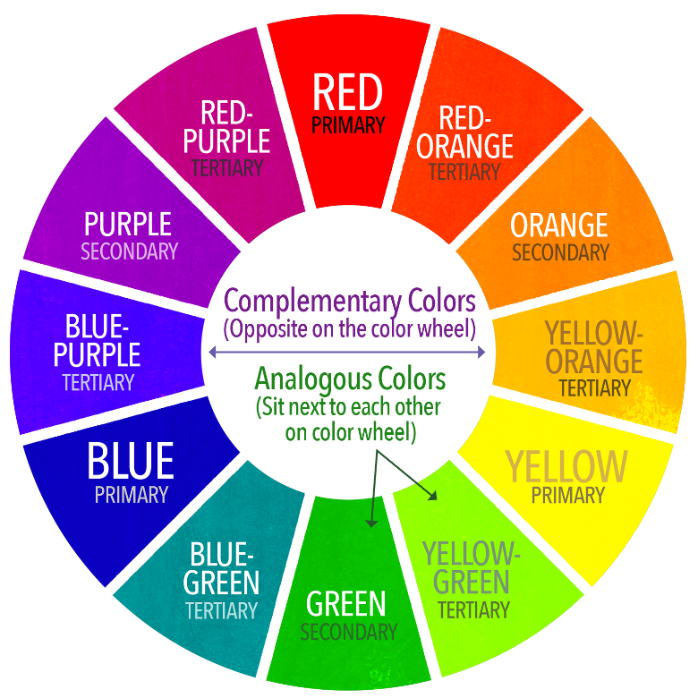
Certain schemes of interior designing have been developed by combining various types of colors. Some of the schemes are:
- Monochromatic color scheme:-Employs tints and shades of the same color. Black and white is also used in monochromatic color schemes.
- Complementary color scheme:-Employs two colors opposite to each other in the color wheel. e.g.: red and green.
- Analogous color scheme:-Also known as the harmonious color scheme .It is brought about by using a single primary color, it's secondary and corresponding tertiary color. These colors may be used in varying proportions and can also utilize the shades and tints of the same colors .e.g.; red, yellow orange and orange.
- Triad color scheme: - Employs the three colors appearing at equidistance to each other in the color wheel. e.g.: violet, green and orange. This color scheme is rarely employed, since it is very difficult to use all three colors and yet not have a gaudy look.
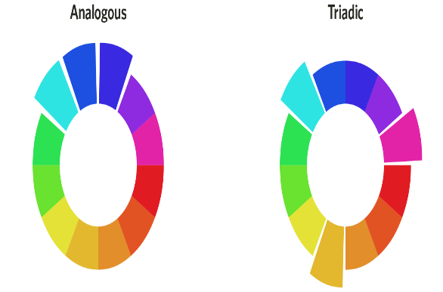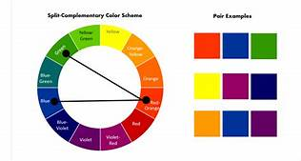
- Split complementary color scheme-Employs a specific color along with the colors on either side of the color opposite to it. e.g.: blue, red orange and yellow orange.

2 Properties of colors

A color has three properties:
- Hue: is the name given to a specific color.
- Value: indicates the darkness or lightness of a specific color. The darker values of a specific color are called shades and the lighter values are called tints. A contrast is usually brought about by using colors of different values. The sharpness of both shades and tints are clearly distinctive when the colors are of extreme values. 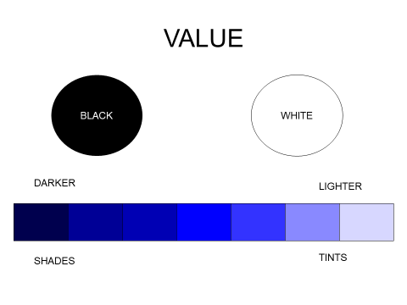
- Intensity: indicates the dullness and brightness of a specific value of a specific color. Bright colors are highly intensified while dull colors have low intensity. Colors of high intensity can be described as gaudy, flashy whilst colors of low intensity are treated as dull, ,drab etc.

Dark colors are advancing and light colors are receding. This property can alter the apparent size of a room. Reds, yellows and oranges are warm colors whereas greens, blues and violets are cool colors.

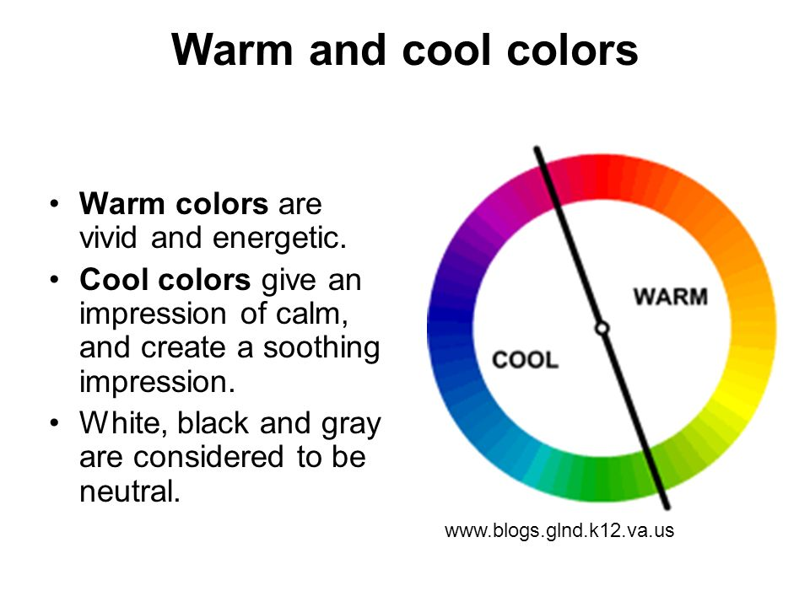
3 Planning of a color scheme

The color scheme of a room can be planned according to the various areas within:

- Dominant Areas: Includes ceiling, walls and floor. Normally the color chosen for the ceiling is lighter than the walls, the walls lighter than the floor.
- Medium Areas: Includes, furniture, draperies, upholstery.
- Small Areas: Small upholstery furniture like ottoman stools.
- Accents: Accessories like artifacts, cushions, plants, books.

The Law of Chromatic Distribution states that the larger areas must be covered in the most neutralized colors of the scheme. As the area reduce in size, the chromatic intensity should be proportionately increased.

4 Factors to be considered while planning a color scheme in a room,
Optical illusions caused by the effect of color, pattern and texture

Color magically communicates with us on physical and emotional levels, influencing not only the look of the room, but also the mood of the people within. Following are the three factors to be kept in mind while planning a color scheme for a room.

- Light and room heating.
- Size and proportion of the room.
- Purpose of the room.

Light And Room Heating: Depending upon the amount of natural light in the room, color can be chosen. A room with very less light and low heating can utilize light warm colors like white, off-white, cream, light yellow to brighten up the room. A room with a lot of light and heating can use dark and cool colors like, blue, green to bring down the light and heat.
This effect can dramatically change in the night when artificial lights are used.
Because color and light are inextricably linked, it is necessary to check samples in daylight as well as in artificial light. They may look surprisingly different. Incandescent lights usually add a warm yellow cast to colors, standard fluorescent lamps tend to cool colors down and halogen lamps produce very white light with little color distortion. If a room enjoys a sunny exposure, temper the bright light with cool hues like blue, green. Bright, warm colors like red , yellow, orange can cheer a dark windowless room.

5 Effect of Colour, Texture and Pattern
Color is a great deceiver, and by using the right hues and techniques, an awkward room can be visually remodeled, inexpensively.
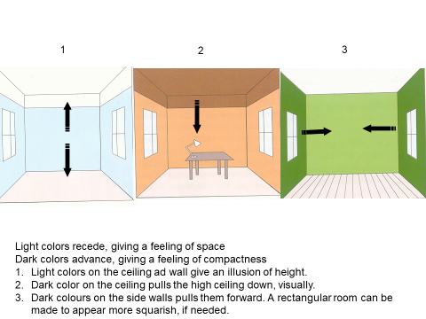

Small rooms can be made to "look" larger by uniting the walls and the ceiling in a single sweep of white or light color.
Cozy up an over-sized room with a rich combination of dark and warm colors. Rough texture in carpets and upholstery; absorb a greater amount of light, thus appearing darker.
Square up a long narrow room by using warm, dark hues (advancing colors) on short end walls to coax them forward visually. Light hues or soft white diminish the importance of the long walls.
Tame a too high ceiling by painting it in advancing colors. The effect can be enhanced by extending the dark color down the wall to about 9".
Visually raise a too low ceiling using receding colors.
Disguise a room's flaws with color magic. If walls are interrupted by too many doors, windows and nooks, paint them away using a light hue as same as the walls. Dark hue is the perfect cover-up for uneven wall surfaces.
Architectural details like wood work, wainscotting can be accentuated.
With trompe l'oeil painting that literally fools the eye, special effects can be created.

Color selection also depends on the function of the room. Hues for private areas, like rooms and bathrooms may differ from public areas.
In a lounge, the color scheme chosen must be comfortable in order to create a welcome atmosphere for visitors.
Dining rooms and restaurants should have appetizing colors. The colors most stimulating to the thoughts of food are peach, pink and other tints of red and orange.
To give a clean crisp look, hotel kitchens can be painted in white.
Warm colors are good choices for offices.
Restful pastels may suit the bedroom, but not the living room.

By introducing pattern and texture into your basic color scheme, you will begin to discover the endless possibilities as seen in wall and floor coverings.
Smooth surfaces lack the dimensional interest of rougher ones. An empty room with painted walls, smooth floor and uncurtained expanse of glass at the windows is bland and dead looking. Add a shaggy rug, a pebbly woven drapery and the room begins to come alive.
The shadow-play that light sets up in textured material, creating changing patterns and subtle nuances of color is a part of the magic. Another element is the pleasure that many textures, smooth or rough, gives the sense of touch a pleasure that is suggestive just by looking at them. The cool sleek feel of metal, the softness of satin, the roughness of burlap contribute to the effect of their use in a room.
The rule for texture is the same as that of color. Don't over do it. Just as a room lacking in texture is bland, so one with an excess of textured materials or with too many different kinds is distracting. What is needed is a delicate balance of smooth, and rough textures each one enhancing the other. Some imitation textures:-wall paper that looks like brick-work can create the effect of the real thing.
Textures affect the colors as you see it. A shiny smooth surface reflects light whilst rough materials absorb the light and the color may appear deeper and duller. Velvet because of it’s deep cut pile, both absorbs and reflects light so the color appears to be different in the folds of the fabric. If you put a piece of white satin and white muslin in a kettle of dye and leave them for the same length of time, the resulting color would appear to be somewhat different in each fabric because of their varying textures.
Rough textured objects seem to advance and take up more space while smooth textured ones seem to recede.
The presence of a design adds variety and excitement to any surface. Effect of texture may be formal or informal. Silk, damask, satin, taffeta, fine grain wood, elaborately carved surfaces belong to formal rooms whereas tweeds, muslin, chintz, furs belong to informal ones. Texture can also affect the dimensions of the room. A high or a shaggy pile rug tends to fill a room from the bottom up, and makes a low ceiling seem even lower. Such a rug would be much more effective in a room with a pitched or a vaulted ceiling.

Patterns are designs with a definite character that have been printed, woven, stamped or otherwise produced in fabrics and wall and floor coverings. To use them effectively there are a few things to remember.
The safest course is to avoid using more than one strong pattern in a room. Too much pattern is disturbing to the eye and creates a `busy' room. Thus a patterned carpet may be used with plain upholstery, patterned curtains with plain walls and vice versa. If two patterns are thought necessary, they should be different in character and one should be dominant. For example - a striped and a floral pattern; and one should always be dominant.
Large patterns can be overpowering in a small room; small patterns may be lost in a large area.
Like color and texture, patterns can play tricks on your eyes.
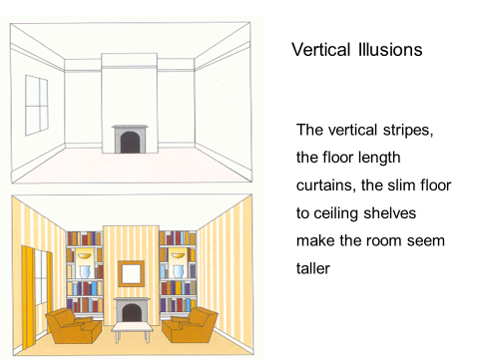
Wall paper with vertical design leads the eye upwards making the ceiling seem higher, while a strong horizontal motif seemingly lowers the ceiling height.
Pattern can disguise architectural defects. If you have a foyer cut up by many doors, cover walls and doors with an exciting pattern to give it an interesting and unified look. A mottled pattern is good for disguising patchy walls and other blemishes.
A strongly colored splashy pattern is usually better confined to a fairly small area, where it will provide a center of interest. Used too lavishly it can seem over-powering.
Patterned surfaces do not show soil as much as plain surfaces.

While choosing patterns, ensure that
- the pattern is seen as a large sample.
- carpets are seen lying flat in the floor.
- wall papers are seen hanging vertically.
- curtain materials are seen hanging in folds.
The introduction of pattern needs careful consideration and the desired effect may be lost, otherwise.

