BAR OPERATIONS - EQUIPMENT and CARE

The bartenders side of the bar, commonly referred to as " behind the bar” is the area where all the equipment’s, tools and Supplies necessary for preparing and dispensing of drinks are kept. Because speed is such an essential part of bartending, this area is designed for compactness and efficiency.

PARTS OF A BAR
- Front Bar
- Under Bar
- Back Bar

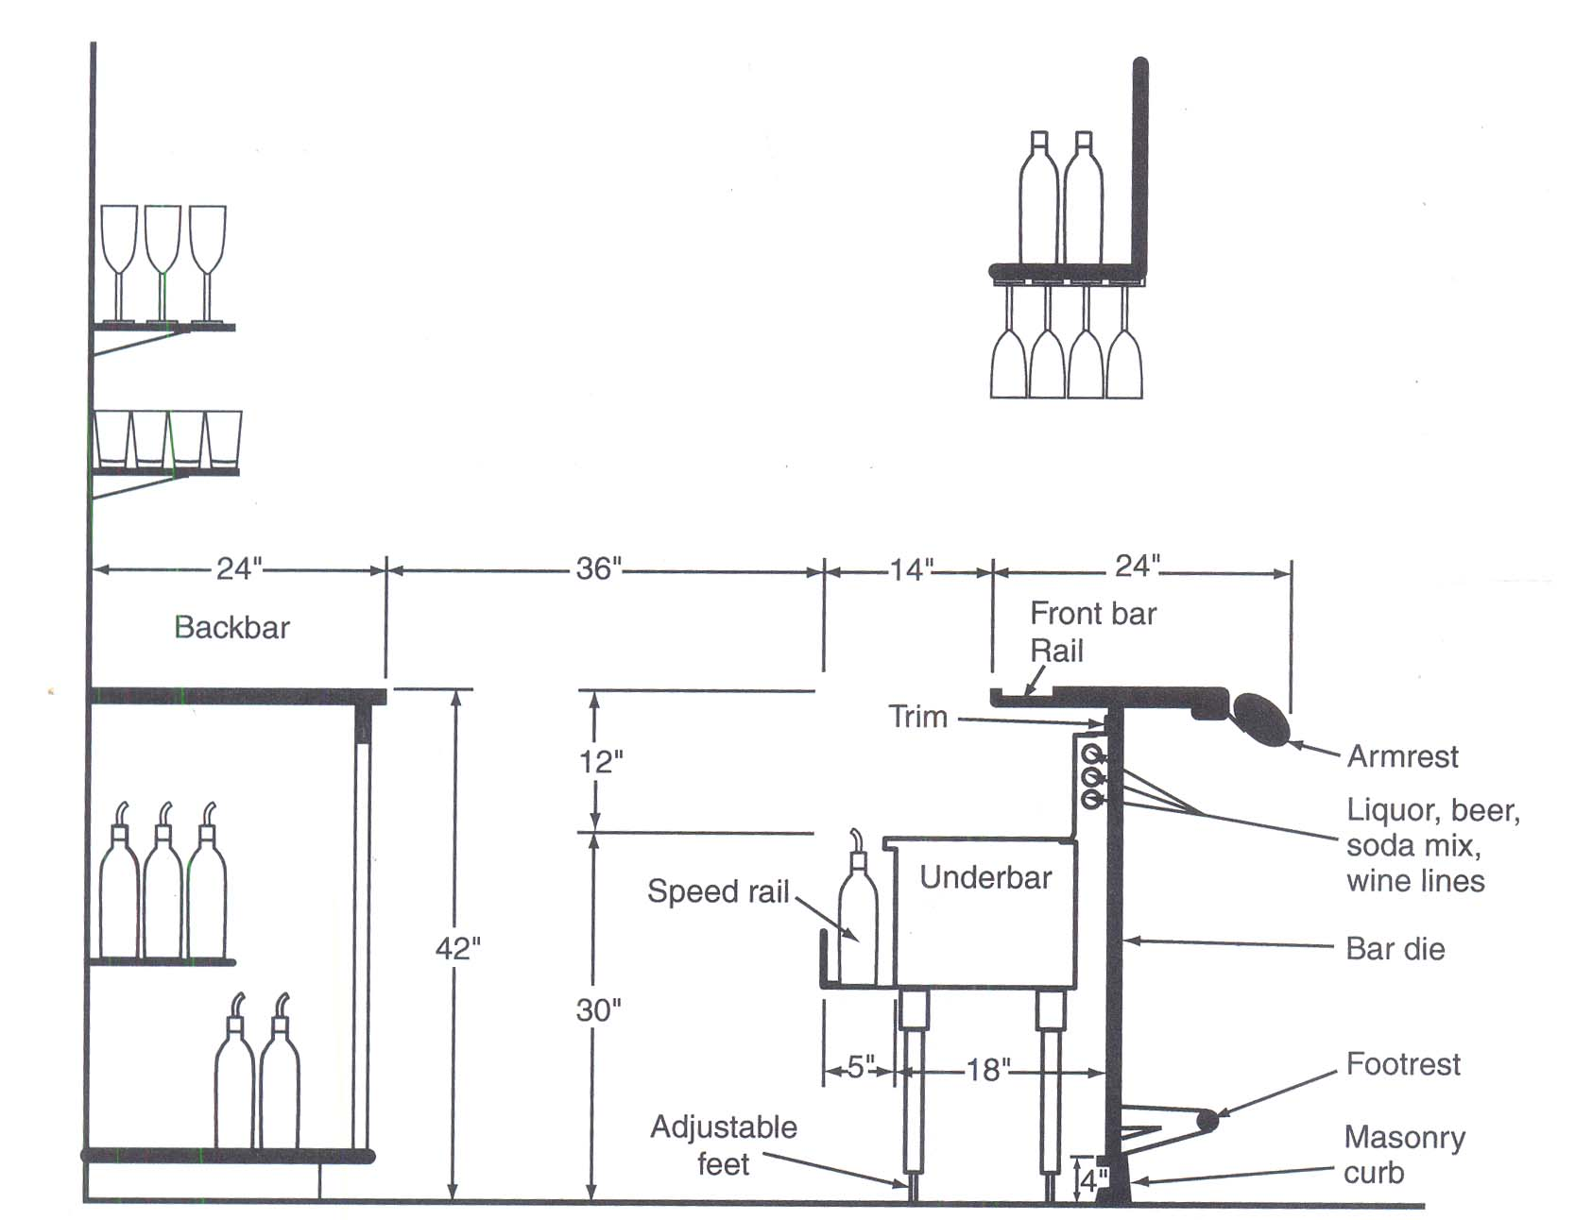

In the bars, there are many small tools that are essential in the preparation of drinks - they should be kept within reach of the bartender, so goes the sayings,

Keep the equipment clean at all times.
Keep them in good repair.
Keep them in the proper place.

Small equipment include-
-----------------------
Corkscrews
Bottle and can openers
Jiggers
Speed pourers
Jigger / Pourers
Mixing glass
Shakers
Strainers
Blenders
Bar spoons
Bar Muddlers
Measuring spoons
Fruit Juicers
Funnels
Ice Scoop / Tongs
Ice Buckets
Garnish Trays
Nutmeg Grater

Accessories include-
-------------------
Straws - long and short
Small napkins and / or coasters
Bar matches
Ashtrays
Cocktail sticks
Garnish spears

Garnishes Include-
-----------------
Cherries
Olives
Onions (cocktail variety)
Orange slices
Lime / lemon slice / wedges / peels
Mint leaves
Cucumber
Cinnamon

SMALL EQUIPMENT:-
----------------
A. Cork screws:- have been discussed during wine service – they are also an essential part of bar operation.

B. Bottle and can openers:- Every bar should have bottle openers and can openers as part of their equipment - they need no explanation as they are used so frequently.

C. Jiggers: - Jiggers are measures for liquor that are used in preparing drinks. The stainless steel or silver plate in good bars - are the types used in practically all bar operations. Jiggers (or tots or Measures) are available in various sizes ranging from á1/2 ounce to 2 oz. The most useful is the double-sided jigger - 1 oz on one side and 1 1/2 oz on the other.

D. Speed pourers:- Speed pourers are the spout-like devices which are inserted into the tops of bottles to ensure a steady, even flow of liquid. All speed pourers have slender air rods, which extend into the bottle about an inch. These rods are connected to air vents in the top of the speed pourers which allow air to enter the bottle as liquid is poured from it. They are usually stainless steel with a cork insert.

E. Automatic pourers / jiggers:- This pourer has a bulbous glass container which measures (usually 1 1/2 oz) so that it can be permanently inserted into the bottle of spirits and will give accurate measures without having to rely on slips of the hand or generous bartenders.

E. Mixing Glass:- Mixing glasses are containers made of heavy glass, sometimes with a slight lip. These are used for mixing and shaking drinks. They are usually about 16 oz.

F. Shakers:- Shakers are heavy, stainless steel or silver plated containers with fitted tops to prevent any leakage - then have an in built strainer to prevent ice going into the glass.

G. Strainers:- Strainers are devices which are placed over the tops of mixing glasses to separate ice from drinks as they are being poured, made of silver or stainless steel, they have small handle. and perforations with a circular spring which holds back the crushed ice and allows the liquid to flow.

H. Blenders:- Electric blenders are used in most of today’s modern bars. Most are made of stainless steel (occasionally of glass but this is not very practical for a commercial operation). They have rotating steel blades for crushing ice or blending fruits, etc. Sometimes called a Warring blender.

I. Bar Spoons:- Bar spoons are long slender stainless steel or silver spoons used for stirring drinks in mixing glasses. Occasionally they can be used for measuring purposes, having 3/8 oz capacity. Generally 10-12 inches long with a twisted handle.

J. Bar Muddlers:- Like mortar and pestle, should be made of lignum vitae (hard wood) for the bar but marble will also being more practical in India. Used for muddling sugar or crushing mint and other herbs for drinks.

L. Measuring Spoons:- Measuring spoons are small metal spoons, used to measure exact amounts of ingredients. These spoons are usually fastened together for easy selection and use.

M. Fruit Juicers:- There are several types of juicers, manual and electric. Most bars use a hand juicer. After each usage the juicer should be cleaned - citrus fruits will dry fast on the juicer and collect bacteria. Take care!

N. Funnels:- Funnels are indispensable tools in bar operations -transferring liquids from one container to another. Funnels should be quite durable and of several sizes.

O. Ice scoops:- Tongs / scoops should always be used. Never hands (or glasses for scooping) It usually has 6 oz or 8 oz capacity. A standard size makes it easy to get just right amount of ice with one swoop of the scoop. Actually, bartenders often scoop with the glass, a very dangerous practice!! It is too easy to break or chip the glass, leaving broken glass in the ice bin and a cutting rim on the glass. It shouldn't be done.

P. Ice tongs:- Ice tong are designed to handle one cube of ice at a time. They are very important, since the ice that will go into a drink should not be touched by hands.

Q. Garnish Trays:- Garnish trays are essential part of bar equipment though not always used in Indian bars. These are often stainless steel or glass made with small containers for various items like lemon slices and wedges, cherries, olives, cocktail onions and the like.

R. Other Accessories:- Several other accessories and supplies required in bar operation include, straws - long and short flexible straws preferably ), small napkins and / or coasters, stir or swizzle sticks, matches, ashtrays, garnish spears., etc.

S. Garnishes:- Include, Cherries, olives, onions, orange slices, lime/lemon slices and wedges, lime peel, cucumber and the like.

T. Groceries:- Include, Salt, Pepper, cube sugar, granulated and castor sugar, cloves cinnamon sticks, Nutmeg (and a nutmeg grater as part of the equipment ), eggs and cream.

It goes without saying that all equipment should be kept in spotlessly clean condition. Any metal that comes in frequent contact with citrus juice is liable to contamination unless scrupulously clean at all times.

A word or two about water and ice. Water is very important ingredient in bars and it differs from state to state. Most travelers, domestic and particularly foreign are wary about drinking water even as a mix in whisky. Monsoon time is usually a problem time for water. Make sure your bar stocks mineral water and have this on offer to your client.

BAR OPERATION - BAR STOCKS AND INVENTORY

Objective : That as a student you are familiar with par stocks and are capable of taking a physical inventory of the liquor stores and bar.

Liquor laws in India - varying from state to state hamper the hotelier, particularly in stocking of foreign liquors.
In some states in India the hoteliers choice is further limited by the structure of the market. The manufacture or the brewer may have their own distribution network, or sales may be through distributor, which handles several manufacturers. It is further complicated by the structure of imported liquor through state licensed distributors who in turn are hampered by imports themselves.

All this affects the hotel in the constancy of supplies - particularly in the areas of wine sale. It is dangerous for a hotel to print, for instance, a vast wine list. when the chances are that the wine available today, may not be available in 6 months time. Even Indian wines can be erratic in their production and distribution so there is no actual guarantee of supply. This brings us to the problem of how much to buy. Liquor stocks represent a great deal of investment for an hotel and having the cellars full of liquor standing idle on shelves tying up money that could be put to better use. One has to "play the market by the ear " so to speak. Bars should never run out of draft beer (if it is on tap), popular bottle beers, and popular brands of spirits - imported and domestic. However slow moving items need not be reordered until the last bottle has started.

Each bar should set a standard for an adequate supply, establishing par stock - and par stock can be established from detailed sales records. From par stock needs it can be reckoned on how much should be in the store room - the normal store room inventory.

Par stocks can also be used to measure daily consumption. The bottles it takes to bring the bar stocks to par represents roughly the consumption of the previous day. During a week, these bottles will yield an accurate figure of average daily consumption. This too, can guide the rate of purchase. Par stocks in also one way of keeping up with your clients tastes. One knows what brands are moving quickly because one has par stocks as a measure of their popularity. Thus it informs - what to buy as well as how much is being used.

Whatever the stock intervals - it is a good idea to set minimum and maximum stock levels for each item to maintain storeroom inventory. The maximum level represents the dividing line between enough and too much.

There are several arguments for keeping a small inventory geared to sales volume. The major point is that liquor is expensive, and it ties up money that is not earning anything. There are other problems with large stocks. One is security: the more liquor in stock the more tempting it is, the harder to keep track of and easier to steal - more space and staff are needed and the greater burden of record keeping and taking physical inventory. Perishable items like beer and some wines should be bought in quantity because they are scarce and will quickly disappear from the market.

The inventory is of central importance to the purchasing function. There are two reasons for keeping a constant check on inventory. One is to pin point losses quickly in order to stop them. The other reason has to do with purchasing. If you have lost stock due to theft, breakage, error or whatever, you must buy stock to replace it, so that you can serve your clients.

The only way to know what is in stock is to take a PHYSICAL INVENTORY - that is to count each bottle on a regular basis - weekly. If possible the inventory should be taken by person who neither buys nor handle liquor. It is best to have two people one counting and one writing. The inventory record should follow the arrangement of the store room, grouping items by category and brand. The liquor in the bar is also a part of the inventory unless it is sold.

All inventories must be taken at the same time and must be done when the bar is closed, so that nothing changes while the counting is being taken.

When the inventory is completed one can get the rupee value of the total stock. To do this the unit cost of each item is entered on the liquor inventory. The next step is to multiply the unit cost by the number of units to find the rupee value of the stock for each item. Enter each total on the form in the last column. Totaling the value of all the items then gives the value of the entire inventory. The figure is known as the closing inventory for the accounting period. The same figure becomes the opening inventory for the next accounting period.

The rupee cost for liquor used in a given period is usually expressed as a percentage of the sales for the same period. To figure this percentage divide cost by sales:

C/S = C %

This percentage figure is often referred to simply as BAR COST.

BAR OPERATION - STAFFING A BAR

The people who deal with the guests are a crucial element in the
profitability of any bar operation. It is they who represent the
enterprise to the public, who create the human side of its ambience,who sells its products. They also often represent the largest percentage of its cost and usually the greatest percentage of its headaches. High turnover, poor performance, and unreliability are frequent complaints among employers.

The Bar Supervisor / Manager should:

- identify jobs for which staff are to be hired.
- write job descriptions.
- schedule staff to meet daily needs.
- recruit, interview and select appropriate staff.
- develop successful training routines.
- supervise staff effectively.
- satisfy state / government licensing laws.

One of the major ingredients in the atmosphere of any bar or restaurant is the staff. Staff members can make customers feel welcome and important, or small and unwanted. They can create a feeling of fun and festivity or throw a wet blanket on any party.
They can please customers with their efficiency or turn them off with inattention, carelessness, bad manners, or dishonesty.

Staff affect profit in many other ways. They are important links in any cost-control system. They are the hotels best selling agents. To the guest they represent the Hotel and its philosophy.

How does the hotel go about finding the right people and putting them altogether to function in a smooth operation ? Who are the right people anyway and where does one find them ?

In India because of so many state taboos in the only recent past, drinking in hotel bars is considered very daring and almost socially incorrect. Looking around any hotel bar the number of Indian ladies, for instance is usually extremely few. It is a mans world, except for a sprinkling of foreign woman. For this reason the bar and bar staff are sometimes neglected. Any one can pour a whisky and soda or a beer - and after all what else are Indians interested in drinking. Cocktails are alright for very rare occasions but not as a regular pastime.

So the barman need not know any of these things. His personality is immaterial as he seldom needs to chat with guests. These are old excuses and obviously need to be rectified. It can only be done by making the bars in the hotels more interesting and a socially acceptable place to visit to relax and enjoy the odd
drink.

JOB DESCRIPTION OF A BARTENDER

JOB TITLE: Bartender

REPORTS TO Senior Bartender

JOB SUMMARY

Responsible for day to day running of the bar standards of hygiene, and reporting of defective equipment / machinery.

DUTIES

* Organizing the service in the bar area and operating in an efficient and
hygienic manner.
* Maintaining the bar stocks in good order.
* Handing over the operation to the next shift in a state of preparedness.
* Leaving the bar secure at the end of the day.

QUALITIES

Good appearance.
Sense of responsibility.
Honest and reliable.

QUALIFICATIONS

A good general education, Hotel school graduate and / or hotel experience.

JOB DESCRIPTION OF A SENIOR BAR TENDER

JOB TITLE: SENIOR BAR TENDER

REPORTS TO: BAR MANAGER / FOOD & BEVERAGE MANAGER

JOB SUMMARY

RESPONSIBLE FOR DAILY BAR OPERATION STANDARDS OF HYGIENE AND CLEANLINESS, AND PROPER CONTROL AND STORAGE OF LIQUOR, JUICES AND OTHER DRINKS.

DUTIES:

* MAINTAINING AND ORDERING ADEQUATE STOCKS
* CONTROLLING DAILY SUPPLIES OF BAR STOCKS
* ORGANISING ROTAS AND DUTY SCHEDULES FOR BAR STAFF.
* MAINTAINING DISCIPLINE WITHIN THE BAR AND ASSURING GOOD
BAR SERVICE AT ALL TIMES.

GOOD QUALITIES

APPEARANCE, ORGANISING ABILITIES, HONEST, RELIABLE, AND SOBER, BRIGHT PERSONALITY AND CONVERSATIONALIST.

QUALIFICATIONS

A GOOD GENERAL EDUCATION, BAR EXPERIENCE OF INTERNATIONAL HOTEL STANDING INCLUDING KNOWLEDGE OF BOTH ALCOHOLIC AND NON-ALCOHOLIC BEVERAGES, FOREIGN LANGUAGE IS AN ADVANTAGE.
____________________________________________
TASK ANALYSIS

HOW TO:

- PERFORM OPENING DUTIES
- SHAKE / STIR / POUR DRINKS
- KEEP THE AREA CLEAN
- PERFORM CLOSING DUTIES

BAR OPERATION - TASK ANALYSIS_

HOW TO: PERFORM OPENING DUTIES

STEPS

KEY POINTS

REASONS

1. Keys

a) Pick up keys from Security.

2. Mis-en-place

a) Set up Bar for efficient service
b) Slice fresh fruits for Garnishes
c) Squeeze fruits for juices for service
d) Place juice in stainless steel containers
d) Keep it in fridge

3. Accompaniments

a) Olives, nuts in proper containers.

4. Glassware

a) In glass racks or on shelves from wash-up area.

5. Bottles

a) Wipe mineral bottles, remove dust and dirt
6. Refrigerators
a) Check interiors.
a) Standards of hygiene

KEY POINTS

REASONS

1. Cocktails-shaken

a) Clean ice into container
a) To cool drink.
2. Tot measure
a) Use measure for syrups,
a) Correct amounts.
juices and liquors
b) Add ingredients.
b) According to receipe
c) Close shaker properly
c) For safety reasons.
d) Shake shortly and sharply
d) For proper mixing.

3. Pour in cocktail shaker. _
a) For pouring.
b) Use the right glass.
c) Correct amount
procedure.
4. Cocktail-stirred_
a) Clean ice into mixing
a) To cool drink.
glass.
b) Use measure / add
b) Correct amounts.
ingredients._
c) Pour drink into glass_
c) Procedure.

HOW TO: KEEP THE AREA CLEAN

