FOOD
&
BEVERAGE
MANAGEMENT

COURSE PLAN
- Preamble

Course Title: Food and Beverage Management
Course Number: BHM 305
Prerequisites: 6th Semester of 3 Years B.Sc. in Hospitality and Hotel Administration
Number of Hours: 60 classroom hours
8 Tutorial Hours
3 TEE Examination Hours
Module Leader: Mr. Pradosh Pai
Last Update: January 2020

- Course Description

Modern day food and beverage (or food service) operations are continuing to improve in the quality of food, beverages and the service on offer. Professionalism is increasing, through better training and development, and there is a much greater understanding of customer needs with the quality of service now becoming a key differentiating factor when customers are choosing between similar establishments. It is to provide support for these approaches that this course has been designed. Successful food and beverage operations are those that have a clear understanding of their customer’s needs, which they continually seek to meet.
Food and Beverage management deals with the various aspects of managerial practices in a catering operations such as planning for purchase, receive, issuing, storing and most important aspect is to bring down the cost so maximum profit can be achieved by an organization. Course has wide coverage of menu planning, menu merchandising and menu engineering and budgetary control in food and beverage operations and management.
Content of the course is intended to be reflective of current industrial practice and provides information and viewpoints on a variety of aspects of food and beverage management and considers various approaches which learners may find useful in their professional and personal career.
- Learning Objectives:
By the end of the course, learners will be able to
Knowledge
1. To identify of the customer’s needs by conducting market surveys.
2. To formulate financial, marketing and catering policies, business goals and objectives as per the needs of the market and catering industry.
3. To study and analyse the demands and to assist senior management in decision making for designing the facilities, product, and to assess the requirement of plant and equipment.
4. To streamline the operations by developing standard operating procedures for food production and service. To design the various methods of control in different food service areas such as purchasing, receiving, issuing and storing, preparation and sales.
- To control various costs such as material. Labour and overheads to earn maximum profit.
- To monitor of guest’s satisfaction level and to review the cost control cycle control for further modifications.

Competencies

Prepare Standard operating procedures of purchasing, receiving, issuing, controlling, preparation and service of food and beverage items according to catering policies of the organization.

Apply the practices of breakeven analysis, inventory management, variance analysis, sales control, menu merchandising and menu engineering in day to day food and beverage operations and management.

Compute and generate various cost control and sales reports required by senior management for monitoring the performance and decision making purpose.

Mindset
- Differentiate between cost variances and sales variances.
- Differentiate between menu merchandising and menu engineering.
- Defend the relationship between cost, volume and profit.

- TRAINING PLAN:CHRONOLOGY TABLE

WEEK | TIME  2 HOURS | ROOM | LESSON NUMBER | CONTENTS
 |  |  |  | FACILITATOR – CENTRED | LEARNER- CENTRED
1 | SESSION 01 | LR-1 | 1 | - Icebreaker  - Introduction  - Definition of cost  - Elements of cost  - Classification of cost  - Cost behavior  - Group exercise | - Quiz I Individual  - Homework: interview with food and beverage manager of local hotels/ restaurants/ institutions
 | SESSION 02 | LR-1 | 2 | - Recapitulation  - Group presentation  - Introduction  - Sales concept  - Uses of sales concept | - Quiz 2 and group presentation  - Homework  - Read interviews of sales managers from Hotelier magazine.
2 | SESSION 3 | LR-1 | 3 | - Recapitulation  - Group presentation  - Introduction:  Inventory Management  - Objectives: Inventory management  - Inventory control cycle | - Group presentation and QA  - Homework  - Visit of websites on inventory control techniques
 | TUTORIAL | LR-1 | Tutorial 1 of 8
3 | SESSION 4 | LR-1 | 3 | - Recapitulation  - Q/A Session  - Methods of inventory control | - Feedback  - Homework  - Exercise based on inventory control method: EOQ, ABC Analysis
 | SESSION 5 | LR-1 | 3 | - Recapitulation  - Stock levels and techniques  - Graphical representation of various stock levels, lead time and EOQ  - Group exercises | - Feedback and assessment of homework.  - Homework : Search websites on inventory management practices
4 | TUTORIAL | LR I | Tutorial 2 of 8
 | SESSION 6 | LR-1 | 3 | - Recapitulation  - Types of inventory  - Comparison of physical and perpetual inventory | - Feedback and assessment of homework.  - Homework  - Conduct interviews with store managers
5 | SESSION 7 | LR-1 | 3 | - Recapitulation  - Group Presentation  - Pricing of commodities  - Analytical problems based on pricing of commodities  - Group exercises | - Feedback and assessment of homework.  - Presentation  - Quiz 3
 | SESSION 8 | LR-1 | 4 | - Icebreaker  - Introduction  - Definition of control  - Objectives of Beverage control  - Problems associated with beverage control. | - Feedback and group work in class  - Homework  - Preparation for Quiz
6 | SESSION 9 | LR-1 | 4 | - Recapitulation  - Individual Quiz  - Methodology of Beverage Control  - Beverage control cycle | - Feedback and group work in class  - Homework  - Conduct interviews with Bar Tenders and Cellar Managers.
 | SESSION 10 | LR-1 | 4 | - Recapitulation  - Group presentation  - Definition of purchase  - Types of purchase  - Purchasing procedures | - Feedback and group work in class  - Homework  - Collect details of tenders and bids from local newspaper.  - Conduct interviews with purchase manager.
7 | SESSION 11 | LR-1 | 4 | - Recapitulation  - Group presentation  - Aims and objectives of receiving  - Receiving procedures  - Receiving documents  - Hygiene & Cleanliness of the Receiving area  - Setting of receiving department | - Feedback and group work in class  - Recall layout:  Receiving department of a five-star hotel from IET.
 | SESSION 12 | LR-1 | 4 | - Recapitulation  - Group presentation  - Aims and objectives of storing  - Storing procedures & documents.  - Production control  - Bar frauds | - Feedback and group work in class  - QA Session  - Quiz 4
8 | TUTORIAL | LR-1 | Tutorial 3 of 8
 | SESSION 13 | LR-1 | 5 | - Recapitulation  - Introduction to sales control  - Importance of sales control  - Sales control techniques | - Feedback  - QA Session  - Homework  - Visit electronic stores and compare the various features of models/ machines available in the market.
9 | SESSION 14 | LR-1 | 5 | - Recapitulation  - Group presentation  - Point of sales  - Documents used in sales control  - Cash handling procedure  - Preventive measures of cash thefts | - Feedback  - QA Session
 | SESSION 15 | LR-1 | 6 | - Recapitulation  - Introduction to Budget  - Importance of budgetary control  - Types of budget | - Group Homework:  Interview with any H.O.D of local hotels/ restaurants to study their style of budget.
10 | SESSION 16 | LR-1 | 6 | - Recapitulation  - Types of budget  - Drafting a master budget | - Group Homework:  - Plan a theme lunch within a given budget by four groups representing 4 departments.
 | SESSION 17 | LR-1 | 7 | - Recapitulation  - Group presentation  - Variance Analysis  - Standard Cost  - Standard Costing | - Feedback and group work in class  - Homework: problems based on costing
11 | SESSION 18 | LR-1 | 7 | - Recapitulation  - Group presentation  - Types of Variances:  Material, Labour , Overhead ,  Sales, Profit Variance. | - Feedback and group work in class  - Homework: problems based on variance
 | TUTORIAL | LR-1 | Tutorial 4 of 8
12 | SESSION 19 | LR-1 | 8 | - Breakeven analysis  - Preparing a Breakeven Chart | - Feedback and group work in class  - Individual Homework:  : Solving 3 Breakeven Problems  - QA Session
 | SESSION 20 | LR-1 | 8 | - Profit volume Ratio  - Contribution  - Marginal Cost | - QA Session
 | TUTORIAL | LR-1 | Tutorial 5 of 8
13 | SESSION 21 | LR-1 | 8 | - Plotting a Breakeven Graph | - Quiz 5
 | SESSION 22 | LR-1 | 9 | - Discussion: BE Problems  - Recapitulation:  - Introduction to Menu merchandising.  - Menu Structure  - Planning  - Pricing of Menus  - Types of Menus  - Concept of Menu merchandising. | - Feedback and group work in class  - QA Session
 | TUTORIAL | LR-1 | Tutorial 6 of 8
14 | SESSION 23 |  | 9 | - Menu as Marketing Tool  - Designing a menu Layout.  - Constraints of Menu Planning | - Dinner with students in a fine dine restaurant. Every student to note two points of selling techniques used by the outlet to sell dishes.
 | SESSION 24 | LR-1 | 10 | - Recapitulation.  - Discussion on menu merchandising from dinner experience.  - Menu engineering: Introduction  - Definition and Objectives | - Feedback and group work in class  - Homework  - Visit a local coffee shop to find how changes were implemented in menu, the last time.
15 | SESSION 25 | LR-1 | 10 | - Methodology  - Popularity  - Profitability | - Group work: problem
 | SESSION 26 | LR-1 | 10 | - Advantages: How to handle  the four categories of menu engineering matrix | - Quiz 6
 | TUTORIAL | LR-1 | Tutorial 7 of 8
16 | SESSION 27 | LR-1 | 11 | - Recapitulation  - MIS  - Reports  - Objectives of MIS | - Feedback and group work in class  - QA Session  - Collect monthly food cost from a local restaurant and verify the calculation of food cost.
 | SESSION 28 | LR-1 | 11 | - Calculation of actual cost  - Daily Food Cost  - Monthly Food Cost | - Case study
17 | SESSION 29 | LR-1 | 11 | - Statistical Revenue Reports  - Cumulative and non-cumulative food cost reports. | - QA Session
 | TUTORIAL | LR-1 | Tutorial 8 of 8

- Learning Methodologies
Real class time breakdown
Learning methodologies Hours
- Lecture- discussion 40
- Exercises---- individual 6
- Group ----exercises 6
- Group presentation 6
- Group role play 2
Total 60 Hours
- Course Evaluation
  - Course Assessment
Classroom Test Weightage / %
- Mid-term examination 50 Marks
- Final Semester Term End Examination 100 Marks
- Total 100 %
Term marks will comprise 30% in-course and 70% Term end exam marks.

  - Course appraisal
As per Standard course appraisal devised by NCHMCT.

- Course references
- Food And Beverage Management
By Jagmohan Negi
- Managing Food And Beverage Operations
By S K Bhatnagar
- Food And Beverage Management
By Bernard Davis & Sally Stone
- JACK. E. MILLER, DAVID K. HAYES, LEA R. DOPSON (2002), Food and Beverage Cost Control, Second edition, John Wiley & Sons, Inc, New York, ISBN 0471-35515-1
- JOHN COUSINS, DAVID FOSKETT, CAILEIN GILLESPIE (2007), Food and Beverage Management, Second Edition, Pearson Education, India, ISBN 81-317-0134-4
- Supplemental Handouts on the Intranet.

- Bibliography & Webliography

  - Bibliography
- Adams, Deborah. Management Accounting for the Hospitality Industry: A Strategic Approach. London: Cassell Academic, 1997.
- American Hotel and Motel Association. Uniform System of Accounts for the Lodging Industry. Ninth edition. Orlando: Educational Institute of the American Hotel and Motel Association, 1996.
- Chaban, Joel. Practical Foodservice Spreadsheets with Lotus 1-2-3. New York: John Wiley & Sons, 1997.
- Club Managers Association of America (Editor). Uniform System of Financial Reporting for Clubs. Dubuque, IA: Kendall/Hunt Publishing, 1996.
- Coltman, Michael M., and Martin G. Jagels. Hospitality Management Accounting. 7th ed. New York: John Wiley & Sons, 2000.
- Defranco, Agnes L., and Pender B. M. Noriega. Cost Control in the Hospitality Industry. Upper Saddle River, NJ: Prentice Hall, 1999.
- Deloitte & Touche, LLP. Uniform System of Accounts for Restaurants. 7th ed. Washington, DC: National Restaurant Association, 1996.
- Dittmer, Paul R., and Gerald G. Griffin. Principles of Food, Beverage, and Labor Cost Controls for Hotels and Restaurants. 6th edition. New York: John Wiley & Sons, 1999.
- Drysdale, John A. Profitable Menu Planning. Upper Saddle River, NJ: Prentice Hall, 1997.

  - Webliography

- www.studymode.com/course-notes/Menu-Management-1875562.html
- hotmama.at/Images/menueengineering.pdf
- http://www.hospitality-school.com/free-hotel-management-training/food-beverage-service
- http://www.scribd.com/doc/14416785/Food-and-Beverage-Sequence-Of-Service
- http://www.b-u.ac.in/sde_book/bsc_beverage.pdf
- http://en.wikipedia.org/wiki/Food_industry
- en.wikipedia.org/wiki/Inventory
- www.accountingformanagement.org/break-even-point-analysis
- www.businessdictionary.com/definition/budgetary-control.html
- www.accountingcoach.com/blog/variance-analysis-standard-cost
- www.accountingtools.com/book-cost-accounting
- www.scribd.com/doc/24073087/Beverage-Control
- www.douglascollege.ca/programs-courses/catalogue/.../HOSP233
- quizlet.com/.../merchandising-techniques-for-food-service-flash-cards/
- www.foodservicewarehouse.com

BHM305 - FOOD & BEVERAGE MANAGEMENT
HOURS ALLOTED: 60 MAXIMUM MARKS: 100

S.No. | Topic | Hours | Weight  age
01 | COST DYNAMICS  A. Elements of Cost  B. Classification of Cost | 02 | 05%
02 | SALES CONCEPTS  A. Various Sales Concept  B. Uses of Sales Concept | 02 | 05%
03 | INVENTORY CONTROL  A. Importance  B. Objective  C. Method  D. Levels and Technique  E. Perpetual Inventory  F. Monthly Inventory  G. Pricing of Commodities  H. Comparison of Physical and Perpetual Inventory | 10 | 15%
04 | BEVERAGE CONTROL  A.Purchasing  B.Receiving  C. Storing  D. Issuing  E. Production Control  F. Standard Recipe  G.Standard Portion Size  H. Bar Frauds  I.Books maintained  J. Beverage Control | 10 | 15%
05 | SALES CONTROL  A. Procedure of Cash Control  B. Machine System  C. ECR  D. NCR  E. Preset Machines  F. POS  G. Reports  H. Thefts  I. Cash Handling | 05 | 10%
06 | BUDGETARY CONTROL  A. Define Budget  B. Define Budgetary Control | 05 | 10%

C. Objectives
D. Frame Work
E. Key Factors
F. Types of Budget
G. Budgetary Control
07 | VARIANCE ANALYSIS  A. Standard Cost  B. Standard Costing  C. Cost Variances  D. Material Variances  E. Labour Variances  F. Overhead Variance  G. Fixed Overhead Variance  H. Sales Variance  I. Profit Variance | 05 | 10%
08 | BREAKEVEN ANALYSIS  A. Breakeven Chart  B. P V Ratio  C.Contribution D.Marginal Cost E. Graphs | 07 | 10%
09 | MENU MERCHANDISING  A. Menu Control  B. Menu Structure  C. Planning  D. Pricing of Menus  E. Types of Menus  F. Menu as Marketing Tool  G. Layout  H. Constraints of Menu Planning | 05 | 10%
10. | MENU ENGINEERING  A. Definition and Objectives  B. Methods  C. Advantages  C. Advantages | 05 | 05%
11. | MIS  A. Reports  B. Calculation of actual cost  C. Daily Food Cost  D. Monthly Food Cost  E. Statistical Revenue Reports  F. Cumulative and non-cumulative | 04 | 05%
TOTAL |  | 60 | 100%

FOOD & BEVERAGE MANAGEMENT (BHM 305)
1.LESSON PLAN: COST DYNAMICS

SUBJECT | : | FOOD & BEVERAGE MANAGEMENT (BHM 305)
TOPIC | : | COST DYNAMICS
OBJECTIVE | : | The students will be able to:  - Define costing.  - List the classifications of cost.  - Distinguish elements and behavior of costs.  - Explain what elements of cost are?  - List the behavioral classification of costs.
TEACHING  METHODS  TRAINING AIDS  DURATION | :  :  : | Lecturing, Power Point.  White board/marker, Laptop/LCD  ONE SESSION OF TWO HOURS.
ACTIVITY | CONTENT | TRAINEE’S ACTIVITY
Key Words | - Costing.  - Elements of cost: material cost, labour cost, overheads, profit/loss.  - Graphical presentation.  - Classification: fixed, variable, semifixed. | Listen/Note/answer.
Introduction | The teacher will introduce the topic by briefing the relation with cost price and selling price. | Listen/Note/participate
Development | Enumerate and discuss the terminology pertaining to the real case situation/examples of restaurant business. | Listen/Note/participate
Assessment | Discuss the management terms with respect to student awareness. | Present related examples/Participate.
Assignment | List down a few examples in each classified type of cost. | Prepare relevant examples.

FOOD & BEVERAGE MANAGEMENT (BHM 305)
3.LESSON PLAN: INVENTORY CONTROL

SUBJECT | : | FOOD & BEVERAGE MANAGEMENT (BHM 305)
TOPIC | : | INVENTORY CONTROL
OBJECTIVE | : | The students will be able to:  - Define inventory.  - List the objectives of inventory control.  - Distinguish monthly and perpetual inventory.  - Explain pricing of commodities.
TEACHING  METHODS  TRAINING AIDS  DURATION | :  :  : | Lecturing, Power Point.  White board/marker, Laptop/LCD  THREE SESSIONS OF TWO HOURS.
ACTIVITY | CONTENT |  | TRAINEE’S ACTIVITY
Key Words | - Inventory control.  - Stock nil and tie-up, pilferage, ullage/spoilage  - Perpetual inventory: running balance.  - FIFO, LIFO, simple and weighted average.  - Monthly inventory: stock taking. |  | Listen/Note/answer.
Introduction | The teacher will introduce the topic by briefing the concept of “money saved as money earned”. |  | Listen/Note/participate
Development | Enumerate and discuss the terminology pertaining to the real case situation/examples of restaurant business. |  | Listen/Note/participate
Assessment | Discuss the management terms with respect to student awareness. |  | Present related examples/Participate.
Assignment | Prepare the formats for physical and perpetual inventory. |  | Prepare relevant examples.

FOOD & BEVERAGE MANAGEMENT (BHM 305)
4. LESSON PLAN: BEVERAGE CONTROL

SUBJECT | : | FOOD & BEVERAGE MANAGEMENT (BHM 305)
TOPIC | : | BEVERAGE CONTROL
OBJECTIVE | : | The students will be able to:  - Define Purchasing.  - Explain the process of receiving.  - Put in plain words the process of issueing.  - Distinguish various frauds in bar.  - Explain what a standard recipe is?  - List the books /records used in beverage control.
TEACHING  METHODS  TRAINING AIDS  DURATION | :  :  : | Lecturing, Power Point.  White board/marker, Laptop/LCD  FIVE SESSIONS OF TWO HOURS.
ACTIVITY | CONTENT |  | TRAINEE’S ACTIVITY
Key Words | - Purchasing: Criteria, Methods.  - Receiving: Blind Receiving, Process  - Issueing: Cellar, Indents  - Standard Recipe: Format, Objectives  - Standard Portion Size: Importance,Tools  - Bar Frauds.  - Sales Summary, Goods Received Book.  - Beverage Control Procedures |  | Listen/Note/answer.
Introduction | The teacher will introduce the topic by briefing the cyclical nature of beverage control and the importance of stringent control on beverages, compared to food. |  | Listen/Note/participate
Development | Enumerate and discuss the terminology pertaining to the operational situation/examples of restaurant business. |  | Listen/Note/participate
Assessment | Discuss the management terms with respect to student awareness. |  | Present related examples/Participate.
Assignment | List down the procedures observed during industrial training. |  | Prepare relevant notes.

FOOD & BEVERAGE MANAGEMENT (BHM 305)
5. LESSON PLAN: SALES CONTROL

SUBJECT | : | FOOD & BEVERAGE MANAGEMENT (BHM 305)
TOPIC | : | SALES CONTROL
OBJECTIVE | : | The students will be able to:  - Explain what N C R is?  - Explain what E C R is?  - Explain what P O S is?  - Identify some thefts/fraudulent practices by cashier.
TEACHING  METHODS  TRAINING AIDS  DURATION | :  :  : | Lecturing, Power Point.  White board/marker, Laptop/LCD  TWO SESSIONS OF TWO HOURS.
ACTIVITY | CONTENT |  | TRAINEE’S ACTIVITY
Key Words | - Triplicate KOT System.  - E C R, N C R.  - P O S.  - Frauds by cashier.  - Sales summary sheet. |  | Listen/Note/answer.
Introduction | The teacher will introduce the topic by briefing the cash turnover during one session and the need for stringent control. |  | Listen/Note/participate
Development | Enumerate and discuss the terminology pertaining to operational situation/examples of restaurant business. |  | Listen/Note/participate
Assessment | Discuss the management terms with respect to student awareness. |  | Present related examples/Participate.
Assignment | List down the procedures observed during industrial training. |  | Prepare relevant notes.

FOOD & BEVERAGE MANAGEMENT (BHM 305)
6. LESSON PLAN: BUDGETARY CONTROL

SUBJECT | : | FOOD & BEVERAGE MANAGEMENT (BHM 305)
TOPIC | : | BUDGETARY CONTROL
OBJECTIVE | : | The students will be able to:  - Define budget and budgetary control.  - List the objectives of budget.  - Tell apart the various types of budget.  - Explain the framework of budgeting.  - List the key factors in budgeting.
TEACHING  METHODS  TRAINING AIDS  DURATION | :  :  : | Lecturing, Power Point.  White board/marker, Laptop/LCD  TWO SESSIONS OF TWO HOURS.
ACTIVITY | CONTENT |  | TRAINEE’S ACTIVITY
Key Words | - Budget.  - Budgetary control.  - Importance/Objectives of budget.  - Framework of budget.  - Classification: Zero Based Budget Capital, Departmental, Operational,  Master. |  | Listen/Note/answer.
Introduction | The teacher will introduce the topic by briefing how operations shall end up without a well formulated budget. |  | Listen/Note/participate
Development | Enumerate and discuss the terminology pertaining to operational situation/examples of restaurant business. |  | Listen/Note/participate
Assessment | Discuss the management terms with respect to student awareness. |  | Present related examples/Participate.
Assignment | List down the budget related procedures observed in industry during training. |  | Prepare relevant notes.

FOOD & BEVERAGE MANAGEMENT (BHM 305)
8. LESSON PLAN: BREAKEVEN ANALYSIS

SUBJECT | : | FOOD & BEVERAGE MANAGEMENT (BHM 305)
TOPIC | : | BREAKEVEN ANALYSIS
OBJECTIVE | : | The students will be able to:  - Define costing.  - List the behavioral classification of costs.  - Explain breakeven graph with the help of a graph.  - Explain P V ratio
TEACHING  METHODS  TRAINING AIDS  DURATION | :  :  : | Lecturing, Power Point.  White board/marker, Laptop/LCD  THREE SESSIONS OF TWO HOURS.
ACTIVITY | CONTENT |  | TRAINEE’S ACTIVITY
Key Words | - Costing.  - Classification: fixed, variable, semifixed.  - Breakeven analysis.  - Graphical presentation. |  | Listen/Note/answer.
Introduction | The teacher will introduce the topic by briefing the relation with cost price and selling price. |  | Listen/Note/participate
Development | Enumerate and discuss the terminology pertaining to operational situation/examples of restaurant business. |  | Listen/Note/participate
Assessment | Discuss the management terms with respect to student awareness. |  | Present related examples/Participate.
Assignment | Offer a few problems based on breakeven ratio. |  | Solve the problems.

FOOD & BEVERAGE MANAGEMENT (BHM 305)
9. LESSON PLAN: MENU MERCHANDISING

SUBJECT | : | FOOD & BEVERAGE MANAGEMENT (BHM 305)
TOPIC | : | MENU MERCHANDISING
OBJECTIVE | : | The students will be able to:  - Define Menu.  - List the types of menu.  - Distinguish various pricing methods.  - Explain what factors go into planning.  - Explain the layout of menu.  - Give details on the marketing features of a menu.
TEACHING  METHODS  TRAINING AIDS  DURATION | :  :  : | Lecturing, Power Point.  White board/marker, Laptop/LCD  TWO SESSIONS OF TWO HOURS.
ACTIVITY | CONTENT |  | TRAINEE’S ACTIVITY
Key Words | - Menu:types,factors,layout,constraints.  - Structure of menu.  - Menu Merchandising.  - Marketing features.  - Pricing of menu. |  | Listen/Note/answer.
Introduction | The teacher will introduce the topic by briefing the impact of menus in boosting sales. |  | Listen/Note/participate
Development | Enumerate and discuss the terminology pertaining examples of restaurant business. |  | Listen/Note/participate
Assessment | Discuss the management terms with respect to student awareness. |  | Present related examples/Participate.
Assignment | List down the observation on menu marketing during I E T. |  | Prepare relevant examples.

FOOD & BEVERAGE MANAGEMENT (BHM 305)
10. LESSON PLAN: MENU ENGINEERING

SUBJECT | : | FOOD & BEVERAGE MANAGEMENT (BHM 305)
TOPIC | : | MENU ENGINEERING
OBJECTIVE | : | The students will be able to:  - Define Menu Engineering.  - List the methods involved in menu engineering.  - Explain the advantages and merits of menu engineering.
TEACHING  METHODS  TRAINING AIDS  DURATION | :  :  : | Case study, Lecturing, Power Point.  White board/marker, Laptop/LCD  TWO SESSIONS OF TWO HOURS.
ACTIVITY | CONTENT |  | TRAINEE’S ACTIVITY
Key Words | - B C G Matrix.  - Menu engineering/menu dynamics.  - Popularity and profitability.  - Stars, plough horses, snails, puzzles. |  | Listen/Note/answer.
Introduction | The teacher will introduce the topic by briefing the impact of menus in boosting sales. |  | Listen/Note/participate
Development | Enumerate and discuss the terminology pertaining examples of restaurant business; how to retain or remove dishes from menu. |  | Listen/Note/participate
Assessment | Discuss the management terms with respect to student awareness. |  | Present related examples/Participate.
Assignment | List down the observation on menu engineering during I E T. |  | Prepare relevant examples.

FOOD & BEVERAGE MANAGEMENT (BHM 305)
11. LESSON PLAN: M I S

SUBJECT | : | FOOD & BEVERAGE MANAGEMENT (BHM 305)
TOPIC | : | M I S
OBJECTIVE | : | The students will be able to:  - Define M I S.  - Explain the calculation of food cost.  - List the reports associated with costing.
TEACHING  METHODS  TRAINING AIDS  DURATION | :  :  : | Lecturing, Power Point.  White board/marker, Laptop/LCD  TWO SESSIONS OF TWO HOURS.
ACTIVITY | CONTENT |  | TRAINEE’S ACTIVITY
Key Words | - M I S.  - Food cost computation.  - Daily and monthly food cost reports. |  | Listen/Note/answer.
Introduction | The teacher will introduce the topic by briefing the necessity of executive reports to top brass. |  | Listen/Note/participate
Development | Enumerate and discuss the calculation of daily cost reports and cost to budget analysis. |  | Listen/Note/participate
Assessment | Discuss the management terms with respect to student awareness. |  | Present related examples/Participate.
Assignment | List down the observation on menu marketing during I E T. |  | Prepare relevant examples.

FOOD AND BEVERAGE MANAGEMENT
GUIDED READING MATERIAL

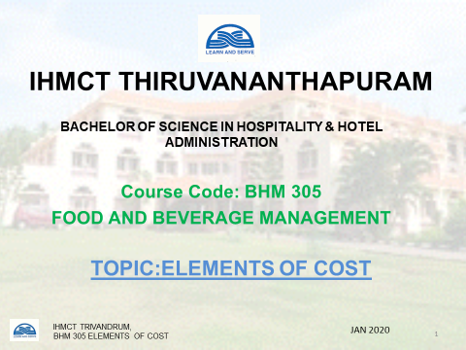

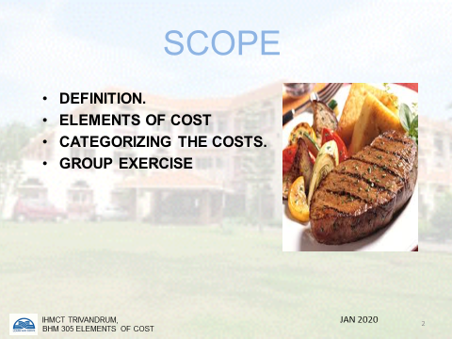

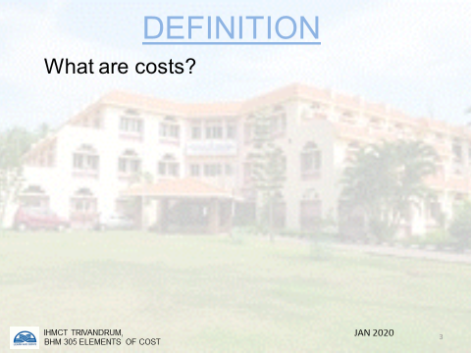

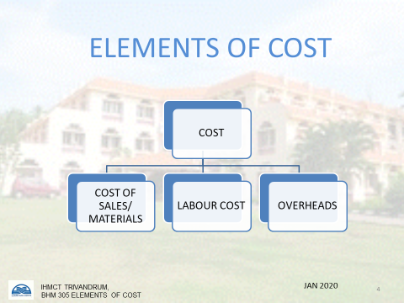
INTRODUCTION
The fact that food and beverage operations in the welfare sector (for example, a hospital dining room or an employee restaurant) may not be required to make a profit in the same way that commercial restaurants are, and that they may receive some form of subsidy, does not make budgeting any less necessary. When food and beverages are being sold at or near cost prices, or are being prepared within very strict subsidy cost limits, it is even more necessary that costs be estimated very accurately than where there is a large gross profit margin which can absorb some errors in costing. When the subsidy. is for such items as heat, light, repairs, maintenance, furnishings, etc., control needs to be exercised on these expenses to keep them within the limits of the subsidy.
THE ELEMENTS OF COST
The cost of operating a catering unit or department is usually analyzed under the three headings of:
1 Material costs — cost of food and beverage consumed and the cost of additional items such as tobacco. (Note: The cost of any food and beverage provided to staff in the form of meals is deducted from material costs and added to labour costs.) The food cost is then calculated by the formula:
opening stock + cost of purchases — closing stock — cost of staff meals = material cost
2 Labour costs — wages and salaries paid to all employees, plus any employer contribution to government taxes, bonuses, staff meals, pension fund, etc.
3 Overhead costs — all costs other than material and labour costs, for example rent, rates, insurance, depreciation, repairs, printing andstationery, china and glassware, capital equipment.
As most catering operations are subject tochanges in the volume of business done, it is normal practice to express the elements of cost and net profit as a percentage of sales. A change in the volume of sales has an effect on the cost structure and on the net profit.

MATERIALS | 30% '
LABOUR | 30%
OVERHEADS | 20%
NET PROFIT | 20%

Total cost (80%)

SALES 100%

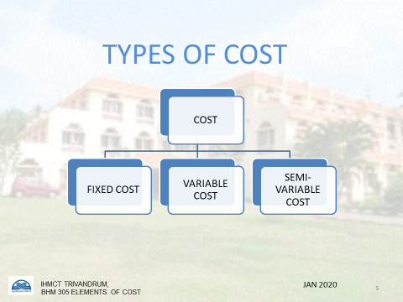

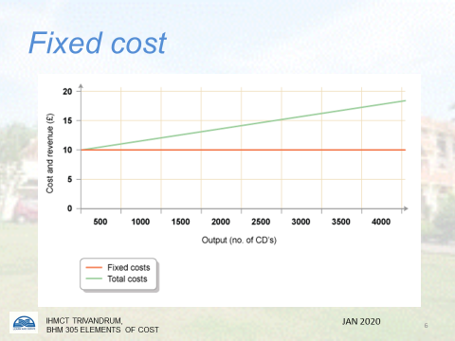

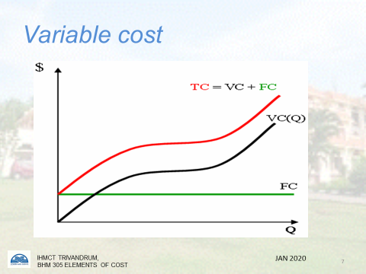

COST GROUPS BASED ON BEHAVIOUR
It is necessary to examine costs not only by their nature (material, labour, overheads) but also by their behavior in relation to changes in the volume of sales. Using this criteria, costs may be identified as being of four kinds:
1 Fixed costs. These are costs which- remain fixed irrespective of the volume of sales, for example rent, rates, insurance, the management element of labour costs.
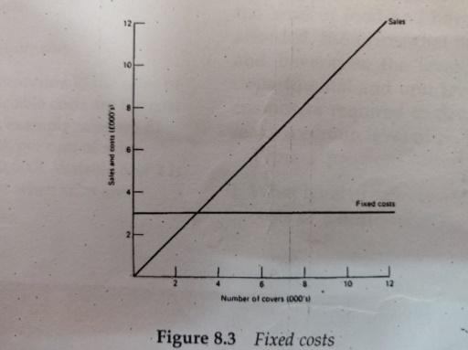
Note: Fixed costs remain fixed, irrespective of the level of sales (for example £3,000). Typical examples of fixed costs are rent, rates, insurance, etc.
2 .Semi-fixed costs. These are costs which move in sympathy with, but not in direct proportion tothe volume of sales, for example fuel costs, telephone, laundry. Semi-fixed costs contain a fixed and variable cost element, for example the charge for the telephone service in the UK contains a fixed cost for the quarterly charge for the rental of each phone and a variable cost depending on the number of phone calls made.
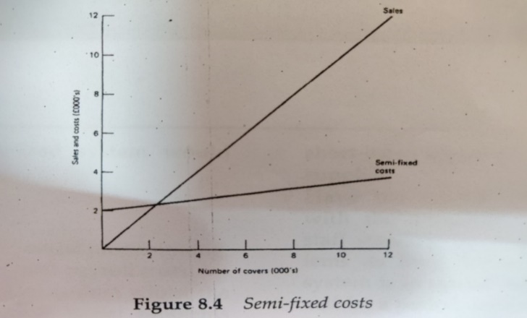
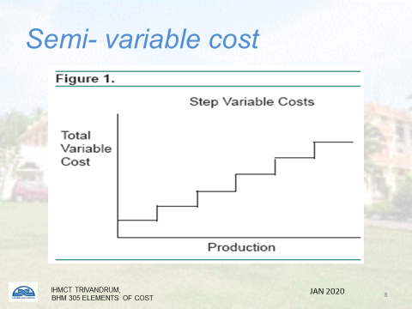

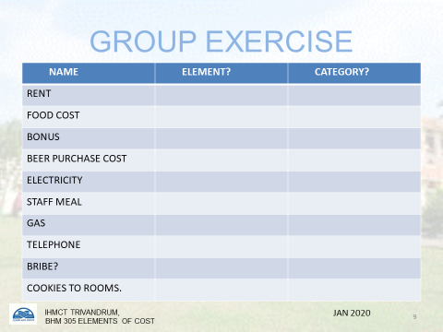

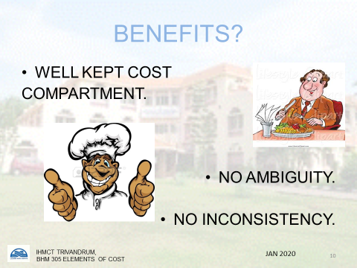
3. Variable costs. These are costs which vary in proportion to the volume of sales, for example food and beverage.
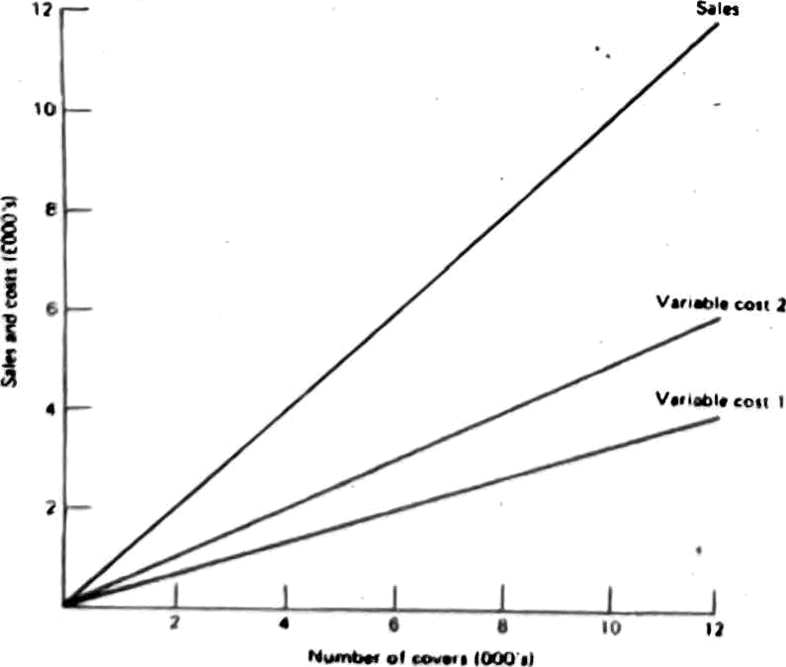
Typical examples of variable costs are the cost of food and beverages

Note: Variable costs vary in proportion to the sales of a unit. Typical examples of variable costs are the cost of food and beverages. In this example sales are per cover. Variable cost 1 is 33% per cent of sales (E4,000 cost when sales are £12,000). Variable cost 2 is 50 per cent of sales (£6,000 cost when sales are £12,000).
4. Total costs. This is the sum of the fixed costs, semi-fixed costs and variable costs involved.

PROFIT
Three main kinds of profit are referred to in F & B operations:
1. Gross profit = total sales cost of materials.
Note: The term gross profit is often referred to as 'kitchen profit' (food) or 'bar profit' (beverages). Room hire is normally treated as 100 percent gross profit.
2.After-wage profit (or net margin) = total sales (material + labour costs).
3. Net profit = total sales total costs (material labour + overhead costs).
All of the above are normally used as measures of performance against past results and budgeted targets. For an example of the use of the three main kinds of profit used in controlling food and beverage operations.
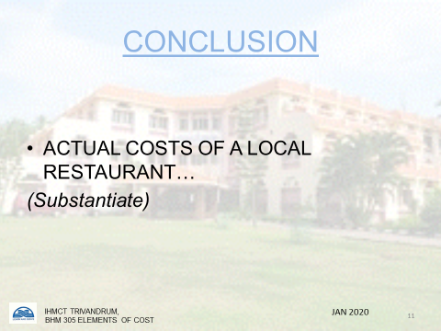

CHAPTER BASED QUESTIONS FROM PREVIOUS PAPERS
Q.1. Define "Cost”. What are the different types of cost in Food & Beverage Business? (2013-14)
Q.2. Define cost. Explain the elements of cost with examples.
Q.3.With the help of a graph diagram, explain the various types of costs. (2017-18)
Q.4. Classify costs based on behavioral dynamics. Explain briefly each type. Discuss the elements of cost. (2014-15)

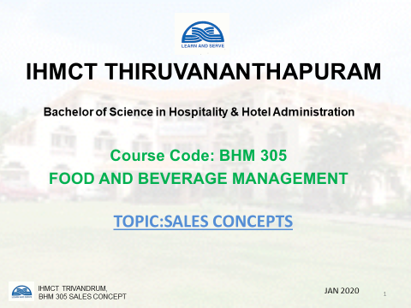
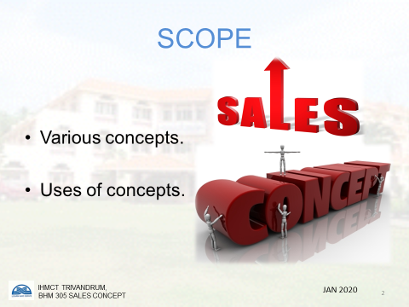
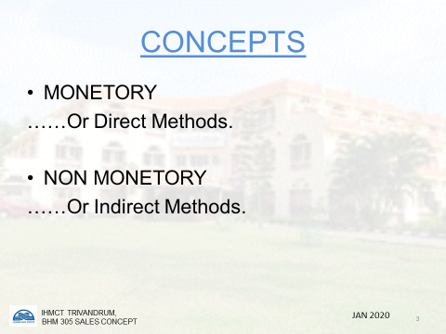
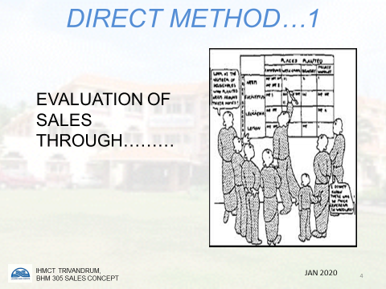
UNIT 2: SALES CONCEPTS
Operating yardsticks used in Controlling

Sales analysis can help the operations stay dynamic in several faces like training of staff, menu planning, layout restructuring, upselling, etc.F&B operations should not limit the analysis/evaluation of sales solely based on monetary inputs. Thus, to have a 360-degree approach sales need to be analyzed from both monetary and non-monetary angles.

- Total food and beverage sales
The total food and beverage sales should be recorded, checked and measured against the budgeted sales figures for the particular period (for example week or month). The analysis of these figures is usually done daily for large establishments and for those that are not operating a manual control system. The analysis would show separately the food sales and the beverage sales per outlet and per meal period. The importance of this yardstick cannot be emphasized enough other than to remind the reader that it is cash and cash only that can be banked and not percentages or any ratio or factor figures.
- Departmental profit Departmental profit is calculated by deducting the departmental expenses from the departmental sales, the expenses being the sum of the cost of food and beverages sold, the cost of labor and the cost of overheads charged against the department, and the profit being usually expressed as a percentage of the departmental sales, for example:
Departmental profit (£1,200) x 100= 15%
Food and beverage sales (£8,000)

The departmental profit should be measured against the budget figures for that period.

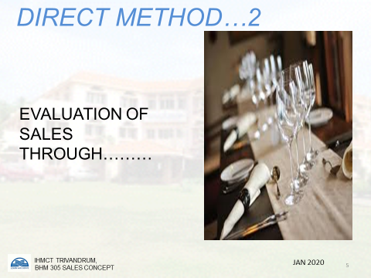

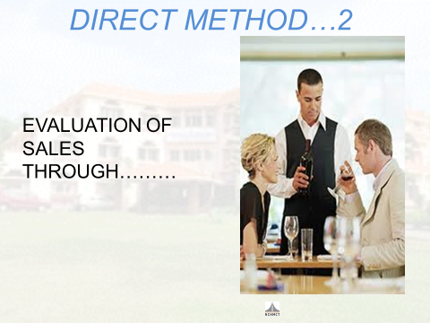

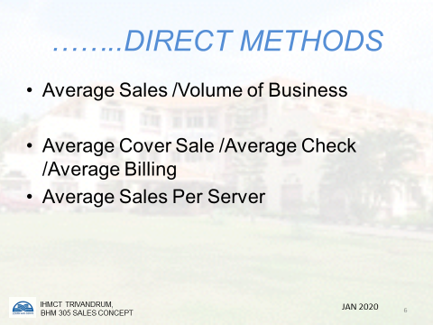

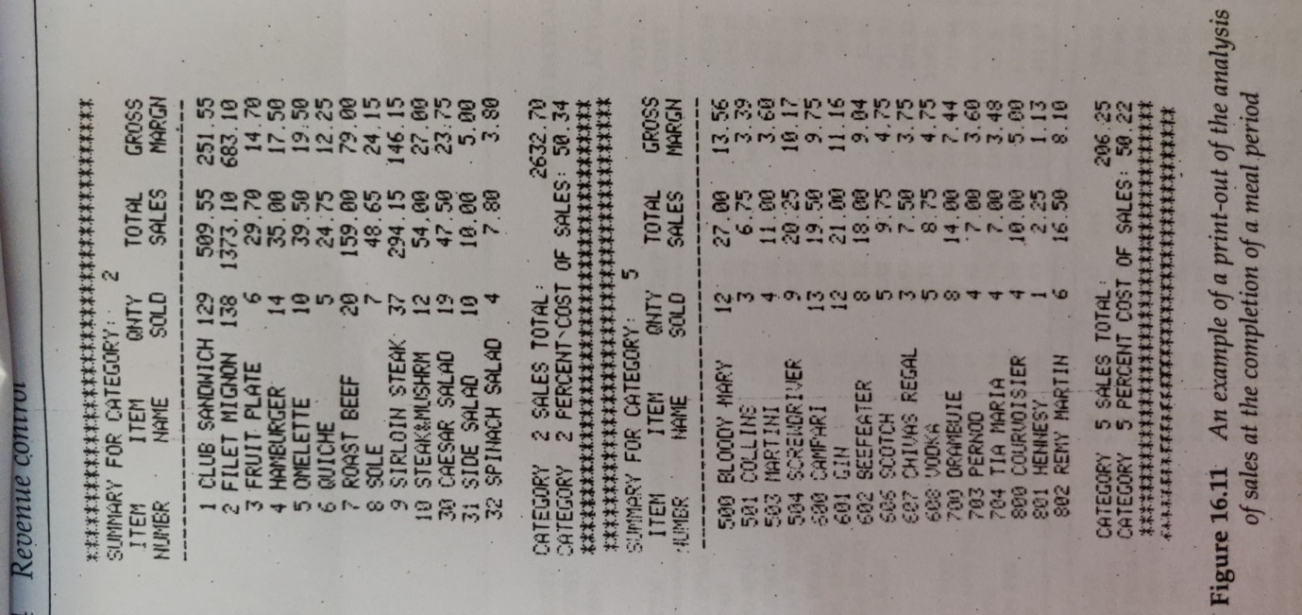
- Ratio of food /beverage sales to total sales
It is worthwhile for food and beverage sales to be separated from each other and to express each of them as a percentage of the total sales. This would be a measure of performance against the established standard budgeted percentage as well as indicating general trends in the business.

- Average spending power
This measures the relationship between food sales and beverage sales to the number of customers served. If food sales are RS.3500 and the number of customers served is seventy, the average spend by each customers is RS.50. The average spending power (ASP) for beverages is usually related to the number of items recorded on the till roll, rather than to the number of customers, and the total beverage sales. Thus if RS.60000 is the recorded beverage sales and an analysis of the till roll showed that 400 drinks had been sold, the average spend per drink would be RS.150. What is different here is that a customer may order several drinks during an evening and therefore the average amount spent on a drink is more important than the ASP per customer. To calculate the ASP for bottled wine sales in a restaurant or at a banquet though could be a useful exercise.
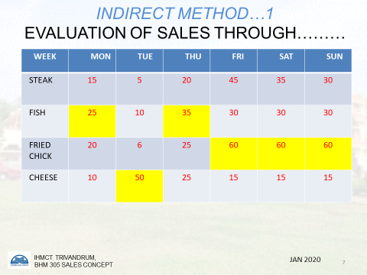
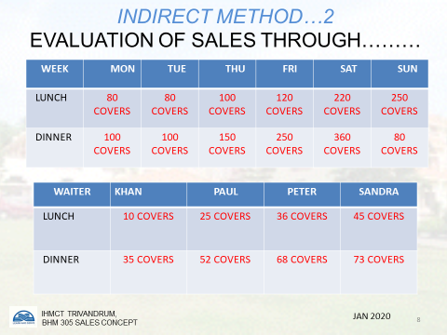
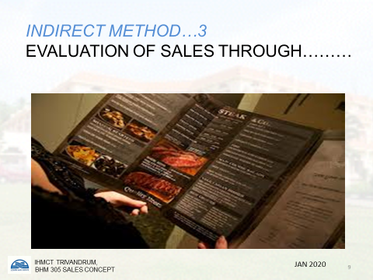
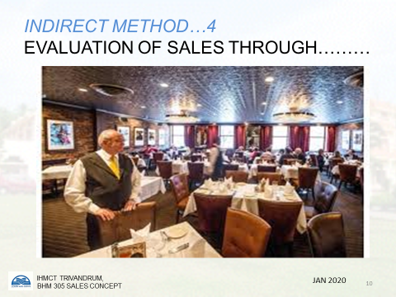
- Sales mix
This measures the relationship between the various components of the total sales of a unit, for example:

Sales Mix
Coffee shop sales
Food 20
Beverages 5
Restaurant sales
Food 25
Beverages 1 5
Banqueting sales
Food 20
Beverages 10
Cocktail bar sales
Beverages 5
------
100
-------
Example of monthly food analysis sheet
In addition, a sales mix may be calculated for the food and beverage menus for each outlet under group headings such as appetizers, main course items, sweet course, coffees, etc.; and spirits, cocktails, beers and lagers, etc. This would not only highlight the most and least popular items, but would at times help to explain a disappointing gross profit percentage that occurred in spite of a good volume of business; the reason often being that each item is usually costed at different gross profit percentages and if the customers are choosing those items with a low gross profit this would result in the overall gross profit figure being less than budgeted for.

- Payroll costs

Payroll costs are usually expressed as a percentage of sales and are normally higher, the higher the level of service offered. It is vital that they are tightly controlled as they contribute a high percentage of the total costs of running an operation. Payroll costs can be controlled by establishing a head count of employees per department, or establishing the total number of employee hours allowed per department in relation to a known average volume of business. In addition, all overtime must be strictly controlled and should only be permitted when absolutely necessary.

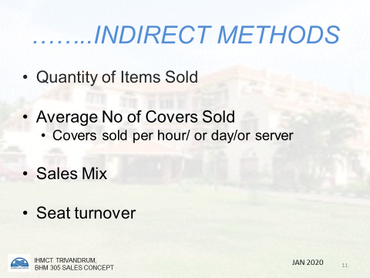
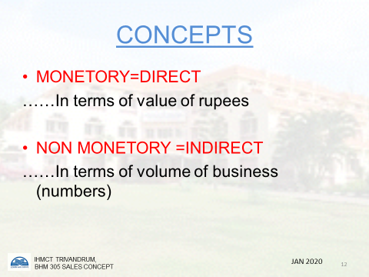

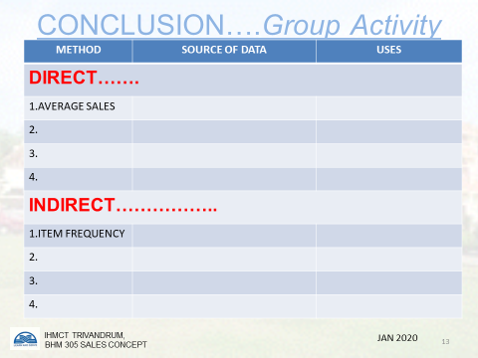

- Index of productivity

This is calculated by the formula

sales
payroll (including any staff benefits costs)
The index of productivity can be calculated separately for food sales, beverage sales or for total food and beverage sales.The use of the term 'payroll costs' in the formula includes not only the appropriate payroll costs, but also any other employee benefits such as employers' pension contributions, medical insurance, etc.
The index of productivity would vary depending on the type of operation, for example a fast food restaurant with a take-away service would have a high index of productivity, as the payroll costs would be lower than a luxury restaurant employing highly skilled and expensive staff with a high ratio of staff to customers, which may have a relatively low index of productivity. As payroll costs can be controlled and should be related to the forecasted volume of business, a standard index of productivity can be established to measure how accurately the two elements are related.

- Stock turnover
It is calculated by the formula:

Rate of stock turnover = cost of food or beverages consumed

Average stock value (food or beverage) at cost

The rate of stock turnover gives the number of times that the average level of stock has turned over in a given period.
Too high a turnover would indicate very low levels of stocks being held and a large number of small value purchases being made. This costly and time consuming for whoever does the purchasing as well as costly for the purchases as no price advantage can be taken of the standard quantity offers made by suppliers. Too low a turnover would indicate unnecessary capital tied up in an operation and therefore additionally a larger control and security problem.

- Sales per seat available
This shows the sales value that can be earned by each seat in a restaurant, coffee shop, etc. The seat is the selling point and is required to contribute a certain value to turnover and profits.

- ⁻Rate of seat turnover
This shows the number of times that each seat ina restaurant, coffee shop, etc. is used by customers during a specific period. Thus, if in a 120-seater coffee shop 400 customers were served in a three-hour lunch period, the rate of seat turnover would be 400 divided by 120, that is, 3.33. As the coffee shop staff can only sell food to customers while they are seated at a table, the importance of the rate of seat turnover is highlighted.

- Sales per waiter/ waitress
Each waiter/waitress will have a known number of covers for which he/she is responsible. This would vary depending on the style of food and beverage service offered. As salespeople for the restaurant or coffee shop, their takings should be of a predetermined target level so as to contribute to asatisfactory level of turnover and profit.

- Sales per square foot/metre²
This is sell-explanatory in that the space of all selling outlets needs to be used to its best advantage so as to achieve a desired turnover and profit. This can be calculated on a square foot/metre basis. As the square footage per customer varies with the type of food and beverage service offered, so must the costs to the customer so that an establishment is earning the desired turnover and profit per square foot of selling space.

PREVIOUS YEARS’ QUESTION PAPER
Sales can be expressed in various measures to improve efficiency. Explain in detail the various sales concepts. (2014-15)

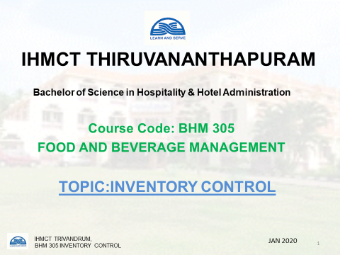
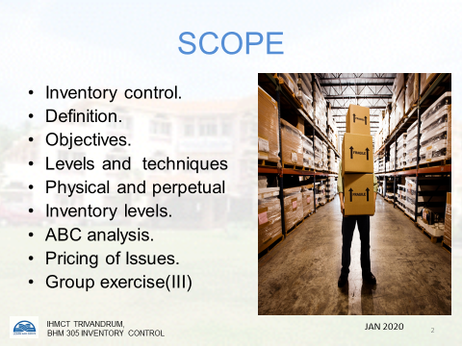
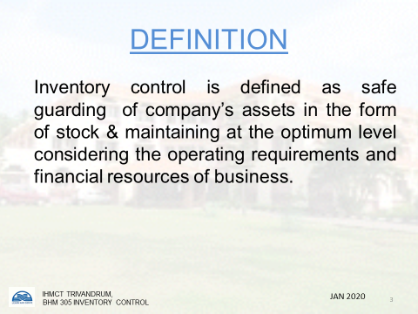
CHAPTER 03: INVENTORY CONTROL
Inventory can be described as the stock of goods and raw materials (both perishables and non-perishables) and inventory control is the technique of maintaining and checking the stocks. The stock control involves purchasing, requisitions, receiving, storing and issuing to various departments.
Methods of Inventory Control
There are two methods to control the inventory of stores:
1. Physical Inventory System
2. Perpetual Inventory System
1. Physical Inventory System
A physical inventory is a periodic actual counting of all the products in the storage areas. Usually store items are counted once in a month and usually the physical counting is done either before the normal opening timings of stores or after the normal closing hours as otherwise it may disturb the normal issuing schedules to various departments. In large organizations, a complete inventory may not be taken at one time. Instead, inventories can be taken in parts on weekly basis. The inventory process should involve at least two people out of which one is from control department and is not directly involved with the store room operations. And the other should be from the accounts department. One person counts the food which is arranged systematically in the store room. The stores items are either stored in the form of groups; like all pulses are stored at one place and all bottled and canned items are stored at one place; or they are stored alphabetically. Usually the items which are issued more frequently are stored near the delivery window and others can be stored at different place. The other person records the data on a physical inventory form which is designed according to the physical arrangement of foods frequently on shelves. This helps in taking the physical inventory of all the items in the shortest possible time. The expensive items should be physically counted /weighed more frequently.
2. Perpetual Inventory:
The process of maintaining a continuous record of all purchases and items being issued is called perpetual inventory system. This process provides a continuous record of goods available at hand at any given time as well as the value of supplies at hand. Generally, a perpetual inventory record is used to restrict the products in dry stores and frozen stores.
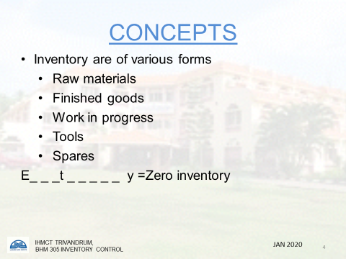

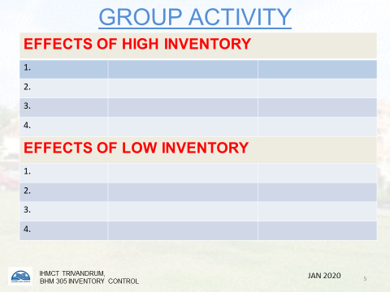

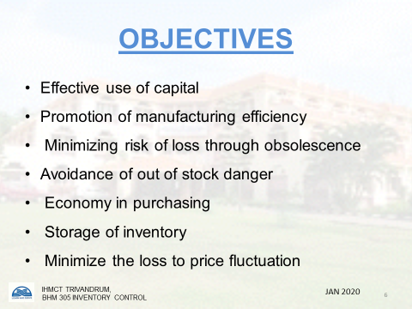

Perpetual Inventory requires a considerable amount of labour to maintain and is maintained only for selected items, usually, very expensive ones. A perpetual inventory record is not sufficient for accurate, accounting and control of food and supplies. Therefore, it becomes necessary that perpetual inventory is tallied with the physical inventory.
COMPARISON OF PHYSICAL AND PERPETUAL INVENTORY:
A perpetual inventory is an inventory that is maintained on a regular basis by the concerned departments, taking into consideration the issues and daily usage. On the other hand, physical inventory is an inventory which is recorded on the basis of regular checks which can be fortnightly, weekly or monthly, depending upon the organization’s policies. When we are talking about a comparison between the perpetual and physical inventory: we mean that the perpetual inventory should be equal to the physical inventory, i.e., the goods entered in the perpetual inventory should match with the goods that result from the physical inventory. If there is large discrepancy. i.e., any extra stock or stock not matching with that of a physical inventory, desired actions need to be taken and any disciplinary action if it needs to be taken, should be prompted.
Economic Order Quantity (EOQ)
One of the major inventory management problems to be solved is how much inventory stock should be procured when stock is replenished. If the hotel is buying raw materials, it has to be decided the lots in which it has to be purchased on each replenishment. The hotel's food and beverage department produces food; the issue is that how much food should be produced. This leads to Order Quantity Problem and the Chef is to determine the optimum or Economic Order Quantity (or Economic Lot Size). Determining the optimum inventory level involves two types of costs:
a) Ordering Costs Set-up Costs
b) Carrying Costs.
The economic order quantity is that inventory level which minimizes the total or ordering and carrying costs.
a) Ordering Costs: The term ordering costs includes the entire costs of acquiring raw materials. This is not only the cost of raw material but also includes requisitioning, purchasing, ordering, transporting, receiving,
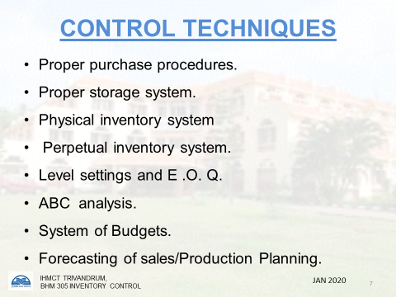

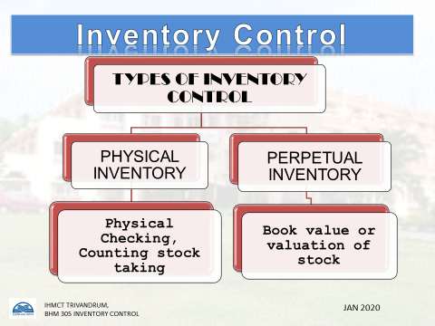

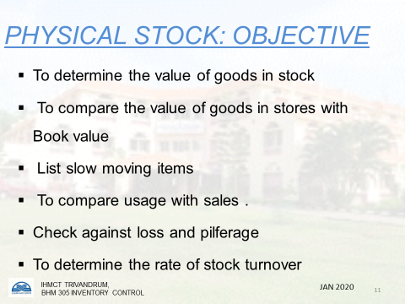

inspecting, storing, etc. The ordering cost increases with the number of orders placed. More the orders placed a day, more will be the ordering cost. If more number of orders are placed then more clerical staff is to be hired in order to place the orders, etc. and on the contrary if number of orders are reduced drastically then management can think of reducing the staff and hence the ordering cost reduces. It is more appropriate to include clerical and staff costs on a prorata basis. It hotel is keeping a large quantity of par stock then it will have to place less number of orders and on the contrary if hotel is maintaining a low par stock then more number of orders will have to be placed.
b) Carrying Costs: The costs which are incurred for holding a given level of stock are termed as carrying costs. This includes the investment cost, storage cost, insurance, taxes, cost of deterioration and obsolescence. It is common practice to calculate opportunity cost of funds invested in inventories, and not the interest on borrowings for stores and stock. Opportunity cost is the earnings foregone on the best available investment opportunities. The storage cost will include the cost of storage space, in terms of rent and depreciation on building, maintenance, stores handling expenses, clerical and staff service costs, etc. To keep the inventory carrying costs low, inventories should be purchased in small lot sizes but more frequently. But this will increase the Ordering Cost. To determine the optimum size of inventory,a trade-off between carrying costs and ordering costs should be reached.
PAR STOCK
It is also known as the Bottle Control System of controlling beverages. It is the simplest yet effective and useful in small operation, when there is a few full time control staff. While maintaining a Par Stock Control System, the following points need to be considered:
1. The level of par stock needs to be established for each bar. This Par Stock is determined to be the stock level to be held in the bar at the beginning of the service each day plus a small safety factor (usually about + 10%). To simplify this system, only full bottles are counted.
2. The number and type of empty bottles are noted each day and these form the basis for the amount and type of requisition for the next day.
3. The potential sales are based upon the quantities issued at selling price and are compared to actual revenue received.
4. Adjustments need to be made to the initial selling price if many mixed drinks are sold. This will only be necessary if the difference between potential and actual sales figures give any cause for investigation.

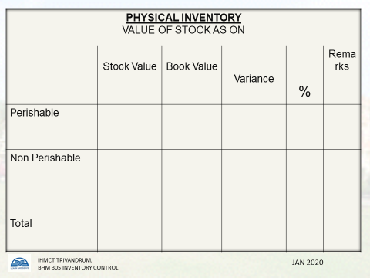
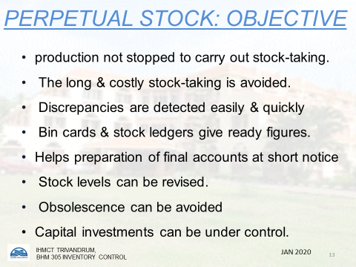
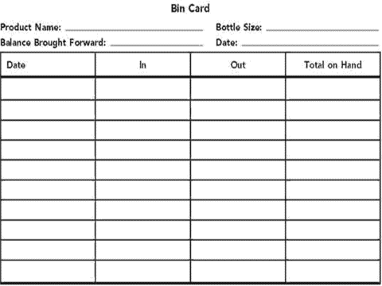
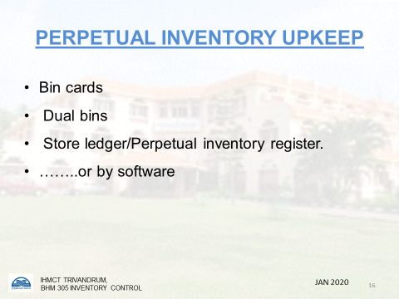

OBJECTIVES OF INVENTORY CONTROL
The following are the objectives of inventory control:
1. To ensure correct supply of materials and finished goods so that production should not suffer at any time.
2. To avoid both over stocking and under stocking of stocks.
3. To maintain investments in working capital at the minimum level that is required according to the operations and sales.
4. To keep operation cost under control.
5. To minimize the loss through depreciation, pilferage, wastage, damage, etc.
6. To design a proper inventory management system for the hotel.
7. To ensure perpetual inventory control so that stock shown in the stock level should be actually used and properly stored in the respective stores.
8. To ensure right quality goods at a reasonable price.
9. To facilitate furnishing of data for a short time and long term planning.
Inventory Control Tools:
The perishability of food and for cost containment in all types of food service operations, efficient inventory control is very important. The major function of control system is to co-ordinate activities, influence decisions and actions to ensure that objectives are being met by providing feed back on operations with the goal of ensuring adequate production and service needs while minimizing inventory investments. To fulfill the above objectives, the control and management's role has become more complicated and critical. Variety of tools is available to assist managers in determining quantities for purchase and recommends stock levels to determining costs of maintaining stocks. The following are the techniques used in the industry for controlling stocks.
1. ABC ANALYSIS
In order to fully understand the principles of ABC analysis (inventory control), one must be very familiar with the concepts of physical inventory and perpetual inventory. In most restaurant / hotel operations, a small number of purchased items account for the major portion of the inventory purchase value. Therefore, a method for classifying purchase items

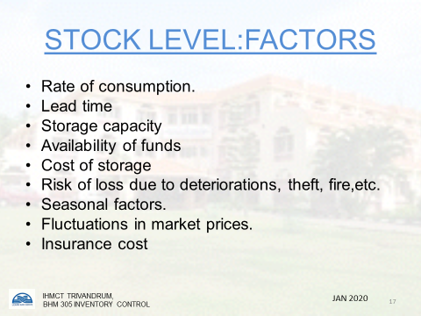

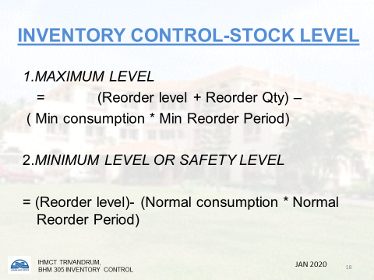

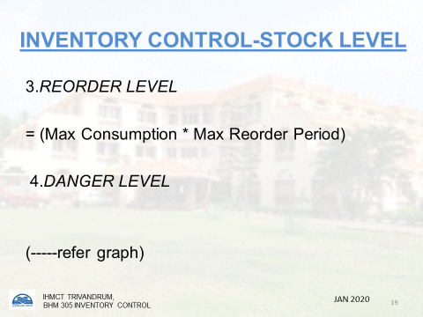
according to the value is often admissible. This procedure is generally referred to as ABC analysis. The principle underline of the ABC analysis is that effort, time and money for inventory control should be allocated amongst items in proportion to their value.
The purchased items should be divided into three categories.
c) 'A' Class: This category represents only 15 to 20 percentages of the inventory items but typically account for 75 to 80 percentages of the value of the total inventory. These items should be reviewed continuously to estimate requirements to check stock balances and to determine the quantity of material to order. The inventory level of these important rupee components should be maintained at an absolute minimum.
d) 'B' Class: This category consists of lesser value of items that typically vary between 20 to 25 percentages of items inventory and 10 to 15 percentages of the inventory value.
e) 'C' Class: This category comprises of items which constitute 60 to 65 breakfast cereals would be in 'C' Class and monitors less closely.
2. MINI MAX METHOD:
This is one of the most widely used methods of controlling inventories and involves the establishment of minimum and maximum levels of inventory and is commonly referred to as the Mini Max Method. In this method, a safety factor is established which becomes the minimum point below which the inventory should not fall under normal circumstances. The maximum inventory consists of the safety factor plus the correct ordering quantity. The safety factor or safety stock is a back-up supply to ensure against certain rise in usage rate which results due to the failure to receive ordered materials or clerical errors in inventory records. The size of safety factor depends upon the importance of items in the operation, the value of investments and the availability of substitutes on short notice.
The safety factor can be determined by the following factors
a) Lead Time: It is the interval between the time that a requisition is initiated and the product is received. The shortest lead time occurs when material is purchased from a local supplier who carries it in stock and the longest lead time occurs when materials are ordered from out of town suppliers.
b) Usage Rate: Under the Mini Max Method, the usage rate of a particular period is determined by past experience and forecast and by the length of time required to obtain deliveries. An ordered minimum or re-order point is established from this data.

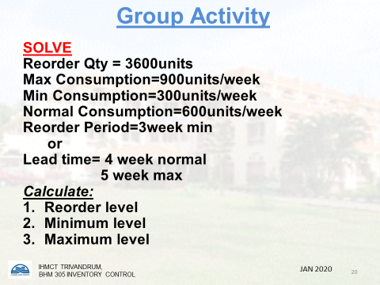

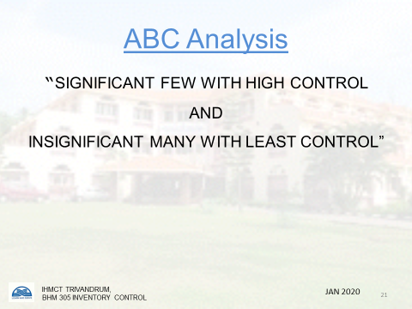

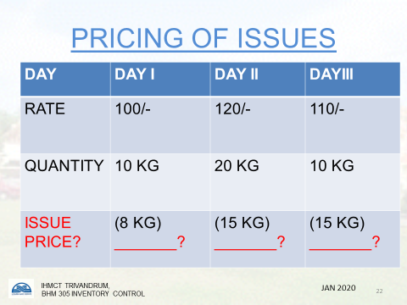

The minimum, therefore, is the lowest stock, level that can be safely maintained to avoid a stock out or emergency purchasing. The maximum inventory level is equal to estimated usage plus the safety stock.
- Storage Capacity: The storage capacity of the store is analysed before deciding on the volume of inventory. In case stores can store the perishable and non perishable stuffs in large quantity than hotel may go for larger inventories comparatively and on the contrary if there is not enough storage space available than it will not be possible to have large inventory.
- Shelf Life: The large quantity of stores can be procured if it has a larger shelf life or if it can be stored in the suitable deep freezers. There is no point storing large quantity of inventories and have a risk of getting food stuff getting spoiled.
- Delivery Schedules: If hotel is situated in the heart of town and stores (especially perishables) can be supplied immediately on order than it is always advisable not to have a large inventory as large inventory both costs money and space. Larger inventory is also a cause for pilferage and wastage.
- Savings on Volume Purchasing- In case supplier is offering large discount on volume purchasing than it is advisable to have larger inventory and save on the operation cost. But it is only possible to place larger orders if hotel has working capital, space to store inventories, etc.
- Operation Periods- There are some establishments which do not operate on all the seven days like Catering colleges, industrial canteens, etc. If establishment is operating five days a week than the inventory requirement is accordingly reduced? Some resort hotels serve meals only on week ends and during week days the food is cooked on orders.
- Volume of Sales- If the hotel is having large sales than the requirement of inventory is also more comparatively. When the volume of sale is forecasted than it is important to forecast the volume of sale of particular dishes as well. For example, if hotel is having more sale of chicken than it requires a larger quantity of chicken as stock and not mutton or fish.

7. Working Capital- In case hotel does not have large working capital then it is not possible for it to have a large inventory in spite of all other points being favorable to have a large inventory. Sometimes it is not easy to have purchases on credit or suppliers have different quotation for cash purchases and credit purchases.
- Future Availability- In case management is of the view that the availability of a particular commodity will be scarce in future or its price will increase drastically than it prefers to procure large quantity of stock of that particular item. For example, in hills gas, coke, Wood, etc. is to be purchased in large quantity before the commencement of winter session as these items are not easily available during winters. Before the commencement of marriage season some hotels prefer to store a large quantity of chicken, cream, etc. as these items normally go very expensive or some times they are not available during marriage seasons.
- Variety on Menus- In case hotel is having a large variety on menus available in the hotel's restaurants then the requirement of inventory will be larger. A hotel is expected to sell all menu items at all hours during the day. And in order to make all dishes available at all times hotel requires a larger inventory of raw material.

PREVIOUS YEARS’ QUESTIONS
1.Distinguish between Perpetual and physical inventory (2013-14).
2.Write short notes (any two) (2013-14)
(a) Par stock
(b) Reorder point
3.List the objectives of inventory control. With the help of graph, explain various levels of stock (2017-18)
4. Explain the various methods employed for inventory control in a 5-star hotel. (2017-18)
5.Write short notes ABC technique. (2017-18)
6.What are the different inventory tools? Explain in detail mini max method.
7.List the objectives of inventory Control. Explain various levels of stocks with format (2017-18)
8.List the objectives of inventory control. Compare and contrast the two commonly used methods of inventory control. (2014-15)

CHAPTER 04: BEVERAGE CONTROL

- PURCHASING
The purchasing of beverages
The purchasing of alcoholic and non-alcoholic beverages, like that of foodstuffs, has the aim to purchase the very best quality of items, at the lowest price, for a specific purpose. The purchasing of beverages should be undertaken by the purchasing manager together with such experts as the Food and Beverage manager, the Head Cellar man and the Sommelier.
As beverages will frequently contribute more to profits than foods, and as they require considerably fewer staff to process them into a finished product for the customer, it is essential that adequate attention is given to this area. What is important to bear in mind always when purchasing beverages is that expensive products or products with pretty labels do not necessarily indicate or guarantee superior quality.
With beverage purchasing the following points are generally noticeable:
- There are fewer and often restricted sources of supply.
- The high value of beverage purchases.
- That free advice and assistance with purchasing are given by the wine and spirit trade.
- That quality factors are difficult to evaluate and require special training to identify them. This means setting up or attending tasting sessions several times a year.
- There are far fewer standard purchasing units than for food.
- There is an established standard of product. Many items like minerals, spirits, etc., will have a standard that will not vary over the years and items such as a well-known wine from an established shipper will be of a standard for a specific year, whereas with food items there may be several grades and a wide range of ungraded items available. In addition, food items may be purchased in different forms such as fresh, chilled, frozen, canned, etc.
- The prices of alcoholic beverages do not fluctuate to the extent that food prices do.
- Shelf life of beverages as in comparison to perishable nature of food.
- Assured profit from a bottle of beverage!!!
A beverage selected for a wine list would not only have to be of an acceptable quality to members of the selection team, but also to the type of customer served. It should complement the food menu and be available for purchasing overlong enough period and at a price that is

competitive. The continuity of supply of any wine should be established before it is added to a wine list.
There are some five main sources of supply that can be used for purchasing beverages and it is most likely that a purchasing manager would use at least two of them. The methods used for purchasing would vary between establishments because of such criteria as the type of customer; the type, size and location of the establishment; the storage facilities available; and the purchasing power of the buyer.
1.Wine shippers
These are firms that purchase wine in the country of origin and ship it to whatever country it is be sold in. Usually shippers are concerned with the wine from a particular region only. This means that the range of products that they are to sell is limited. Further to this problem, shippers are unlikely to want to deal with customers other than prestigious establishments or the very large companies. The products of wine shippers are usually bought from a wine and spirit wholesaler.
2.Wholesalers
These are usually the subsidiary wine companies of large breweries or independent wine companies
The brewery companies sell their own label products as a first preference to other proprietary products. Wholesalers offer a very wide range of all beverages as well as a regular delivery service to the caterer. In addition, they can assist the caterer with promotional literature for both bar and restaurant sales. As the beverage supply industry is highly competitive wholesalers will also offer the following services to selected clients.
2.a) Suspended debt- Suppliers would invoice caterers for their initial cellar stock purchases, but would request payment only on subsequent purchases, the first purchase invoice being 'suspended' until the account is closed with the supplier. This has the advantage for caterers of a free loan to their business, but the drawback that they would be required to make specific beverage purchases from this one supplier only.
2. b) Cellar inventory and suspended debt Account
This is similar to method of purchase above. The supplier will stock the caterers' cellar to an agreed level, for a specific period of time, free of charge, the opening stock levels being recorded by the supplier and the caterer. A stock take is made by both parties at the end of the agreed period and all items used are then charged for. The supplier then makes a delivery to replenish the stock to the levels first agreed upon. The drawback to this method for the caterer is the tying of purchases to this one supplier, while the advantage is that the caterer only has to pay for what has been sold to customers and then only some several weeks after, during which time the caterer will have been able to use the money taken in the business.
Wholesalers will usually assist in the printing of wine lists and publicity material for promotional events.
3.Beverage manufacturers
This method of purchasing is used when purchasing manager is able to buy in sufficiently large quantities to deal direct with the manufacturer. This is most commonly practiced for the purchasing of the main spirits, minerals and beers. The advantage to the caterer is the lower price that would have to be paid as compared to purchasing through a wholesaler.
GERMANY
After a fairly bleak period for German wine growers who really care about the quality of their wine, there is a revival in interest for top estates. The reason is, quite simply that Riesling is an instrument which, in skilled hands can create wines as great as any in the world from the delicate, slaty elegance of the Saar and Mosel, to the richer, spicy styles of the Rheinpfalz, these are wines to savour by themselves, as some of the most scintillating apéritifs you will ever find. The Pinot Blanc from Baden has another role, as the sort of balanced food wine that the Germans have been trying for so long to perfect, and are just beginning to achieve.
NIERSTEINER GUTES DOMTHAL, RHEINHESSEN, 1994
Wine code: 1135
PRODUCED & BOTTLED RHEINHESSEN WINZER
£4.70 per bottle
4.60 per case
A well-made hock with the delicious, orangey flavour of really ripe grapes. Mildly medium-dry, this is the sort of wine which will appeal to almost any guest, and is ideal for serving at parties and receptions.
MONZINGER PARADIESGARTEN RIESLING, NAHE, 1995
PRODUCED & BOTTLED WEINGUT HEHNER-KILZ Wine code: 0964
157.60 per case
£4.95 per bottle
This is the sort of deliciously refreshing aperitif that will restore Germany's reputation for fine, medium-dry wines at sensible prices. With crisp acidity and the finesse that only a pure Riesling can offer, here is the solution for those who find Sauvignon Blanc too Dry.
Recommended For Value
AUERBACHER FÜRSTENLAGER RIESLING KABINETT HALBTROCKEN, HESSISCHE BURGSTRASSE, 1993
PRODUCED & BOTTLED WEINGUT SIMON BURKLE. Winecode:0963
£76.20 per case
£6.50 per bottle.
How many wines have you drunk from the HessischeBergstrasse region, just North of Heidelberg? Very few
actually leave the area, but we are delighted that this one got away, because it displays the Riesling's marvelous complexity of flavour. Peaches, citrus fruit, slate and mineral notes all find their place, enhanced by a creamy texture and fresh acidity.
LIESER SÜSSENBERG RIESLING KABINETT, MOSEL, 1992
PRODUCED & BOTTLED 'WEINGUT SCHLOSS LIESER
£91.80 per case
£7.80 per bottle
Wine code: 0956
Green tinged, with a classic, slaty Riesling nose. Delicately balanced with finely honed flavours and a lingering finish. SchlossLieser is fast becoming one of the Mosel's top estates and, with prices in this village more modest than those of its neighbours, Berncastel and Wehlen, the wines are good value. A scintillating apéritif.
GEWÜRZTRAMINER SPÄTLESE, RHEINHESSEN, 1992
PRODUCED & BOTTLED WEINGUT SCHALES
£93.60 per case
£7.95 per bottle
Wine code:1064
Considering that Alsace Gewurztraminer often suffers from low acidity, it is surprising that the cooler German climate does not produce more delicious examples such as this one. Tasting of the grape itself, rather than of lychees or Turkish Delight, in this wine the fresh acidity produces a creamy, apricot character. Why not try it in mixed case?
4.Cash-and-carry
Cash-and-carry businesses offer a very limited range of spirits, wines, beers, etc. at very keen prices, but no other service. They are useful in emergencies or when special offers are being made.
5. Auctions
This is a method of purchasing that has limitations in that it usually is only for the sale of wines. It can be a useful way of buying 'end of bin' wines in small quantities from a private home or from another hotel or catering establishment. As long as purchasing managers know their wines thoroughly this can be useful source for wines for a special occasion. It would be unlikely that the quantity offered would justify this method of purchasing of wines for inclusion in a standard wine list.
Purchase specifications for beverages
The purpose of a purchasing specification is to set down in writing the standard of a product for specific use by an establishment. This is then used by the purchasing manager to inform suppliers exactly what is required and is vital information when negotiating prices. It is also invaluable to the receiving and cellar department staff to know what to accept when deliveries are being made.

Unlike purchasing specifications for food, specifications for beverages are much simpler and to understand. The reason is that beverages are sold and purchased by the brand name label of the product, each having a consistent quality and quantity standard of content for each selling unit!! e.g. barrels, kegs, bottles, splits, etc.
As the specification is brief it can always be written in full on a purchase order. Specification for wines also includes the details of vintage and shipper.
It should be particularly noted that as the quality, consistency and quantity are virtually guaranteed the price to be paid for the product is constant. It is for this reason that close attention very important as it is the one factor that is not is given by the purchaser to offers by suppliers of special discounts for, say, five, ten, twenty-case lots.
Receiving of beverages
The objectives for beverage receiving are similar in many ways to those of food receiving. However, as the value of beverage purchases and the ensuing profits from the sale of beverages are high, it is important that due attention is given to the receiving of beverages.
The main objectives are to ensure that:
1.The quantity of beverages delivered matches that which has been ordered. This requires methodical approach to checking the goods against the purchase order and the delivery
NOTE: Items would be in standard units of crates, cases, etc., with standard contents of specific size. Crates and cases should be opened to check for such things as empty, missing or broken bottles.
2 The quality inspection is simple, but again requires a thorough and methodical approach. It involves such name and things as checking the brand and label on each item, the alcohol proof, the vintage and shipper, against the Delivery note and the purchase order.
3 The prices stated on the delivery note are in accordance with the negotiated prices shown on the purchase order form.
4 When the quantity or quality (or both) of the beverage delivered is not in accordance with the purchase order, or an item is omitted from the order, that a request for credit note is raised by receiving clerk or cellarman.
5 An accurate record is made in the goods received book recording details of the delivery.
6 An accurate record is kept of all chargeable empties delivered and returned.
7 Deliveries of beverages are timetabled with the suppliers, often to an afternoon, when receiving and cellar staff are normally not so busy and the receiving area is free from other deliveries.

C.STORING
Once beverages are received they must be removed immediately to the cellar and a tight level of control maintained at all times. The storage of beverages is ideally separated into five areas as follows:
- The main storage area for spirits and red wine held at a dry and draught-free temperature of 55°-60°F (130-16°C). This area is also used for the general collection and preparation of orders for the various bars and the storage of keg beers when there is a reasonable turnover.
- A refrigerated area of 50°F (10°C) for the storage of white and sparkling wines.
- A further refrigerated area of 43°-47°F (6-8°C). This is really necessary only when the turnover of kegs is slow as otherwise they may be stored at 55°-60°F (13°-16°C)
- An area held at a temperature of 55°F (13°C) for the storage of bottle beers and soft drinks.
- A totally separate area, from those above, for the storage of empty bottles, kegs and crates. This area needs to be as tightly controlled as the beverage storage area, not only because of the returnable value of the crates and bottles etc., but to prevent free access by bar when an 'empty for full bottle method of issuing is in operation.
The merchandise is unpacked in the cellar an at stored correctly (table wines with an alcohol content of less than 16 per cent by volume are stored on their sides, bottles of fortified wine, spirits and vintage ports are stored upright) on shelves or racks in the same order as on the standard bottle code/bin list. The objective for preparing a standard bottle code/bin list is to eliminate the confusion of bottle sizes, spelling of names and different brands, and to establish an appropriate starting point for the control of beverages. All requisitions, inventories, wine lists, etc., are related to the code/bin list. An extract from a list could be as follows:
Bin numbers 100–149 English table wines
Bin numbers 150–199 Imported white wines
Bin numbers 200-299 Imported red wines
Bin numbers 300-399 Sparkling wines
Bin numbers 400-419 Scotch and Irish whisky
Bin numbers 420-449 Gin
To avoid confusion, the letter M is usually assigned for magnums, H for half bottles, S for split bottles.

CELLAR RECORDS
As the value of cellar stocks is high, it is usual for the following cellar records to be kept.
A cellar inwards book
This provides accurate reference to all beverages coming into the cellar, and posting data for the cellar man’s bin cards. Whenever necessary it is useful check against the perpetual beverage inventory ledger held in the food and beverage control or accounts office.
Bin cards
These are provided for each individual type of beverage held in stock and record all deliveries and issues made, the cards being fixed on the shelves or racks against each beverage, the bincard numbers referring to the same bin numbers as the wine list and originating from the standard bottle code list.
Cellar control book
This provides a record of all daily deliveries to the cellar and the daily issues of each beverage from the cellar to the various bars and should cross-check with the entries on the bin cards and the perpetual inventory ledger held in the food control or the accounts office.
Beverages perpetual inventory ledger
This master ledger, which is prepared in the control or accounts office, consists of cards prepared for each individual type of beverage held in stock. The purpose is to keep a daily record of any purchases of the separate types of beverages and of the quantities issued from the cellar to each individual bar or other area, and to record a perpetual inventory balance for each item. The information is obtained from the suppliers' delivery notes or invoices (adjusted at times with credit notes) and the daily beverage requisition notes from the different bars. When the physical stocktaking of the cellar is undertaken, the physical stocktake figures should match to those in the perpetual inventory ledger.
Ullages and breakage registers
It is necessary for any ullages and breakages to be recorded on a standard form, together explanation, and countersigned by a member the food and beverage management department. The frequency of the recording of any ullages and breakages would determine the necessity for management to take corrective action. The term 'ullage' is used to cover all substandard beverages such as bottles of weeping wines, bottles of wine with faulty corks, unfit barrels of beer, etc., which, whenever possible, would be returned to the supplier for replacement. Breakages of bottled beverages usually occur by mishandling by cellar and bar staff.
Empties return book
Many of the containers of beverages such as crates, kegs, beer bottles, soda syphons, etc. are charged for by the supplier against a delivery. It is therefore necessary that control is maintained on these charged items to ensure that they are returned to the supplier and the correct credit obtained. A container record book is required which records all containers received from the various suppliers, containers returned and the balance matching the stocktake of containers.
Hospitality book (non-chargeable/complimentary issues)
This is necessary to record the issue of drinks to the kitchen and other grades of staff as laid down by the company policy.
D.ISSUING OF BEVERAGES
Issuing of beverages should take place at set times during the day and only against a requisition note signed by an authorized person, for example head barman, banqueting head waiter, etc. Ideally when the requisition is a large one, it should be handed in several hours before the items are required, to allow the cellar staff plenty of time to assemble the order together. Requisition notes are usually made in duplicate, one copy being retained by the cellarman so that entries can be made to the cellar records and it is passed to the control or accounts office While the second copy is retained by the person who originated the requisition and handed in with the daily takings and other control documents.
The pricing of issues for beverages is different from that for food in that two prices are recorded, the cost price and the selling price. The cost price is recorded to credit the cellar account and for trading account and balance sheet purposes. The selling price is recorded for control purposes to measure the sales potential of a selling outlet using the basic formula:
opening stock + purchases closing stock = total beverage consumed
beverage consumed = beverage revenue
It should be noted that the above formula may be calculated for the value of stock and purchase's either:
1 At cost price in order to compare the usage with the actual sales and to ascertain the profit margin and beverage gross profit.
2 At sales price in order to compare potential sales with the actual recorded sales.
It is usual for the beverage revenue to be different from the sales potential figure because of such factors as a high percentage of mixed drinks being sold or full bottle sales being made over counter of a bar.

E. PRODUCTION CONTROL
Beverage production control
The planning of beverage production is a comparatively simpler task than the planning of food production for a number of reasons. First, unless the catering outlet is a wine bar or similar, the main reason customers are frequenting the establishment is for the purpose of having meal, so the purchasing of drink is of secondary importance to the customer; and, second, beverages, with few exceptions, are non-perishable and therefore do not deteriorate over a long period, in fact in the case of wines for example, they may even improve. Although beverage production control is not so complex as food production control it may still, however, employ several of the same management techniques. For the purpose of comparison beverage production control may be production control may be discussed under the same headings as food production control
Production planning
Production planning, or volume forecasting, is the forecasting of the volume of sales for an establishment for a specified period and the detailing of the volume of sales for each outlet such as a dispense bar, cocktail bar, cash, and inclusive function bars, etc. The method is more straightforward than that for food because the product is usually non-perishable and therefore there is very little waste, and also the product is generally purchased in a ready-to-serve state. It is common practice to have established par stocks for all selling outlets. A standard par stock is a predetermined of bottles of each item and brand used in a particular bar, and the size of the par stock is calculated to be sufficient to meet the demand for busy day plus a safety factor. The main purpose of a standard par stock is to help determine the average daily consumption of a bar, to assist with requisitioning, and to promote good control over the stock.

Sales histories
These records may be kept by a catering establishment to monitor their beverage sales, and from these develop lists of the most requested drinks. It may be that 90 per cent of the outlet's mixed drinks orders, for example, comes from this beverage list, while the remaining 10 per cent will consist of a variety of other drinks. Such information may be used for future purchasing planning or as a basis of special promotions featuring varieties of these popular mixed drinks etc.
Standard yields
The standard yields of beverage products may, with few exceptions, be accurately calculated because for the majority of beverages there is little wastage and all the contents of, for example, bottle of spirits may be used. For the purpose of beverage control all beverages bought in to an establishment should have standard yields calculated, on which the pricing of each drink may be based, and to control wastage and pilferage. If, for example, a 75cl bottle of wine is bought in, allowing 15 cl of wine to a glass, five good measures should be obtained.
Standard drink recipes
Standard recipes should also be compiled for the majority of beverage products offered for sale by the establishment. Like standard yields, Standard recipes may be very accurately produced all the contents of a drink may be itemized the standard recipe.
Obviously only a certain number of standard recipes may be produced for an establishment, and this is where the sales histories discussed earlier may be particularly useful - they do at least ensure that the recipes for the most popular drinks have been standardized. With such a variety of components with which to make different drinks, it would not be practical to write standard recipes for every possible combination; so the bar staff should be provided with a book or books chosen by management on how to prepare those varieties of drinks that may be rather unusual or rare. Computer terminals and visual display units may be used in bars where the mixing and service details of various drinks can be displayed to order giving a speedier visual recipe than using a book.
Bar staff should also be provided with the correct equipment for measuring and mixing drinks. Standard bar equipment would include such items as a fruit knife and board, sticks for cherries and olives, ice bowls, fruit squeezers, a cocktail shaker and stirrer, etc.
Standard portion sizes
As with standard recipes, standard portion sizes for beverages should be easier to control than those for food products. With some beverages, for example a bottled baby orange juice, all the contents of the bottle will be emptied into the customer's glass. Other beverages such as spirits need to be measured before being poured into the customer's glass, the use of optics being an accurate method.
Another aid to control the portion size is to use standard glassware for specific drinks. This not only helps staff to become consistently accurate when free pouring drinks but it prevents customer dissatisfaction when they may receive the correct portion size but served in a larger glass when it appears the portion size is smaller than the previous drink
Automatic beverage dispensing machines
A more recent method for controlling accurately beverage costs and ensuring standard portion sizes is to use automatic beverage dispensing machines. The bottles of beverage are inverted and connected with small bore pipes within locked storeroom, to each selling outlet. The advantages of this method are numerous, but include the following:
- The drink size is pre-set and the drink automatically measured.
- The yield is consistently higher than when using other methods as the bottles drain completely into the dispenser.
- Each drink can be metered by the selling outlet. This helps with inventory control and the calculation of estimated bar revenue.
- It prevents bar staff from handling bottles. Every drink that they need for a customer is obtained by just pressing the correct drink button on the dispenser.
- Many beverages dispense machines are connected to microcomputers so that they can measure the drinks, dispense, display the prices, print the guest's bill, as well as maintain the inventory and analyse drink sales.
Unfortunately, there are some disadvantages in using beverage dispensing machines, such as:
- Unsuitability for certain types of beverage operations, for example a cocktail bar in a luxury type hotel where the clientele expects personal service with the mixing of their drinks.
- The cost of installing dispensing machines is high, although the higher level of control should help to repay the initial costs relatively quickly.
In general, they are only suitable for use in bars, with a very high volume of sales and where the customer is not so concerned with traditional bar service.

BAR FRAUDS:

Frauds/Thefts by Bartender/Waiter/Waitress
- Dilution of merchandise:

Dilution takes place in several ways:
- Bottling pour brands with call brands.
- Adding excess ice, soda, cocktail ingredients, etc…
- Using a syringe into expensive wine bottles to remove wine.
- Substituting drinks…or food:
In some establishments with fairly tight system of control, it may be impossible for a waitress or waiter to supply friends with free merchandise. However, substitution can be made by ordering higher priced items from the bar/kitchen and charging for lower priced ones (call brand instead of pour brand). The waiter orders a higher priced item but records a lower priced item on the check. The friend is presented with a check for the smaller amount.
The case also has a flip side…here the drunken guest who has been drinking a few shots premium or call brand is unable to realize his “repeat drink” which is smartly substituted for a home brand or pour brand.
- Bringing own drink:
In some cases, the items that are to be sold are already under the control of the service staff, as in the case of own liquor bottles in the service area. No records are maintained when a waitress or waiter pour a drink. Should this charge be omitted from the check, it would be impossible to track down the guilty party, unless the management is sharp!
- Over pouring:
Beverages are served excess in order to establish a rapport with customers, to increase tips. The subsequent stock level or bottled ounces are adjusted by short pouring for a less regular client.
- Short pouring/Under pouring:
Happens when guests are too busy as in banquets /party or when drunk; the bartender deliberately reduces the standard portion size, the excess is either sold to pocket money or served complimentary to friends or…… self!
- Over charging-
In some cases, where many food and beverage sales are complimentary, other incidents occur where a dinner is being paid for by someone other than the guest. Extra amount of beverages or food may be placed on the checks to increase the value of the sale and make up for the order placed. This extra food can be sold to other guests and the cash received pocketed by the waiter or waitress. This padding of the bill may also be done whenever the tip may be a fixed proportion of the total bill. If the sales are increased by Rs.1000 the tip may go up to Rs.100 or more. When given a free dinner the guest does not closely inspect the items on the bill. Instead, he or she merely gives a brief inspection, signs for the full amount, and leaves a tip based on the total value listed on the check.
- Incorrect addition-
Intentionally adding a amount to each check and pocketing the money when check is properly totaled can readily be performed, particularly if amounts are handwritten on the checks. Should the error be discovered by the customer it is normally excused, since an error is over adding can be quickly explained away as poor arithmetic.
This practice may occur when staff members are allowed to make corrections on the checks without supervision. The customers may be charged for merchandise not received. Or higher prices may be entered on the check. After the customer has paid the staff member, the correct prices and amounts are entered, the check is retotalled, and the difference is pocketed by the staff.
- Under charging/Intentional omissions of items:
Items are omitted from the bill in order to establish a rapport with customers, to increase tips, or perhaps to give free merchandise to friends or fellow employees. This type of fraud occurs when inadequate dupe system or validating systems are utilized. A full control system in organizations having full services is impractical, in small time organizations. Bookkeeping costs would be excessive in relation to income.

- Reusing of checks:
This type of theft may occur in any kind of establishment. For high volume operations, it is possible that a large number of sales may be of the small amount. Thus customers presented with a particular check would have no way of verifying whether it was their own or not, since the amount were correct and the items were the same. With the abbreviation normally used on checks it may be impossible for the guest to read a check without an interpreter. So long as the amount is correct, they are satisfied. Unless the amount is higher, most customers do not care if they receive their own check.
- Pocketing checks or using unauthorized checks-
It is often possible to reproduce the checks that are used by an establishment. Certainly if stock checks (not specially imprinted ones) are being used, they may be readily be accessed by anyone. It is also possible when checks are not numbered or recorded (and in those cases where the numbers are recorded but not audited) for a waiter or waitress simply to pocket the check and the cash received, if other control systems are not utilized.
Checks can be counted automatically by the utilization of a check numbering system (pre-check system). Each check is imprinted with a number that can be read by a machine. If a number is omitted or the check not closed out, the machine will report this omission. These systems are readily available that have been made in electronic technology.
- Incorrect change-
Rendering of wrong balance Change to customer is possible no matter what system is used. It cannot be prevented without spot-checker system, which may or may not be able to detect the fraud. Certainly, if repeated complaints by customers occur, immediate action must be taken.
A spot-checker system is one in which a person unknown to the regular employees is hired to come into the store and posing as a customer, checks on the efficiency of the operation and various segments of the system.
- Split rings:
When waiter or waitress also handles the cash registers, split rings may occur this situation arises when for example, a check for Rs.1000/- is rung up Rs.500/- and Rs.400/-. The owner has lost Rs.100/- which the waiter or waitress pockets.
By ringing the second time, the waiter or waitress prevents the customer from seeing the actual amount of the first ring-up. The customer usually presumes there was a simple error. Should anyone question the two rings for one check, the waiter or waitress merely states that he or she made a error on the first ring and rang 900rs by mistake. Using cash register with a tape and giving guests receipt will help to alleviate this type of fraud.
Cashier theft or error
The possibility of theft for cashier is more restricted than with either bartender, waiters, or waitress, since they normally do not handle the products sold. If the cashier is responsible solely for cash collection, errors or theft may occur under any of the following categories:
- Cashier keeps the money and pockets or destroys a check.
- Cashier changes the total of check after collection.
- Cashier bunches sales, split-rings, or under rings.
- Cashier gives incorrect change.
- Cashier performs incorrect addition.
- Cashier falsifies payout or adds items to complimentary checks and removes them from other checks.

PREVIOUS YEARS’ QUESTIONS
- Distinguish between Actual purchase price method and latest purchase price method.
- Distinguish between Call brands and Pouring brands.
- List any ten bar frauds. Explain two with suggestion to control it.
- Explain Beverage Control cycle. Explain the importance of assigning responsibility for beverage purchasing (2017-18)
- Elucidate the methods of beverage control and list the storage records (2016-17)
- List and explain major frauds in bar. How they are controlled? (2016-17)
- Examine in detail the various fraudulent practices that occur in bar operations (2014-15).
- What are the methods adopted for purchasing of beverages? (2015)
- With the help of a flow chart, explain the process of beverage control in a star classified hotel (2014-15).

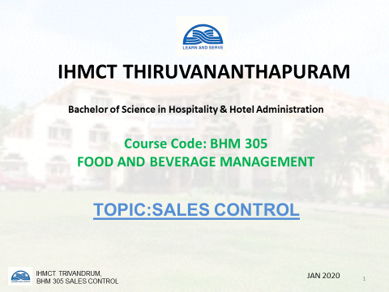

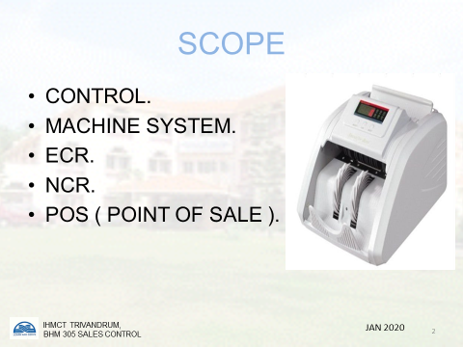

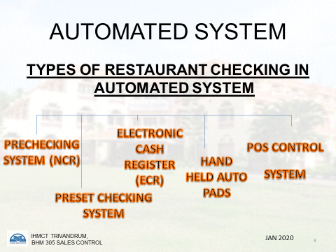
UNIT 5: SALES CONTROL
INTRODUCTION
To control the revenue of a unit, particular attention must be paid to the major factors which can have an influence on the profitability. Therefore, it is essential to control the main factors which can affect the revenue of a business, such as the menu-beverage list, the total volume of food and beverage sales, the sales mix, the average spend of customers in each selling outlet at different times of the day, the number of covers served and the gross profit margins.
It is important to note, particularly in commercial operations that somewhere in the total control system there is a need for the accountability of what has been served to the customer and the payment for what has been issued from kitchen or the bar.
The payment for food and beverage may be made in many forms such as cash, foreign currency, credit cards, cheques, travellers'cheques, vouchers and signed bills.All staff handling cash should be adequately trained in the respective company's methods. It is a common practice for a cashier's or waiter's handbook/manual to be produced so that an established procedure may be followed with the specific aim of ensuring that cash security is efficiently carried out at all times. A typical hand book / manualwould contain information on the standard procedure to be followed for such things as:
- Opening procedure — instructions here would include procedures about checking the float, having a float of specific denominations, checking the till roll, recording waiters' bill pad numbers, etc.
- Working procedure — instructions on how to accept payment and the procedure to follow.
- Closing procedure — instructions on any documentation and recordings to be completed, cashing up, recording of credit cards, cheques, etc.
- Procedure for accepting foreign currency — what currency is to be accepted, how to obtain the current exchange rates, how this is to be recorded, etc.
- Procedure for accepting credit cards — which credit cards are to be accepted, how they are to be checked, method of processing credit cards for payment, recording of credit vouchers, etc.
- Procedures for accepting vouchers such as luncheon vouchers — which vouchers are acceptable, how this is to be recorded.
- Procedure for accepting cheques — how cheques are to be made out, customers to produce a valid cheque guarantee card, checking that signatures correspond, etc.
- Procedure for accepting travellers'cheques — what travellers'cheques are acceptable, what currencies are acceptable, witnessing and checking signatures, how this is to be recorded.
- Procedure for a complimentary or signed bill —check against current list of authorized persons and their signature, how this is to be recorded.
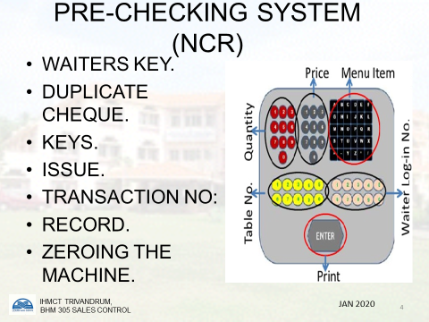

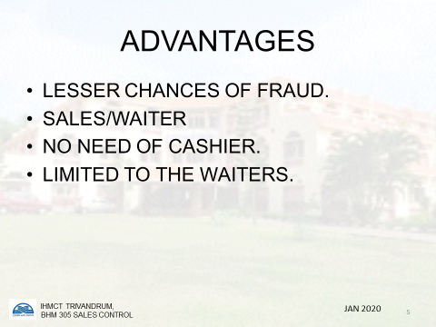

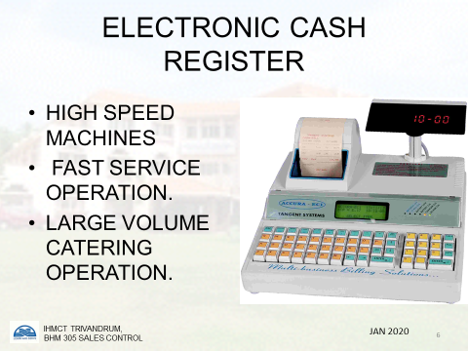

There are two basic approaches to recording and controlling food and beverage sales

1. A manual system, which is commonly used in small and in exclusive type catering units.
2. An automated system, which is commonly used in units with several outlets, in units with a very high volume of business and in up-to-date companies with many units.

MANUAL SYSTEMS
Sales checks

One of the simplest steps to take when attempting to establish sales control procedures is to require that each item ordered and its selling price are recorded on a waiter's sales check. Using some form of a check system serves the following functions:

1 To remind the waiting staff of the order they have taken.
2 To give a record of sales so that portion sales and sales mixes and sales histories can be compiled.
3 To assist the cashier and facilitate easy checking of prices charged.
4 To show the customer a detailed list of charges made.
An additional aid is to use numbered checks and control these tightly, recording all cancelled and missing checks .
It is more common to find duplicate or triplicate checks being used as an aid to control for the following reasons:
1. They provide the kitchen, buffet, or bar with a written record of what has been ordered and issued.
2. They authorize the kitchen, buffet, or bar to issue the food and beverage.
3. They provide the opportunity to compare the top copy of the check with the duplicate to ensure that all that has been issued has been charged and paid for.

The cashier's role
In addition to following precisely the unit's procedure for the handling of all revenue transactions within the restaurant or bars, it is normal practice for the cashier working a manual system to be required to complete the following:
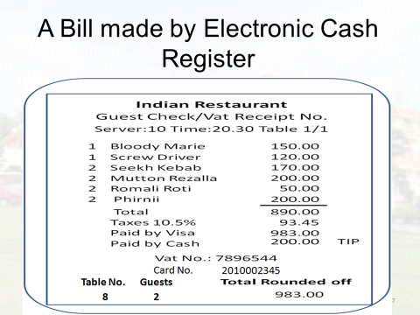

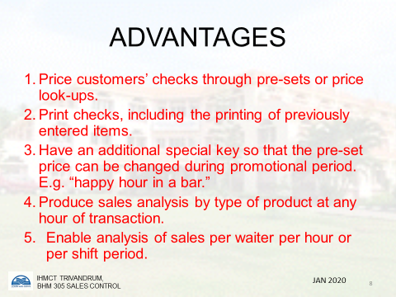

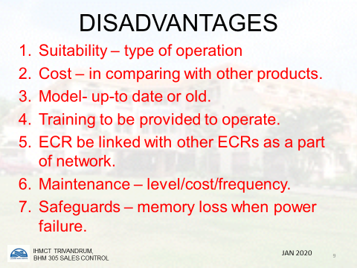
- To issue check pads to the waiting staff prior to a meal period, to record the numbers of the checks issued in each pad, and obtain the waiting staff's signature for them; and on the completion of the meal period to receive from the waiting staff their respective unused check pads, record the numbers, and sign for the receipt of those returned. This information to be recorded on the check number issue control sheet .
2. To check the pricing, extensions and subtotals of all checks and to add any government tax charges and to enter the total amount due.
3. To receive and check money, credit or, when applicable, an approved signature in payment for the total amount due for each check.
4. To complete the missing check list for each meal period. This is an aid to the cashier in controlling what checks are used. The respective check numbers on the list are crossed out when payment is made. When a missing check is identified, investigation to be carried out to find the reason for this, and if no satisfactory explanation is forthcoming, to inform a member of management on duty. Missing checks to be marked on the missing check list .
5. To complete the restaurant sales control sheet for each meal period. This form requires that all revenue received (or its equivalent) is recorded under specific headings, such as cash, cheques, credit card transactions, etc. From this control sheet basic data - such as the number of covers served or the average spend per customer on food and beverages — is quickly obtained.
6. To complete the necessary paying in of cash, etc. in accordance with the unit's established practice. This could be direct to a bank whether a small independent unit, or a unit of a large company, or to the head cashier's office, if a large unit with many outlets. See example of a daily banking and till control sheet.

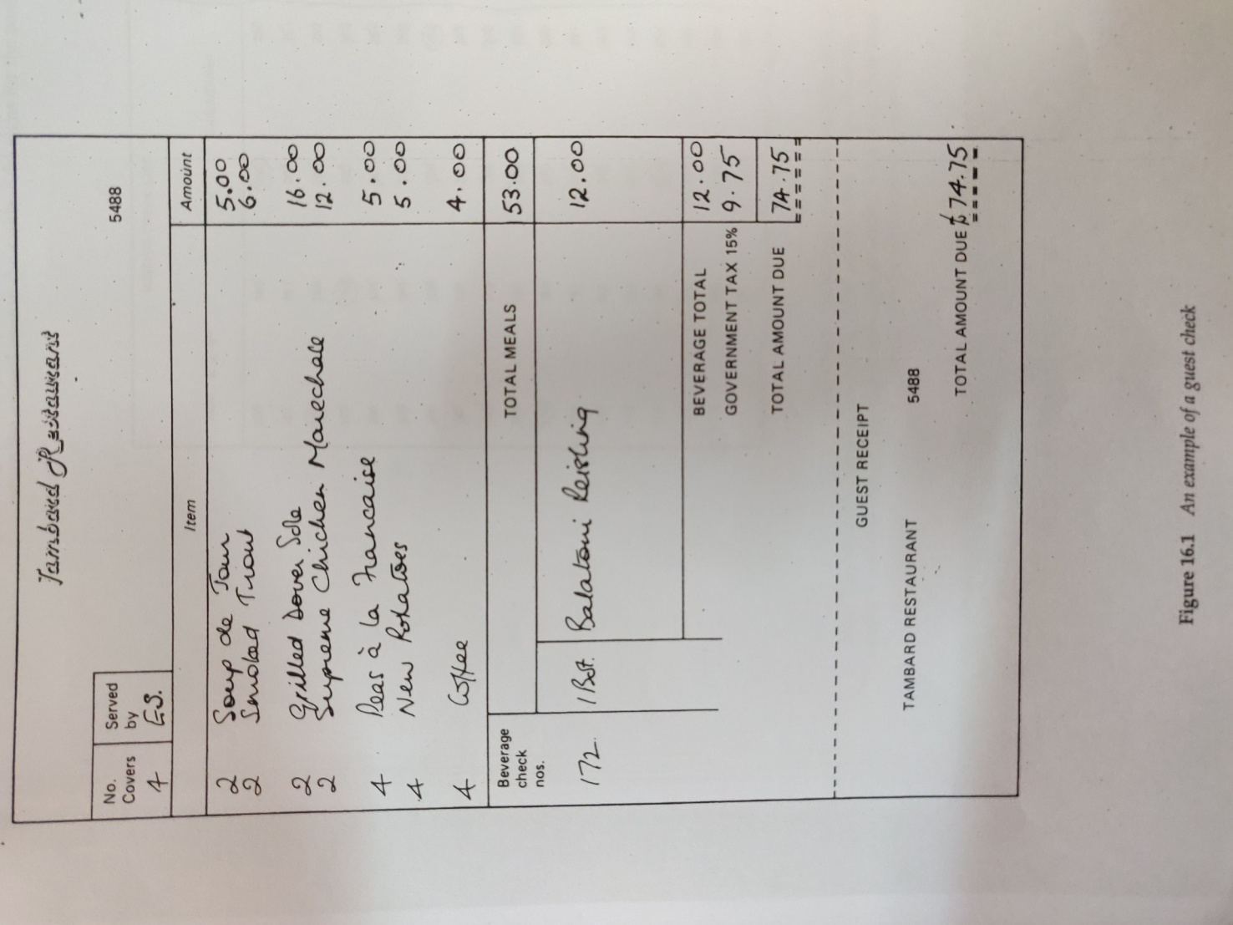
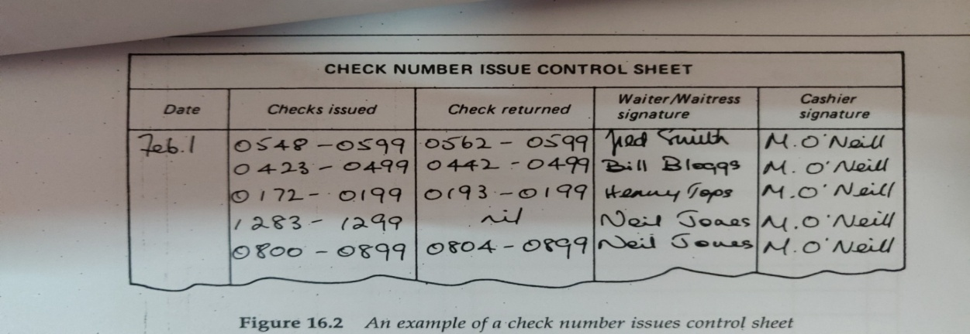

An example of a check number issues control sheet.
The waiting staff sign for the pads of checks issued at the beginning of meal/beverage service period and return unused ones to cashier who signs for receipt of them

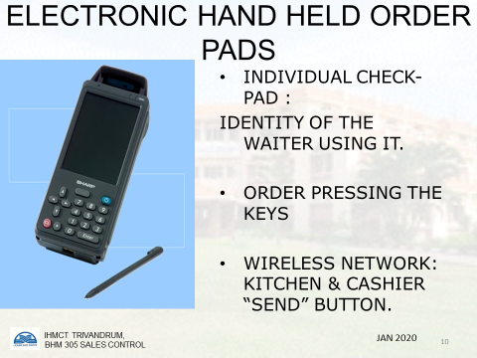

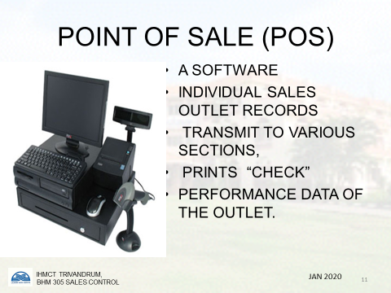

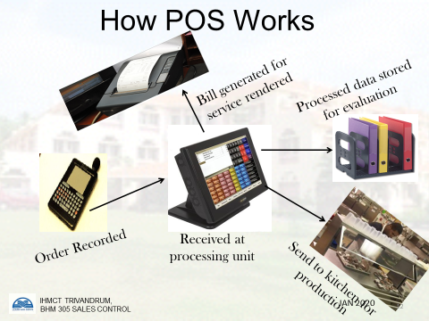

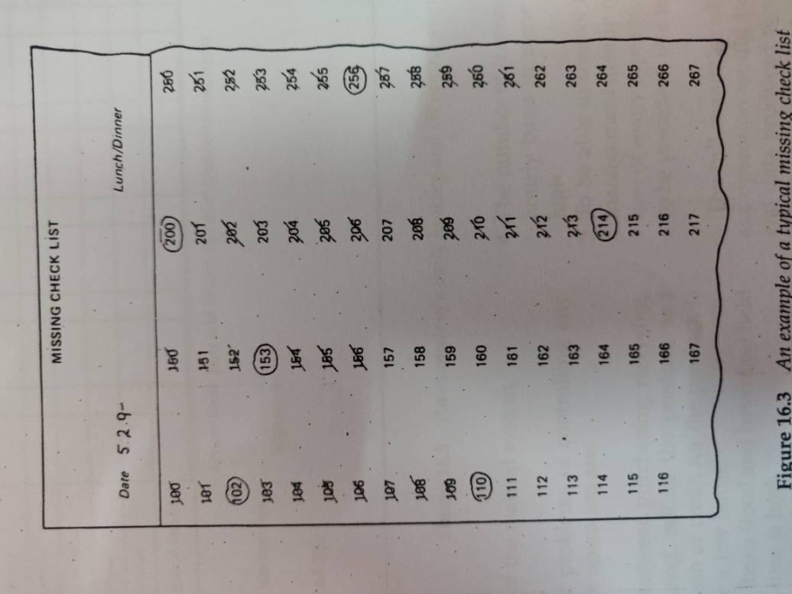
An example of a typical missing check list. This would be kept by the cashier, who would circle on this sheet the opening check number of each waiters pad and then cross off each subsequent number when a check is used. The last check number used would also be circled for easy reference.

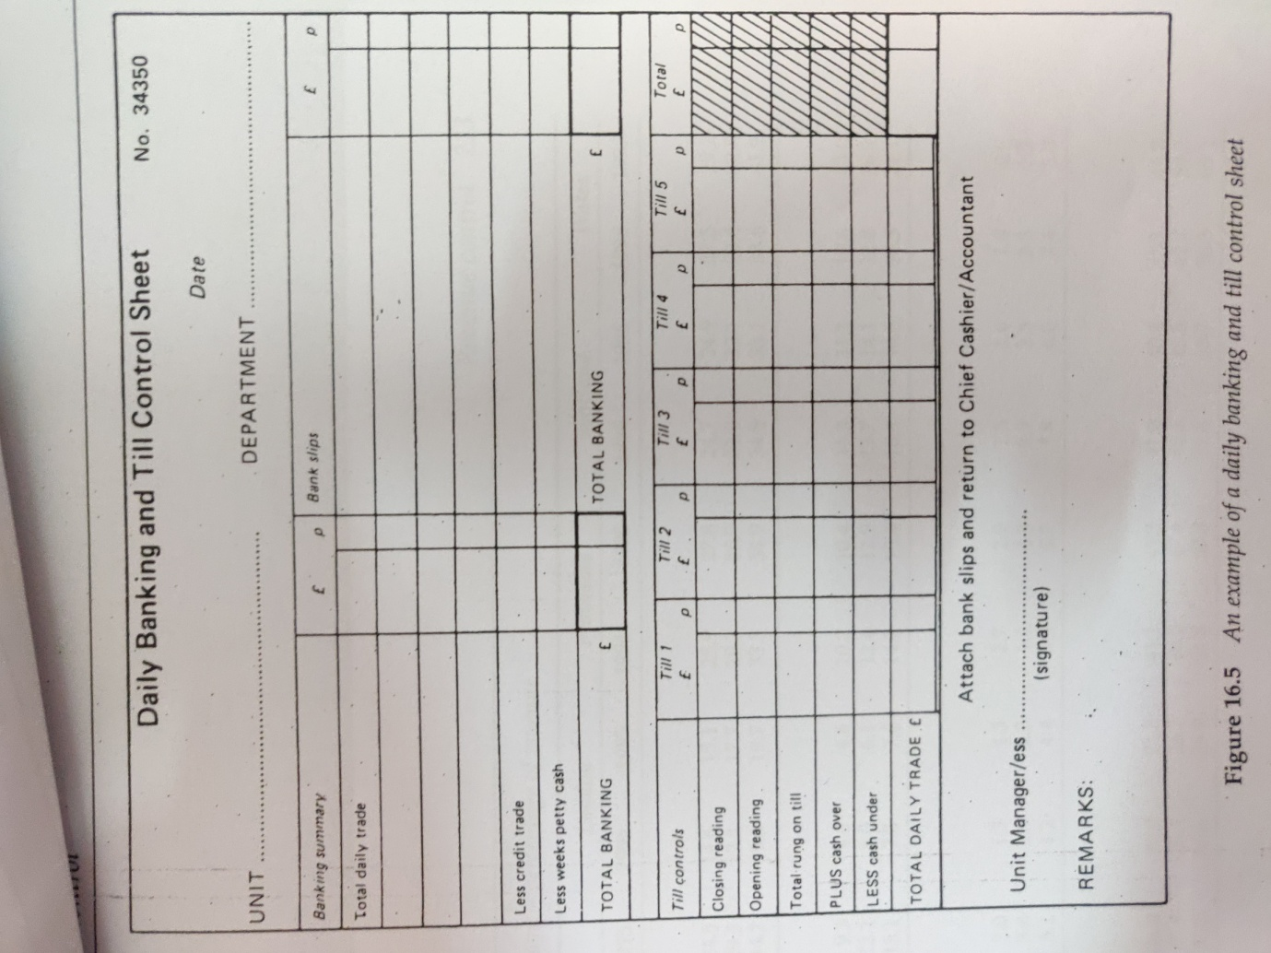
An example of a daily banking and till control sheet

Problems of the manual system
In brief, the basic problems of controlling any food and beverage operation are:
1 The time span between purchasing, receiving, storing, processing, selling the product, and obtaining the cash or credit for the product is sometimes only a few hours.
2 The number of items (food and beverage) held in stock at any time is high.
3 A large number of finished items are produced from a combination of the large number of items held in stock.
4 The number of transactions taking place on an hourly basis in some operations can be very high.
5 To be able to control the operation efficiently, management ideally requires control in formation of many types to be available quickly and to be presented in a meaningful way.
The full manual control of a food and beverage operation would be costly, time Consuming and data produced would frequently be far too late for meaningful management action to take place.
A manual system providing a restricted amount of basic data is still widely used in small- and medium-sized units although they are likely to be replaced in the near future by machine or electronic systems.
The day-to-day operational problems of a manual system are many and include such common problems as:
1. Poor handwriting by waiting staff resulting in:
- Incorrect order given to the kitchen or dispense bar.
- Wrong food being offered to the customer.
- Incorrect prices being charged to the customer.
- Poorly presented bill for the customer, etc.
2. Human error can produce such mistakes as:
- Incorrect prices charged to items- on a bill
- Incorrect additions to a customer's bill
- Incorrect service charge made
- Incorrect government tax (for example VAT) charge made.
3. The communication between departments such as the restaurant, dispense bar, kitchen and cashiers has to be done physically by the waiting staff going to the various departments. This is not only time consuming but inefficient.
4. Manual systems do not provide any quick management information data, any data produced at best being normally 24-48 hours old, as well as being costly to produce.
5. Manual systems have to be restricted to the bare essentials because of the high cost of labour that would be involved in providing detailed up-to-date information.

AUTOMATED / MACHINE SYSTEMS
- PRE-CHECKING SYSTEMS
Pre-check machines are somewhat similar in appearance to a standard cash register and are designed to operate only when a sales check is inserted into the printing table to the side of the machine.
The machine is operated in the following way.
1. A waiter has his/her own machine key.
2. A check is inserted into the printing table and the particular keys, depending on the order taken, are pressed giving an item and price record as well as recording the table number, the number of covers and the waiter's reference number.
3. A duplicate is printed and issued by the machine which is then issued as the duplicate check to, obtain food and/or beverages.
4. For each transaction a reference number is given on the sales check and the duplicate.
5. All data is recorded on a continuous audit tape that can be removed only by authorized persons at the end of the day when the machine is cleared and total sales taken and compared to actual cash received.
The advantages of the system are:
1. The sales check is made out and a record of it made on the audit tape before the specific items can be obtained from the kitchen or bar.
2. Analysis of total sales per waiter is made on the audit tape at the end of each shift.
3. No cashier is required as each waiter acts as his/her own cashier, each keeping the cash collected from customers until the end of the shift and then paying it in.
4. As each waiter has his/her own security key to operate the machine, there is restricted access to the machines and no other way by which pre-checks can be provided and used in exchange for items from the kitchen or bar.
- PRE-SET PRE-CHECKING SYSTEM
This is an up-date on the basic pre-check machine. The keyboard is much larger than the previous machines, and has descriptive keys corresponding to all items on, the menu which are pre-set to the current price of each item. A waiter pressing the key for, say one cheeseburger would not only have the item printed out but also the price. A control panel, kept under lock and key, would enable management to change the price of any item, if required, very quickly. It is also possible to have a running count kept of each item recorded and at the end of a meal period by depressing each key in turn to get a print-out giving a basic analysis of sales made.

- ELECTRONIC CASH REGISTERS (E C R)
These are very high speed machines which were developed mainly for operations such as supermarkets and were further adapted for use in high volume catering operations. Figure beneath show a customer's bill produced on an ECR. The particular advantages of these machines are that they will:
1. Price customers' checks through pre-set or by price look-ups.
2. Print checks, including the printing of previously entered items.
3. Have an additional special key so that the preset price can be changed during promotional periods such as a 'happy hour' in a bar.
4. Provide an analysis of sales made by type of product and if required by hour (or other similar period) of trading.
5. Provide an analysis of sales by waiter per hour or per shift period.
6. Analyze sales by method of payment, for example cash, cheque, type of credit card, etc.
7. Complete automatic tax calculations cover and service charges
8. Provide some limited stock control.
9. Provide waiter checking-in and checking out facilities.
10. Provide facilities for operator training to take place on the machine without disrupting any information already in the ECR.
11. Restrict access to the ECR and the till drawer by the key or code for each operator.
12 Have rotating turret displays of prices charged to individual customer transactions. This is of particular value in self-service and counter operations.
13 Eliminate the need for a cashier, by requiring each waiter to be responsible for taking payment from the customers and paying in the exact amount as recorded by the ECR at the end of each shift.
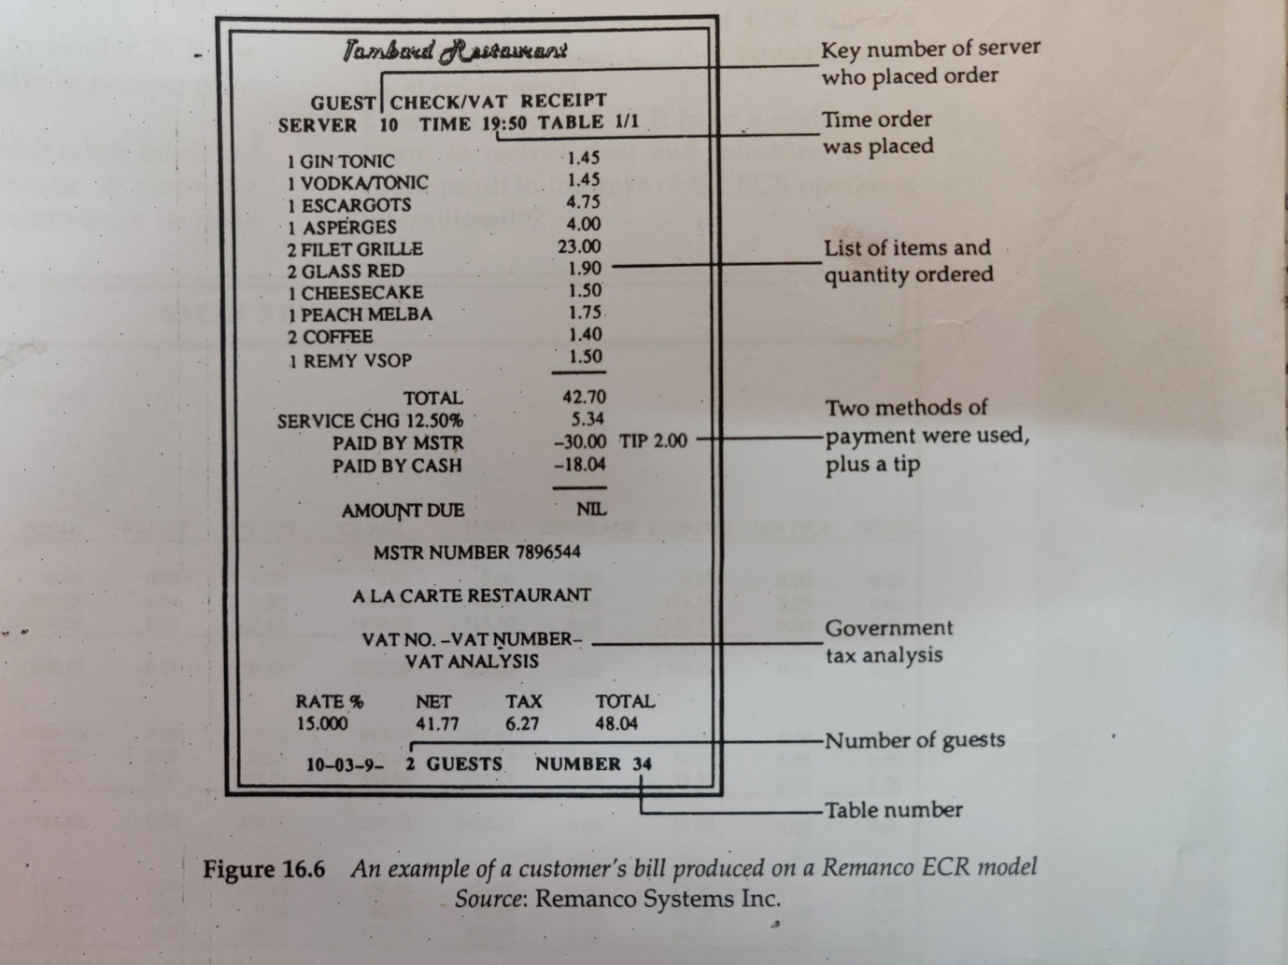
ECR BILL: An example of customer’s bill produced on a remanco ECR.

Electronic cash registers are not without their problems and it is important to consider the following prior to selecting an ECR for purchase.'
1 Is it suitable for the type and size of operation it is to be used in?
2 Cost - how does this compare with other models of similar capacity?
3 Is it an up-to-date model or is it about to be superseded?
4 What on-site training will be offered if this model is purchased?
5 Can this ECR be linked to similar ECRs as part of a network or directly to a micro-computer?
6 Maintenance. How foolproof is this machine? What level of maintenance is normally expected? Can simple maintenance be done by staff for example, changing of the printing ribbon, etc.?
7 What safeguards (for example, battery override) are standard or optional to the model when power failures occur? (The memory of the day's business could be lost in a power failure causing a serious loss of control.)
8 What built-in security features are included so as to restrict access to commands, re-setting, and disclosure of information to authorized personnel?

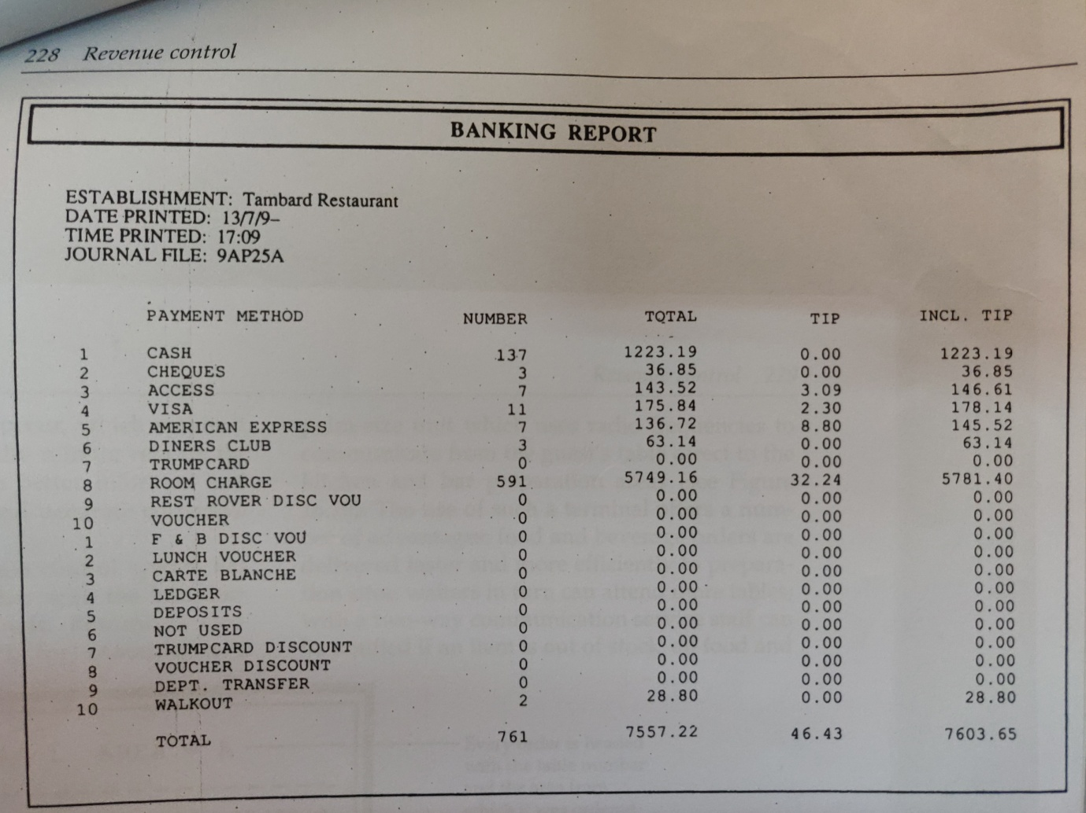
An example of a banking report showing the different methods of payment received
- POINT-OF-SALE CONTROL SYSTEMS(P.0.S)
At a basic level a point-of-sale control system is no more than a modern ECR with the additional feature of one or several printers at such locations as the kitchen (or sections of the kitchen) or dispense bar. Some systems replace the ECR with a 'server terminal' (also called 'waiter communication' systems), which may be placed at several locations within a restaurant, and is a modification of an ECR in that the cash features are eliminated making the terminal relatively small and inconspicuous.
The objectives for having printers are:
1 To provide an instant and separate clear and printed order to the kitchen or bar, of what is required and by and for whom ,to speed up the process of giving the order to the kitchen or bar.
3 To aid control, in that items can only be ordered when they have been entered into the ECR or terminal by an identifiable member of the waiting staff and printed.
4 To reduce the time taken by the waiter in walking to the kitchen or bar to place an order and, as frequently happens, to check if an order is ready for collection. This afford more time for customer contact.
Printers are at times replaced by VDU screens.
Server terminals are part of a computer-based point-of-sale system. These special terminals are linked to other server terminals in the restaurants and bars within one system and, if required to, also interface with other systems so that, for example, the transfer of restaurant and bar charges may be made via the front office computer system. The advantage of a computerized point-of-sale system is that it is capable of processing data as activities occur, which makes it possible to obtain up to the minute reports for management who can be better informed and able to take immediate and accurate corrective action if necessary.
This type of point of sale control system has been taken one step further with the introduction of hand held terminals. Remanco’sElectronic Server Pad (ESP), for example, is a palm size unit which uses radio frequencies to communicate from the guests table direct to the kitchen and bar preparation areas. The use of such a terminal offers a number of advantages; food and beverage orders are delivered faster and more efficiently to preparation sites; waiters in turn can attend more tables; with a two-way communication service staff can be notified if an item is out of stock; all food and beverage items ordered are immediately charged to the guest's bill, which is accurate and easy to read; finally, operations can reassess their labour utilization and efficiency, certain members of the service staff, for example, can take the simple orders, while others can spend more time with customers to increase food and beverage sales.
The ESP is a completely noiseless terminal with orders being entered alphabetically, numerically or by using pre-set codes. When not being used and the unit is closed, its design resembles a conventional order pad, compact and light in weight that can easily be carried around by service staff.

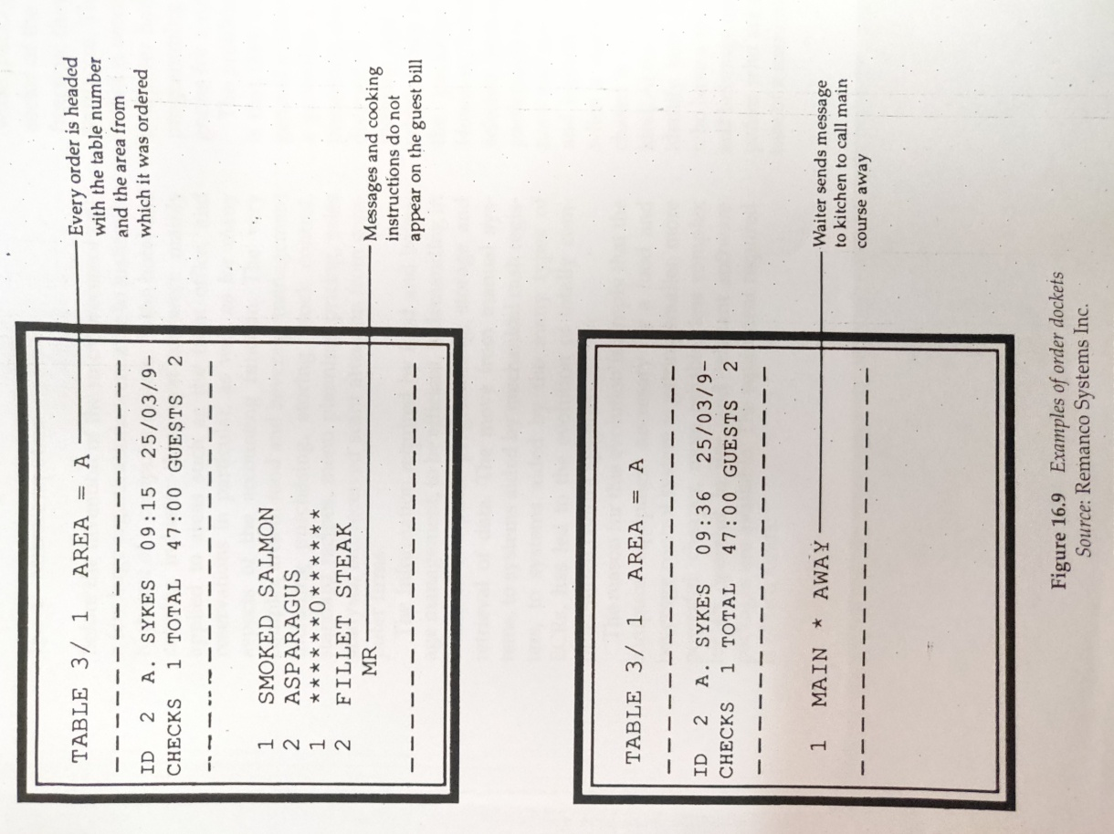

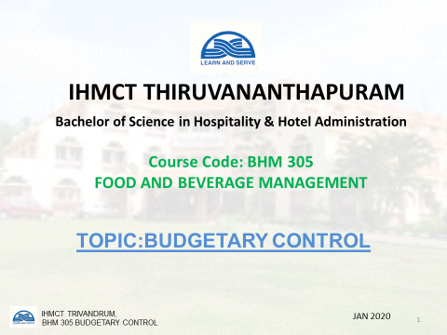
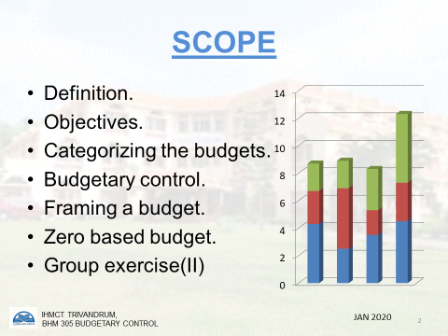
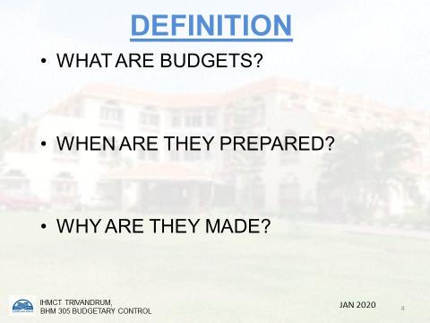

UNIT 06:BUDGETARY CONTROL
Budget is the monitory expression of business plans and financial policies to be pursued in the emerging future period of time. The term budget is associated with the estimated figures regarding sales, production, cost, profit, etc. for future and it requires planning, co-ordination, control, etc.
Preparing a budget may not be very difficult but to prepare a budget which is very close to the actual figures is very important and requires a qualified, experienced staff. Though there may be a separate department consisting of experts for preparing the budgets but they require the help and co-ordination of various other officials and data to prepare budgets.
Budgetary Control: Budgetary control is the preparation of budgets relating tothe responsibilities of executives to the requirement of a policy, and the continuouscomparison of actual with budgeted figures. (1.C.W.A. Terminology of CostAccountancy) Budgetary control is not a type of costing but is extensively used inall types of industries, businesses, Government departments as a system of controlthrough responsible persons such as executives, departmental heads, foremen,supervisors, etc. From the definition of budgetary control, it will be observed thatthe first step is the preparation of a budget.
A budget is a financial and / orquantitative statement prepared and approved prior to a period of time, to the policyto be pursued during that period for the purpose of attaining a given objective.
A budget is a plan — expressed usually in financial and quantitative terms (for example, total value of payroll; number of customers, etc.) — which reflects the policies of an establishment and determines the business operations for a particular trading period. The trading period is usually of one year, but is often broken down into review (or control) periods of either thirteen four-week periods; or alternatively, of thirteen week quarters, each quarter consisting of two four-week and one five-week periods. Whichever method is adopted it is necessary that the periods remain the same so as to make it possible to compare results not only with corresponding periods in the same year, but also with the corresponding periods in earlier years. Bank holidays and special events falling into different periods each year should be noted.
The term budgetary control refers to a method of control where particular responsibility for various budgeted results is assigned to the managers concerned and a continuous comparison of the actual results and budgeted figures is made.

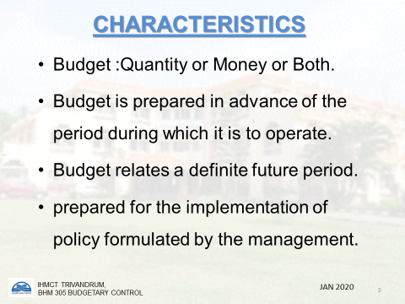

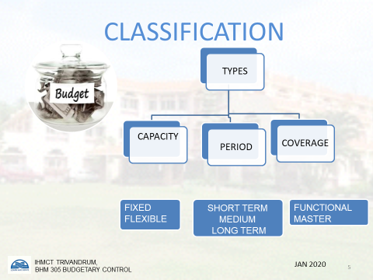

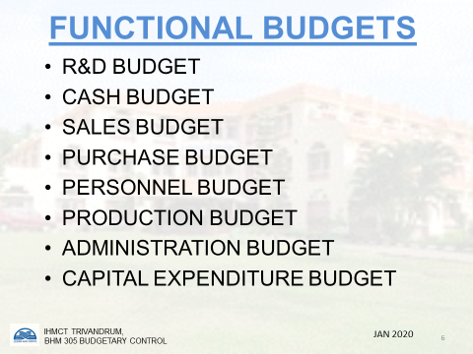

When there are discrepancies between the two, it is necessary to identify the reasons for the variances and to take appropriate action. It is essential that when budgets are set they are clearly seen to be achievable, otherwise they are of little value. It isthe process of determining various budgeted figures for the enterprises for the futureperiod and then comparing the budgeted figures with the actual performance forcalculating variances. First of all, budgets are prepared and then actual results are recorded. The comparison of actual and budgeted figures will be termed asdiscrepancy. The budgets can be revised as the time passes. And that is why it issaid that a budgetary control is a continuous process which helps in planning andco-ordination.Today, with the continual increases in the costs of food, beverages, labour, energy, maintenance and other overheads, most establishments operate some form of budgetary control.
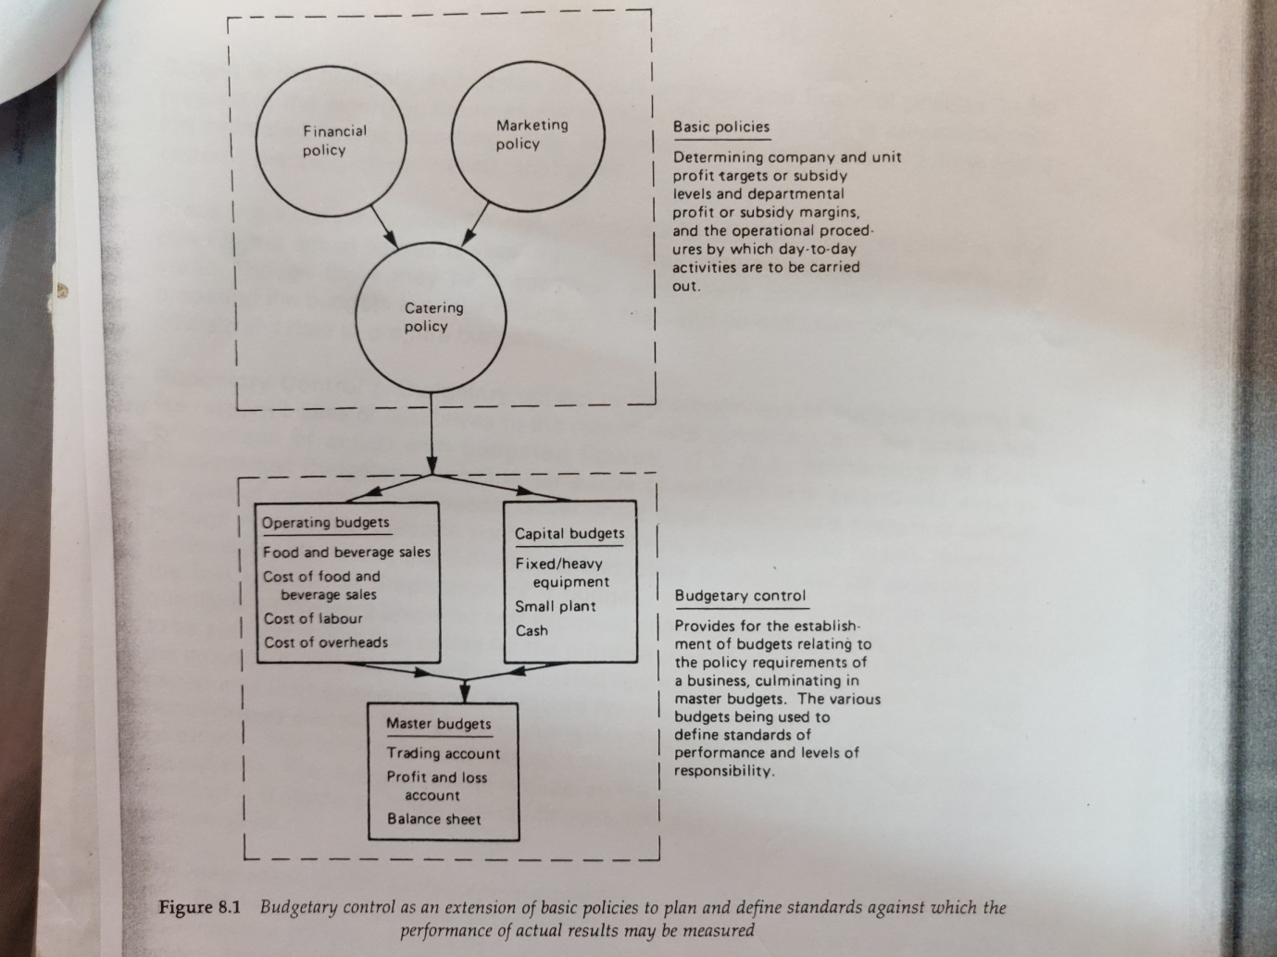
Budgetary control as an extension of basic policies to plan and define standards………against which the performance of actual results may be measured!!!

The above budgets are prepared not only for each unit of a business, but also are broken down into budgets for departments such as individual restaurants, bars and banqueting. It is also common practice to consolidate the above budgets to a set of master budgets such as:
- A master budgeted trading account for a particular trading period showing the predetermined volume of sales, the cost of sales and the gross profit expected.

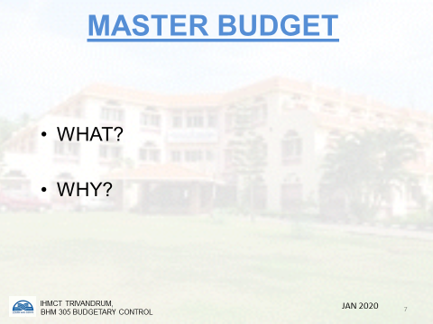

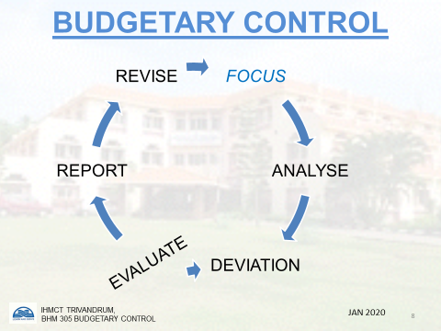

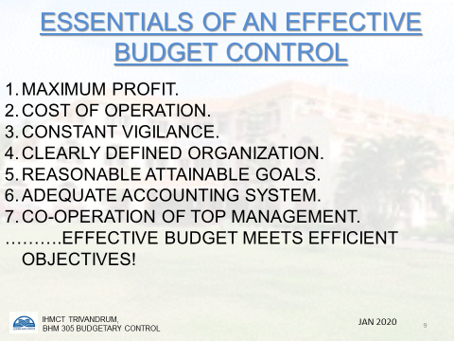

- A master budgeted profit and loss account for a particular trading period showing the predetermined income and expenditure and net
profit expected. This highlights unit and departmental gross profits, labour costs, overhead costs and net profit.

- A master budgeted balance sheet for a particular trading period showing the assets and liabilities at the beginning and at the end of the period.
The main steps under budgetary control are:
- Establishment of budgets for each section of the organization and incorporating the functional budgets in summary or master budget consisting of a forecast or budgeted profit and loss account and balance sheet.
- Recording of actual performances and continuous comparison of the actual performances with that of the budget so as to determine the variances from the budget…… and
- Ascertainment of reasons for such variances and taking suitable actions to remedy the defects in order to achieve the objective under original policy or to provide a basis for its revision.
OBJECTIVES
For policy, planning and control the budgetary control is essential. The main objectives of budgetary control are:
- To plan for future and Timely decision
- To have co-ordination among different departments activities.
- To operate departments with efficiency, economy and perfectly {Carrot and stick policy}
- Minimizing of wastes and increase in profitability/Economy.
- To anticipate capital expenditure for future.
- Correction of deviations from the established standards.
- Fixation of responsibilities of all people working in the company.
- To centralize the control system.
- To anticipate working capital for future.
- To safeguards the assets and get maximum utility from them.
- To reduce the cost both labour and overhead and have a better gross and net profit.
- Measurements of departments performance and Determining weaknesses
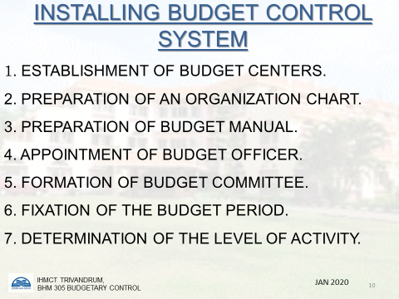

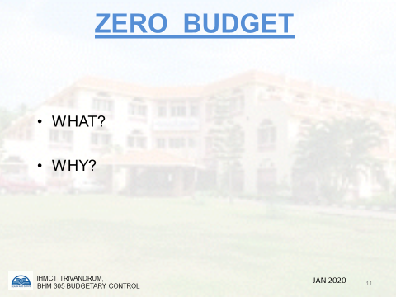

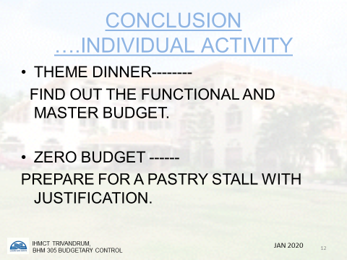

BUDGETARY CONTROL SYSTEM
It is easy said than done; to have a successful implementation of a budgetary control system the following steps are taken:
- Organisation :To have a successful preparation, maintenance and
administration of budget a proper organization is essential.

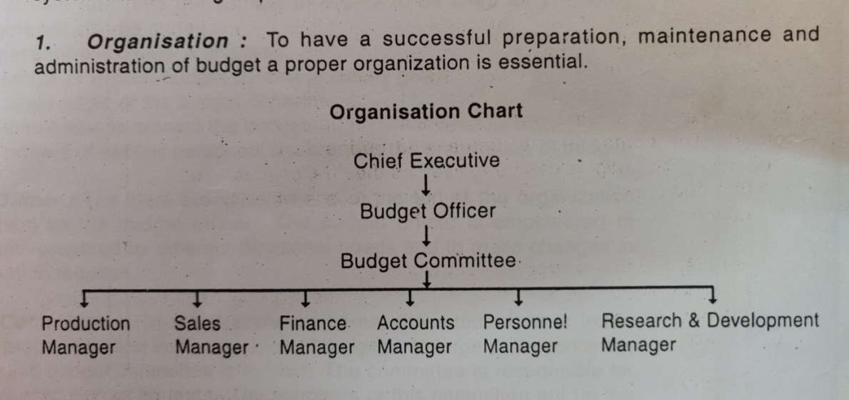

2.Budget Centre: It is that part of organization for which the budget is prepared. It may be a section of a department or the department itself. The establishment of budget centre is essential for covering all parts of the organization.

3.Budget Manual: It is document which spell out the duties and responsibilities of various executives concerned with the budget. A budget manual covers thefollowing matters:
- The objective of budgetary control system along with the benefits of this system.
- The duties and responsibilities of various personnel dealing with thepreparation of budgets.
- It gives information about the sanctioning authorities of various budgets.
- A specimen form and the number of copies to be used for preparingbudgets will also be stated.
- Budget center is clearly mentioned.
- The length of various budget periods is clearly given.
- The total budget of the budget department.
- The time frame to-present the budget.
- The powers of various personnel dealing with the preparation of budget.

- Budget Officer: The chief executivewho is at the top of the organizationappoints a person as the budget officer. The budget officer is empowered toscrutinize budgets prepared by different functional heads and to make 'changes inthem, if the situation requires.
- Budget Committee: Insmall scale concerns, the accountant is maderesponsible for preparation and implementation of budgets. In large scale concerns,a committee called budget committee is formed. The committee is responsible forpreparation and execution of budgets. The members of this committee put up the cases of their respective departments and help the committee to take collective decisions.
- Budget Period: This is the length of time for which a budget is prepared.Budget can be prepared for short term, medium term or long term.
LIMITATIONS OF BUDGETARY CONTROL:
Though there are many advantages of budgetary control but still there are some limitations listed as below:
  - Problem of co-ordination
  - Uncertain future
  - Discourages efficient employees
  - Budgeting revision required
  - Conflict amongst departments
  - Depends upon the support of top management
  - Non availability of future data
  - Act of God: Due to some acts which are not in the control of mankind
TYPES / CLASSIFICATION OF BUDGETS:
1.According to Time
- Long Term
- Medium Term
- Short Term
- Current

2.According to Functions
a) Operating Budget
b) Financial Budget
c) Master Budget

3.According, to Flexibility
- Fixed Budget
- Flexible Budget
1.According to Time:
The budgets can be prepared for short term, medium term, and long term or for current period. Usually long term and medium term budgets are for the capital investment and generally involve more of capital.
a) Long Term Budget It is prepared to depict the long term planning of the company / hotel. These budgets may be prepared five to ten years inadvance. The long term planning is done by top level management and isnot generally known to the lower level of management. These budgetsare prepared for increasing the production or starting a new industry orunit and usually involve a lot of capital. To implement these budgets, thefuture demand, cost, availability of raw material, future competition, etc. are kept in mind.
b) Medium Term Budget These budgets are usually prepared for two tofive years in advance. These budgets are also planned by senior levelmanagement but are prepared when management cannot wait for as longas seven to ten years to implement the decision.
- Short Term Budget: These budgets are generally prepared one to twoyears in advance and are in the form of monetary terms. The consumergoods industries like sugar, cotton, textile, constitute these budgets.
- Current Budgets: The period of current budgets is generally of monthsand weeks. These budgets relate to the current activities of business.According to ICWA London, 'Current budget is a budget which isestablished for use over a short period of time and is related to current conditions.
2.According to Functions:
The budgets can be prepared for different typesof jobs performed by the organization like operation, financial, etc. andthese are termed as budgets as per functions
- Operating Budget: These budgets relate to the different activities /operations performed by a company. The number of such budgets depends upon the size and nature of business. Commonly used operating budgetare sales budget, production budget, purchase budget, plant and machinerybudget, etc. The operating budget for a company may be constructed interms of program or responsibility areas and hence may consist of:
- Financial Budget: Thesebudgets are concerned with cash receipts andpayments, capital expenditure, working capital, financial position and resultsof business operation. Commonly used financial budgets are: Cash budget,Working Capital Budget, Income Statement Budget, Capital ExpenditureBudget, etc.
- Master Budget :Various functional budgets are integrated into masterbudget. This budget is prepared by the ultimate integration of separatefunctional budgets. This budget is used to co-ordinate the activities ofvarious functional departments and also help as central device of acompany.
3.According to Flexibility :The long term budgets once prepared are revisedperiodically keeping in view the new developments and that is why it is said thatthe budgets should not be rigid and there should be a provision to modify itdepending upon the new developments. This modification is termed as flexibility inthe budgets.
- Fixed Budget :These are Prepared for a given level of activity. The budgetis prepared before the beginning of a financial year. If the financial yearstarts in April, then the budget will be prepared a month or two before i.e. in February or March. These budgets are suitable under static conditions.If sales, expenses and costs can be forecasted with greater accuracy, thenthis budget can be very useful.
Flexible Budget: It consists of a series of budgets for different levels ofactivities. It, therefore, varies with the level of activity attained. A flexiblebudget is prepared after taking into consideration unforeseen changes.

PREVIOUS YEARS’ QUESTIONS
- What is budgetary control? State steps in preparing a budget (2014-15)
- What is budgetary control? Discuss the different budgets prepared in F&B
- operations (2017-18)
- Write short notes on:

- Medium term budget
- Operating budget
- Financial budget
- Master budget
- Current budget
- Program budget
- Zero budget

UNIT 7: VARIANCE ANALYSIS
When actual costs are recorded and compared with the standard costs, deviations are quiet a possibility!
These deviations are called VARIANCES.A variance is thus the difference between the budgeted or standard cost / sale and the actual cost / sale during a given period of time. These variances may be favorable or adverse according to circumstances. If actual cost is less than standard cost, then it is called favorable variance and on the contrary if actual cost is more than the standard cost then it is called adverse variance. But in case of sale: if actual sale is more than the standard / budgeted sale then it is called favorable variance and vice versa.
Steps involved in standard costing technique:
- Determine the standard cost
- Recording of actual cost
- Comparison between standard and actual costs
- Calculation of variance
- Reporting of variance to take corrective action and pin points areas of costinefficiency
Standard costing techniques are not useful in places that in which it is not compared with actual cost and can be applied only in areas where costs are standardized
While setting standard costs for each element of cost, we need to determine standards as regards price and quantity, and similarly we have to analyse the variances of each element of cost basically under price / cost variance and usage / quantity variance.

COST VARIANCE
Price variance
- Food cost price variances
- Labour Cost rate variances
- Overhead expenditure variances
Usage variance
- Food cost usage variance
- Labour Cost efficiency variance
- Overhead efficiency variance
It will be observed that all these price variances are not generally further analyzed; but the usage variances in respect of food cost and efficiency variance in respect of labour cost are analyzed further according to causes for change of consumption of food cost or labour cost on hourly basis as follows:

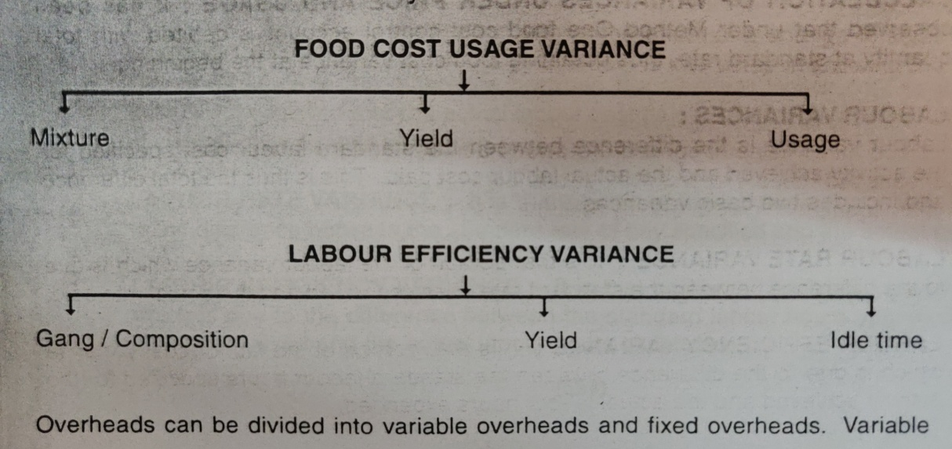

Overheads are analyzed under expenditure and efficiency only. Fixed overhead is however, analysed as follows:
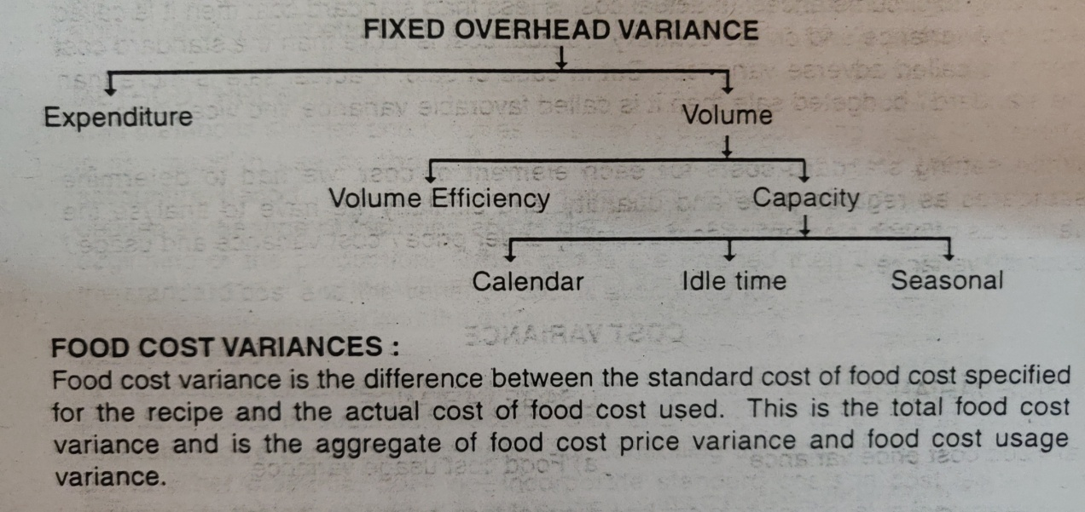
FOOD COST VARIANCES:
Food cost variance is the difference between the standard cost of food cot specified for the recipe and the actual coast of food cost used. This is the total food cost variance and is the aggregate of food cost price variance and food cost usage variance
FOOD COST PRICE VARIANCE:
It is that portion of food cost variance which is due to the difference between the standard price specified and the actual price paid.
FOOD COST USAGE VARIANCE:
It is that portion of food cost variance which is due to the difference between the standard quantity specified and the actual quantity used.
CALCULATION OF VARIANCES UNDER PRICE AND USAGE:
It has been observed that under method one food cost control account is debited with total quantity at standard rate, thus obtaining food cost variance at the beginning.

LABOUR VARIANCE:
It is the difference between the standard labour cost specified for the activity achieved and the actual labour cost paid. This is thus the total difference and includes two basic variances.
LABOUR RATE VARIANCE:
It is that portion of the labour variance which is due to the difference between the standard rate of pay specified and the actual rate paid.
LABOUR EFFICIENCY VARIANCE:
It is that portion of the labour variance which is due to the difference between the standard labour hours specified for the activity achieved and the actual labour hours expended.
CALCULATION OF LABOUR RATE AND LABOUR EFFICIENCY VARIANCES:
These basic variances are similar to labour cost variances. Labour rate variance corresponds to food cost variance, whereas labour efficiency variance correspondsto food usage variance.
OVERHEAD VARIANCES:
It is the difference between the standard cost of overhead absorbed, in the output achieved and the actual overhead cost.
OVERHEAD EXPENDITURE VARIANCE:
It is that portion of the overhead variance which represents the difference between the standard allowance for the output achieved and the actual expenditure incurred.
OVERHEAD VOLUME VARIANCE:
It is that portion of the overhead variance which is the difference between the standard cost of overhead absorbed in actual output and the standard allowance for that output.
SALES VARIANCES:
Cost variances affect profit, but to know the actual financial position, the overall change in profit, one must analyse the sales also as profit is also affected by change In sales price, sales quantity or sales mix, or change in standard allowances, rebates, etc. Two distinct methods of computing and presenting sales variances are as follows :
SALES MARGIN METHOD:
This method shows the effect of a change in sales price or quantity on sales margin / profit. Management is interested in knowing the sales margin variances.
SALES VALUE METHOD:
This method shows the change in sales value due to quantity / price. This is the earliest method and is not generally used, because it does not clearly show the effect of change in sales on profits, on which management is interested. Whatever method may be followed, the cost of units sold must be taken at standard cost so that actual cost does not enter at all into sales variance analysis; because sales function is relatively independent of production from the point of view of control and hence it is logical to exclude all production cost variances while calculating sales variances.

PREVIOUS YEARS QUESTION PAPERS
1.What is variance analysis? Explain the different variances in food & beverage operations (2017-18)

UNIT 8: BREAK-EVEN ANALYSIS
INTRODUCTION
It is very common for food and beverage management to be faced with problems concerning the level of food and beverage cost that can be afforded, the prices that need to be set for food and beverages, the level of profit required at departmental and unit level and the number of customers required to cover specific costs or to make a certain level of profit.

Typical questions raised are:
- What level of sales is needed to cover the fixed costs of a unit?
- What level of sales is required from a particular unit to achieve a net profit?
- What level of sales is required to increase the net profit of a unit by £10,000?
- What will the effect of increasing prices by 5 per cent have on net profit?
- What will be the effect on net profit of increasing the average spend of customers by 50rs per meal?
- What increased level of sales must be obtained to cover the spending of £1,000 on advertising to promote the restaurant?
- What will be the financial implications of discounting beverages during a proposed promotion?
- What is the relationship between the capital invested in a restaurant and its sales and profit?
Answers to the above types of question are normally attempted by using the accepted technique of break-even analysis.
Break-even analysis enables the relationship between fixed, semi-fixed and variable costs at specific volumes of business to be conveniently represented on a graph. This enables the break-even point to be identified and the level of sales necessary to produce a predetermined level of net profit. The term break-even point may be defined as that volume of business at which the total costs are equal to the sales and where neither profit or loss is made. The technique is based on the assumption that: the selling price remains constant irrespective of the volume of business; that certain unit costs remain the same over the sales range of the charted period; that only one product (for example, a meal) is being made or sold; that the product mix remains constant.
cost price and volume and that labor and machine productivity is constant.
Nearly every action or planned decision in a business will affect the costs, prices to be charged, the volume of business and the profit. Profits depend on the balance of the selling prices, the mix of products, the costs and the volume of business. The break-even technique discloses the interplay of all these factors in a way which aids food and beverage management in selecting the best course of action now and in the future.
Breakeven point is that point of time where there is no profit or loss.
$∴$total cost = total revenue
This can be calculated by 3 methods
- Table
- Graph
- Mathematical formula

- TABULATION METHOD
For Fandango a stall is being hired by a soft drink distributer at hire charges of Rs.3000/- for 3 days. He is planning to sell soft drinks at the rate of Rs.10 which has a cost Rs.5/-. He plans to sell approximately 500 soft drinks per day. Calculate his BEP. What is his profit if he sells 1500bottles?
UNITS SOLD | SALES | VARIABLE COST | CONTRIBUTION | FIXED COST | TOTAL COST | PROFIT/LOSS

PROBLEM 1

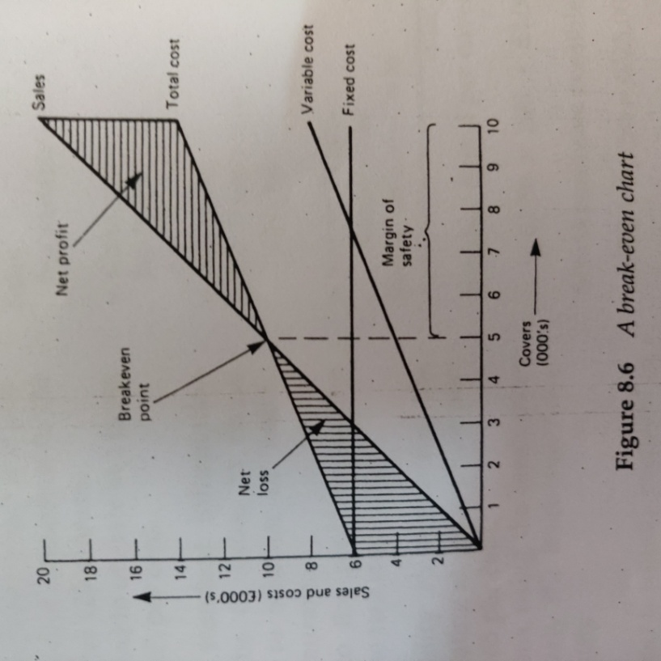

Notes:
1 The fixed costs are £6,000 per period.
2 The variable costs are 40 per cent of sales (maximum sales are 10,000 x £2 = £20,000), that is £8,000.
3 The total cost line is derived by adding together the fixed and variable costs (£6,000 + £8,000), that is, £14,000.
4 The restaurant will make a net loss while it serves less than 5000 covers per period.
5 When the break-even point has been reached the net profit of the restaurant increases more than in proportion to the number of covers.
6 The margin of safety is 5,000 covers.

- BREAK-EVEN FORMULA

- Contribution concept
Contribution maybe defines as sales less variable cost. If expressed as a percentage, it is referred to as PV ratio or profit volume ratio.
Let us assure that the selling price of a fixed meal is Rs. 20.00 and the food cost is Rs.7.00. the gross profit will be as follows:
Selling price of meal 20.00 100%
Variable cost 7.00 35%
---------- ------------
Gross profit Rs.13.00 65%
Contribution is called so because it contributes to recovery of fixed cost and then profits.

- Breakeven concept
Although a break-even chart shows diagrammatically the varying levels of profit or loss from different volumes of sales, the level of accuracy of the information may at times be in doubt owing to the scale of the graph and the skill of the person drawing it. A precise break-even point may be calculated using the formula.
PROBLEM 2
I

PREVIOUS YEARS’ QUESTIONS
- What is Break-even analysis? Draw a Break-even chart using a suitable example. (2013-14)
- Explain break-even analysis in detail with the help of a graph diagram. (2017-18)
- Write short notes on PV ratio (2017-18)
- Explain the importance of break-even analysis for a catering establishment (2016-17)
- Discuss break even analysis with the help of a neat chart and suitable examples. (2014-15)
- The information given below is in respect of restaurant for a period of one month:
Maximum covers sold = 2000 ASP per cover = 350/
Fixed costs = 30,000 Variable cost = 40% of sales
Compute the PV Ratio, BEP Sales, BEP (Covers) Margin of Safety
- Calculate BEP in units and volume and margin of safety from the following:
Fixed Cost Rs.15.000
Selling price per unit Rs. 100/
Variable Cost per unit Rs. 25/
No. of Cover Sold 300 nos.

- Old Wagon Restaurant averages 900 covers per month. The average spending power is Rs.80/- Variable costs equal 45% of revenue. The fixed costs are Rs. 22,000/-. Calculate the Break Even Point as well as Margin of Safety available.

CHAPTER 9
MENU: BILL-OF-FARE
The menu is the foundation for the control process in a food and beverage operation. The menu planning control point begins the control process. This chapter focuses on the menu and presents an overview of other control points that play crucial roles in determining the success or failure of a food and beverage operation.
The menu is the restaurant’s showcase; through its presentation the guest prejudges the quality of the meal. For these reasons, the conception of a new menu should be handled with particular care and should be handled with particular care and should be part of the management concern rather than left to one individual’s decision.
Whenever necessary, help should be sought from a professional designer in order to obtain new ideas and see the problem from different perspective to that of hotel executives.
MENU PRESENTATION
A la Carte
This style of menu is used in the majority of restaurants, and literally translated means ‘from the card’. The customers are given the menu from which they may select as many courses in whichever order they desire. Each dish on the menu is generally more expensive and has a longer waiting time between courses as dishes are cooked only when ordered. This may also necessitate a larger number of staff (both cooking and service) with a higher range of skills.
Table d’hôte
Literally translated means “table of the host”. The host may be the manager, or chef or the establishment, but is more often the person paying for the function; that is, in the case of wedding, the bride’s father would select the menu for his guests. The menu in every case includes a set number of courses which are offered at a set price. The number of courses may vary from three to seven and a choice is sometimes offered within each course. This style of menu allows preparation of some of the dishes and therefore quicker service using fewer staff. Customers are usually served at the same time.
Set menu
This style of menu is mostly used at large functions. As the term implies all the items of the meal have been predetermined, which means that the customers have no choice of dishes. The set menu allows pre-preparation of all the dishes and a set price is charged per person. There are no hard and fast rules about menu presentation, but the following general guidelines may be useful in understanding some of the trends. Quality in the presentation of restaurant menus is essential to preserve the image, not only for the outlet concerned but also for the entire hotel. The restaurant menu is a promotional and Sales tool. It does not only give information but should also motivate the customers.
The process of planning a menu never ends; the final menu is never achieved. Rather the process is ongoing, dynamic and based on the expectations of the operation’s present and prospective guests – its target makers. From creating an image to communicating a plan for satisfying the guests, influencing the guest purchase decision, merchandising the correct product, and more, the menu has continuous effect on all aspects of an operation. A properly planned and well-designed menu stimulates sales and increases the guests check average, because whenever a menu is presented to a guest, a sales transaction begins. And the menu not only creates but reflects the operation’s image. The image may be elegant, business, fun, ethnic, or trendy, depending on what the target markets.However, some basic principles should be followed. These are outlined below.
1.Size: Oversized menus should be avoided, being unpleasant for the guest, difficult to handle and as a result not easy to keep in good condition. However, the format should be sufficient so that the menu remains easy to read, clear and with a limited number of pages (in order to avoid a tariff-style presentation).
2.Illustration: Any illustration should be light, tasteful and in harmony with the company image, match the restaurant and table décor, and be in line with the concept of restaurant. Caricature or heavy illustration should be avoided. Pastel colours in harmony with the environment should be given preference. The menu should be a part of the restaurant decoration with the exception of privately owned restaurants for which the menu can be personalized. There should be some harmony among the menus of the various outlets.
3.Quality of paper: The paper used for the cover should be selected according to the type of restaurant either:
In strong, heavy-duty and easy-to-clean cardboard for outlets such as cafes with large volume of business; or

In a lighter, soft cardboard for brasserie-type and quality restaurants.
Any insert should be in the same quality of paper, but lighter. The insert must be perfectly integrated in the menu by the use of multipurpose glue.
4.Graphic character: The typeface must be clear, easy to read, in the same tone as the menu, but darker . Tariff-style type should not be used; similarly, there should be no dotted line between the item and the price .The type-size for prices should be no larger than for the dishes. Whenever possible, rounded prices should be used. Prices are important for guests, but should not be oversized.
5.Wording: The different categories of item should be listed in the normal sequence of a meal; each category being separated by a blank space. Headings should be avoided. Daily suggestions should be placed on the upper part of the right hand side (this part of the menu being the one guests will look at first).
6.Terms used: The language used must be in keeping with the type of operation, if a foreign language is being used it must he used accurately. As mentioned before, it is essential to keep the customer at ease when making his selection and therefore frequently it will be necessary to provide a simple but accurate translation of the menu items to aid sales. A descriptive flamboyant type language is also often used on menus for themed establishments. It is necessary that the customer should clearly understand what the items are and not to be left guessing.
Names of dishes and their composition must remain simple, concise and understandable for all guests. “Escoffier” or fancy terms should be avoided. Whenever necessary, the composition of the dish should be listed underneath in small characters.
A limited choice of fixed dishes will allow a clear and airy presentation.
Avoid characters which are too small or difficult to read. Wording and terms should remain clear and simple to allow guests an easy choice. Any insert for daily specials must be perfectly integrated in the menu. The text must be clear, easy and pleasant to read.
Altogether the menu must be harmonious, attractive and appetizing.
7.Sales mix:
The term 'sales mix' refers to the composition of the total sales as between the main components such as food and beverages, and also within a Component such as food, to items such as appetizers and soups, fish and meat, sweet dishes, etc. it is Very important that the caterer when designing a menu or beverage list considers the importance of the actual or potential sales mix of items that the customers will choose. It is essential that the sales mix is Satisfactory or it will be difficult for the caterer to either cover his total food or beverage costs or to make the necessary total profit. When the sales mix of items chosen is unsatisfactory it may mean that the customers are only choosing the loss leaders or special offers; or that they are only choosing from lose items which have a high food or beverage cost and a low gross profit; or that the overall average spend by the customers is lower than expected or forecasted. It is necessary, therefore that the averages spend by customers is carefully monitored each day and that sales history of all items sold is also prepared and analysed. Action to correct an unsatisfactory sales mix could be a new aid carefully constructed and priced menu or beverage list; a more carefully designed menu directing the customers in their choice of items by the use of colour, graphics, space, etc. and/or by a short retraining programme on 'selling' for the service personnel.
8. Layout of the Menu
Ti
Conti
depe
for a
menu
Tai
many
The larger the menu the more confusing it is for the customer to make his selection!!! However, if it is too short the customer may not be entirely satisfied by what is offered. The caterer needs to adjust the length of his menu to the particular needs of his customers, bearing in mind that the longer menu becomes the more management control will be necessary for the operations to be successful. What often is particularly confusing and embarrassing—unless the customer' is very knowledgeable—is the length of wine lists offered in many restaurants. The wine list frequently is of the length of a small book. Unless wine lists of this type are extremely well laid out and contain additional help to the customer to aid his selection, they will do very little to help the potential sales of a restaurant……
The skilled use of the important areas on a menu must be utilized to enable an establishment to achieve its budgetary targets.

THE MENU’S INFLUENCE
The menu has an impact on every aspect of a food and beverage manager’s job as well as the operation itself. The menu, for example, influences:
Products: The food and beverage products which must be controlled. If an operation needs shrimp to produce a menu item, shrimp will need to be purchased, received, stored, issued, prepared, cooked and served.
Equipment: Equipment must be available to prepare products required by the menu. The menu must be balanced based on available equipment resources so that one station is overloaded or underutilized.
Layout and space: There must be adequate facilities for the staff and equipment required to produce items listed on the menu. The layout and design of facilities establish the physical space within which food production and service take place. The physical facilities must be adequate for the purchasing, receiving, storing, issuing, production, and serving of every item on the menu.
Staffing: Employees must be available to produce and serve all items required by the menu. As a menu becomes more complex, greater demands may be placed upon the staff. Staffing needs are also influenced by the degree to which the menu uses convenience food items.
Production: Food items required by the menu must be produced consistently. Product quality, staff productivity and skills, timing and scheduling, other kitchen functions are all dictated by menu.
Service: Dining room (front-of-the-house) service requirements. The food and beverage manager must carefully plan how products will be served to guest. The menu affects the skill levels required for service personnel along with equipment, inventory and facilities needed in front of the house.
Nutrition: The nutritional content of meals being served. Institutional food service programs and, increasingly, commercial food service operations are concerned about the nutritional content of food served to client and guests. The menu can have an impact on the health and well-being of those to whom it is offered.
Income control: Sales income control procedures. For example, when a simple menu is served in a fast food operation, the potential for income control problems is not as great as the potential problem in a table service restaurant offering an elaborate menu.
Sanitation management: The operation’s sanitation management program. Since the menu sets the stage for the remaining control points, management must consider menu items light of possible sanitation hazards. Once the potential hazards are identified, the risks can be identified.
Cost control: Careful cost control procedures must be followed as more expensive products are served, as service styles dictated by menu become more complex, as guest desire a “dining experience”, not just a “meal”.
While the focus in the menu planning is on the needs of the guest, there are many control consideration during the process. The menu is not only an important control tool, it is also a sale, advertising, merchandising and marketing tool. In this respect, the menu begins together both control-related and marketing related concern and blends them into a workable system.
Target Markets: Because it lists the item an operation is offering for sale, a menu, in effect, communicates a property’s food and beverage marketing plans. In developing its marketing plans, a property needs to assess the products, service, ambience, and perceived value which its target markets expect. Items selected for inclusion in the menu should be based on the needs and desires of the operation’s target markets. In carrying out its marketing plans, the food and beverage operation must strive to meet or exceed the expectations of its target marketers.
The competition: In addition, menu planners should study the competition and the types of menu offered by both direct and indirect competitors in the area. It is especially necessary to consider items offered by the competitors who are trying to attract the same target markets. What are guests of other property purchasing? Why? What are the selling prices? What can be done to make the property’s own products and services special and more attractive to guests? These and related questions with marketing implications constitute a primary source of information for menu planners in all types of food and beverage operations.

WHAT IS MENU MERCHANDISING?
Merchandising has been defined as the point-of-sale promotion of a catering operation. A customer may decide to eat at a restaurant because he has seen it advertised, and will therefore bring with him preconceived ideas as to variety, standard of food, level of service he will receive…
The efficiency by which menus are merchandised to customers can affect the demand for food and beverage facilities as well as influence the selection of dishes and thereby the sales mix of an outlet. The menu is hence, no doubt the most important sales tools that the caterer has but unfortunately not used to the fullest advantage.
The merchandising of catering operations involves the point of sale promotion of their facilities using non-personal media. Unlike advertising it is not a paid for form of communication, but like sales promotion is more concerned with influencing customer behaviour in the short term.
Once customers are inside a restaurant they have already made their decision as to the type of establishment they wish to eat in; their subsequent decisions are concerned with what particular aspects of the product they will now choose. Customers may decide to eat at a restaurant because they have seen it advertised, and will therefore bring to the restaurant preconceived ideas as to the standard of food, level of service etc., that they will receive. It is important at this stage that the point of sale merchandising of the restaurant should support its advertising campaign in order to achieve a sense of consistency and totality. For example, if the restaurant has been advertising specialty dishes for a particular week, these must be available when the customer arrives at the restaurant.
The major types of merchandising that may be employed by a catering operation include the following:
FLOOR STANDS
Floor stands or bulletin boards are particularly effective if used in waiting and reception areas to advertise special events, forthcoming attractions, etc. In these areas in hotels, restaurants and clubs, people may he waiting in a queue or for the arrival of other guests, and therefore have the time to read the notices on these stands In the work place they can be placed in areas with a high throughput of pedestrian traffic, for example in corridors, and in general locations where people congregate such as beside vending machines. The announcements on these stands must be kept attractive and up to date or the messages grow old and ineffective. Some self-service operations use floor stands at the head of the
waiting line to show the menu in advance and selected specialties of the day.
POSTERS
Posters have a wider circulation than the previously described floor stands. They may be displayed in reception areas, elevators, cloakrooms in the restaurant dining area itself, in fact they may be placed in any strategic positions where people have the time available to read their messages. Consideration must not only be given to the area in which these advertisements should be placed, but also their positions within these areas. In elevators, for example, they are often placed at the back when the majority of people face forwards or look upwards as soon as they enter a lift and therefore only give a poster at the back a momentary glance. Similar thought should be given to the position of posters in reception areas; for example, their height should be at eye level and they need to be placed away.from the entrance and exit doors which people tend to pass through quickly.
WALL DISPLAYS
Illuminated wall displays are used extensively by fast-food operations showing enlarged colour photographs of the food and beverages available. They are also used by wine bars, cocktail bars and lounges and look particularly attractive at night. Blackboards are often found in pub/bars, school cafeterias and theme restaurant-where the dish of the day and other specials can be changed regularly along with their prices
TENT CARDS
Tent cards are often placed on restaurant dining tables to promote special events, attractions, etc. They are a valuable merchandising cool because guests will almost inevitably pick he card up and read it at some point during the meal, and they may even take it away with them. They may be used to advertise special dishes or wines or, announce forthcoming events such as a Christmas Day menu or New Year party. Again, these cards should be changed regularly to hold interest and must always be up to date and clean. In hotels or other operations which have a variety of catering outlets, these tent cards are very useful in advertising the other facilities within the same establishment. In a cocktail bar, for example, tent cards may be used to advertise the a la carte restaurant, and in the restaurant the customers' attention may be drawn to special function arrangements the operation offers. This type of merchandising can help to make customers aware of the operation's alternative facilities and hence boost sales in these areas.
CLIP-ONS
Menu clip-ons are most commonly used in restaurants to advertise speciality items, plats du jour, special table d'hôte lunches offered in an a la carte restaurant and so on; they may also be used on wine lists to promote a particular wine or region. Both tent cards and clip-ons are useful tools for the hotel or restaurant to feature the higher profit earning food and beverage items. 'Loss leaders' may be placed towards the end of the menu selection.
CHILDREN'S MENUS
Children's menus and portion size are particularly applicable to those catering operations who attract family custom, for example resort hotels, fast-food units, medium-priced restaurants etc. In Europe, and particularly in the USA this is a more commonly found restaurant service and is a useful merchandising tool as few parents wish to pay the full restaurant charge for a child when he or she eats less than half the meal
Some restaurants offer a reduced price for children's portion sizes while others produce a separate children's menu which also contains games and puzzles to keep the children occupied while the parents are having their meal . This is particularly applicable to those operations who rely heavily on family trade, and even if children's menus are not offered throughout the year, they may be worth-while considering during the busier summer months.
VISUAL FOOD AND BEVERAGE DISPLAY
It was-once said that 'We eat with our eyes' and in few other situations could this be more true than in the actual cooking and presentation of the food to the customer. Visual selling in a catering operation can be enhanced by the use of several techniques:
7.1. Displays: A good display of well-presented food can do much to increase sales. Impulse buying is the purchasing of a product at a point of sale on the strength of its visual presentation, with little or no preconceived thoughts of buying that product. Good displays are necessary in any situation; customers may be encouraged to purchase more when they actually see the food and beverages, for example at self-service restaurants, buffets, carvery operations and vending machines.
7.2.Trolleys or carts: The use of trolleys or carts is another method of selling food and beverages by using display techniques. In a restaurant there may be a variety of trolleys used for hors d'oeuvres, desserts, hot and cold meat joints, liqueurs and cigars.
7.3. Gueridon cookery: A gueridon trolley in a restaurant may be used for 'finishing off' a particular dish before being presented to the customer, or
it may be used to cook a complete dish, for example flambé desserts. This particular type of action presentation often encourages other guests in the restaurant to also try these types of dishes.
7.4 Other display cookery. Some operations deliberately open up their kitchens so that customers can see their food being cooked for example steak houses where steaks are openly grilled on a charcoal grill, and other operations which roast poultry and other meat on rotating spits. In these types of operation special attention must be given to the balance between this type of display cookery and the other items on the menu to ensure that any additional expenses, such as staffing and food costs, are justified by the increase in custom.
7.5 Beverage display. The display of beverages, alcoholic and non-alcoholic, can also contribute to impulse purchases rather than being just a single coffee sale at the end of a meal. In a self-service cafeteria bottles and glasses of cooled fruit juices, and wine can all look inviting; in a restaurant, full wine racks,or full bottles at the side of the buffet orcarvery table have a similar visual effect.
8.AUDIAL TECHNIQUES
Audial merchandising can be used in situations with a 'captive' audience, for example to promote a coffee shop, pizza bar, ice-cream parlor in a shopping mall, to focus attention on a hospital's cafeteria via the hospital radio, to inform exhibition visitors in a conference center of the catering facilities available. select dishes of certain cuisines like masala Dosa, Ragarapatties,Kothuparatta ,Sizzlers etc., could also be promoted by temptation by audial techniques.
Through all aspects of an organization s merchandising approach, there is a very real need for it to complement its advertising campaign. Advertising the facilities will hopefully have stimulated customer interest. The role of merchandising is to convert that interest into purchases and increased sales.
What is advertising/Sales promotion?
Sales promotion is a form of temporary incentive highlighting aspects of a product. Sales promotion may be aimed at customers, distribution channels and sales employees. It does not necessarily occur at the point of sale. Sales promotion is used by operations to increase the average spend by customers and thereby increase the sales Revenue and to promote a new range of products being featured by the operation.

PRICING OF MENUS
The correct pricing of all food menus and beverage lists is very important to the success of an operation. It is essential that in total all necessary costs are covered; that the prices are attractive to the particular segment of the market that the operation is in; and that the prices are competitive in relation to the level of quality of food and drink and service offered. There are various factors which can affect the pricing strategy operated—such things as the size and type of operation, the location, the profit required, the level of competition and
the sector of the industry. In addition, the caterer would have to take into account such things as the type of menu or beverage list that is being priced, whether or not loss leaders or special offers to attract customers are used, the sales mix of items selected by customers, and the volume of business being done or forecast for each selling outlet.
SUBJECTIVE VS OBJECTIVE PRICING:
Commercial food servicing operations, as well as many institutional facilities, must establish selling price for menu items. Although to a large extent prices determine whether financial goals of the operation are met, many manager use very subjective pricing methods. These pricing methods establish selling prices but generally fail to relate them to profit requirements or even costs. When the subject of pricing methods comes up, many managers speak about the ‘art’ of pricing and suggest that intuition and special knowledge about the customer’s ability to pay are the most important considerations. The problems with popular pricing methods in the food service industry stem from the subjectivity. They are based on strong assumptions, intuitive hunches and guesses; as a result, they are impractical. In particular, they fail to calculate prices on the basis of profit requirements and product costs in any systematic way. Because of this, these common pricing practices are ineffective as tools for evaluating the menu in terms of the marketing plans and financial goals.
Objective pricing methods ensure that the property’s profit requirements as well as the guest’s perceived value of the entire dining experience including service, cleanliness, and ambience- are incorporated in the selling price. Before describing a more practical, objective method of determining selling prices, let’s see how pricing practices are carried out in many properties. In considering these popular pricing methods, notice that each is based simply upon some manager’s assumptions or guesses about what prices should be.
SUBJECTIVE PRICING PRACTICES
The reasonable price method: This method uses a price which the food service manager thinks will represent a value to the guest. The manager

presumes to know from the guest’s perspective what charge is fair and equitable. In other words, the manager asks, “If I were a guest, what price I would pay for the product being served?” The manager’s best guess in answering this question becomes the product’s selling price.
The highest price method. Using this plan, a manager sets the highest price that he/she thinks guests are willing to pay. The concept of value is stretched to the maximum and is then “backed off” to provide for a margin of error in the manager’s estimate.
The loss leader price method. With this plan, an unusually low price is set for an item (or items). The manager assumes that guests will be attracted to the property to purchase the low priced item and that they will then select other items while they are there. Some beverage or food prices are set low to bring guest into the property but the purchases of other items are necessary for the operation to meet profit requirements. This pricing method is sometimes used as an “early bird” or senior citizen discount to attract specific segments of the market.
The intuitive price method: When prices are set by intuition alone, the manager takes little more than a wild guess about the selling price. Closely related to this approach is a trial and error pricing plan-If one doesn’t work, another price is tested. If differs from the reasonable price method in that there is a less direct marketing focus upon value.
Such methods are generally ineffective because they do not consider profit requirements and the product costs necessary to put the item on the table. These methods may be common in the food service industry simply because they have been used in the past, because the manager setting price has no information about product costs or profit requirements to work with, and/or because the manager is not familiar with a more objective process. In today’s market, with increased consumer demands for value in dining, and with higher purchase prices for products needed by the property, these plans seldom work.
OBJECTIVE PRICING PRACTICES
1.Markup pricing: Some pricing methods consider a mark-up from cost of goods sold. The mark-up is designed to cover all costs and to yield the desired profit.
One mark-up approach (ingredient mark-up) attempts to consider all product costs. The four steps to ingredient mark-up are as follows:
- Determine the ingredient costs.
- Determine the multiple to use in marking up the ingredient costs.
- Multiply the ingredient costs by the multiple to get the desired price.
Consider whether the price appears reasonable based on the market.
The multiple determined in step 2 is generally based on the desired product cost percentage and is calculated as follows:
Multiple=1/Desired product cost percentage
For example, if a product cost percentage of 40% is desired, the multiple would be 2.5, determined as follows.
Multiple=1/Desired product cost percentage
Multiple=1/40
Multiple=2.5
2. Profit pricing:
A more objective approach to establishing selling prices is based on information about profit requirements and product costs. Once profit requirements are known, they can be treated as a ’cost’ and factored into the price setting decision in the same way that all other costs are. For example, if the property has a separate operating budget for food and beverage products, this information can be used to establish a markup facility. A mark-up factor indicates the amount that food costs must be increased to cover direct food expenses, other allowable costs, and must be increased to cover direct food expenses, other allowable costs, and contributions toward the property’s total profit needs. The profit pricing method reviewed in this section illustrates one way of developing and using a mark-up factor. Increasing the contribution margin
While the food cost percentage is an important control tool, many managers use it incorrectly as a basis for menu pricing. In many properties, when a new food item is to be offered, the manager determines what would be a reasonable food cost percent for the item. Perhaps the manager will decide that a 40% food cost is desirable, using intuition, a notional average or a previous food cost percentage as a basis for decision. The manager then calculates the standard food cost for the item and uses it to calculate the menu items selling price using the following formula:
Selling price = Standard food cost/Desired food cost percent
(Disproving the theory: The basic behind this pricing method is the popular belief that lower costs mean higher profits. The theory is that lower the food cost percent, the better the operation.)
COMPETITION AND PRICING
One of the most important concerns in setting selling prices involves the operations competition- those other business attempting to attract the same patrons. Most operations have strong competition. There may be competitors offering similar products and services, and perhaps even atmosphere or theme, to customers in the same market. A good food and beverage manager knows the competition, studies their menus, knows what items are begin purchased and at what selling prices. One way to approach the problem of competition is to promote those things that make the property different from its competitors and to distinguish the properties own products from similar products being sold. For example, perhaps your property and another property offer a similar steak dinner. While the price charged for the steak is important, there are other factors which may influence people to visit one property or the other. Perhaps a competitor provides entertainment, while your own property offers an attractive atmosphere. Emphasizing the differences between the property’s own products and services and those offered by other businesses is one way to remain competitive.
Another technique used to lure customers from competitors with similar offerings is lowering the selling price. This technique may succeed in bringing more people into the property, but only if the items being offered by the competition are ‘substitutable’ in the mind of the guest. In other words, if there are no significant differences between the offerings, then price becomes the determining factor, and consumers will often select the least expensive item. However, if there are differences that are important to the guest, then the technique will not work.
On the other hand, raising selling prices is also a way responding to competitive pressures. With higher selling prices, fewer items will need to be sold in order for the property to maintain its required profit leave. Does this technique work? The problem is similar to the one just noted. The answer depends on the potential guest’s needs, desires and preferences. These determine whether or not people will continue to buy the product at the higher selling price.
ELASTICITY OF DEMAND
Elasticity is a term economists use to describe how the quantity demanded responds to changes in price. If a certain percentage price change creates a larger percentage change in the quantity demanded, the demand is elastic; that is the item is price sensitive. If on the other hand the percentage change in the quantity demanded is less than the percentage change in price, the demand is inelastic. When developing menu prices, it is important to know the elasticity of demand.
The elasticity of demand is an important factor considers when a food and beverage operation wishes to increases the total sales revenue. Raising a menu item price may be an effective strategy only if the increased revenue from the price increase makes up for the revenue lost as demand falls off and current customers begin to buy other menu items as substitutes. In some cases, a more effective strategy for increasing total sales revenue may be lowering a menu item’s price. The percentage decrease in a menu item’s selling price may be more than offset by a high percentage change in demand reflected as increased sales. Therefore, in some cases, lowering prices may increase the volume of sales and this increase in volume may produce an increase in total sales revenue.

PREVIOUS YEARS’ QUESTIONS
- Distinguish between Menu planning and Menu merchandising
- Explain Menu Merchandising in detail. (2013-14)
- Elaborate the common methods of pricing of menus followed in catering industry. (2014-15)
- Discuss the various tools of menu merchandising. (2017-18)
- Discuss the increase in merchandising value of menu card. (2016-17)
- How can menu be used as a powerful tool to promote sales in F&B Operations? (2014-15)
- Explain in detail various pricing methods (2016-17)

MENU ENGINEERING
PREFACE
The menu is a most important tool influencing the success or failure of a food and beverage operation. But how should menu is evaluated to determine whether the ‘right’ menu items are being sold? The process of menu engineering is an increasingly popular approach to this problem of menu evaluation.
DEFINITION
Menu engineering is a market oriented approach to the evaluation of a menu with regard to its popularity and profitability.
BASIC CONCEPTS: DEFINING PROFITABILTY AND POPULARITY
In order to develop a menu engineering matrix, managers need to develop a practical way to define and measure the relative profitability and popularity of each menu item. This can be accomplished by using information from standard food costs (from standard recipes) and sales analysis (from sales summary sheet).
PROFITABILTY: CONTRIBUTION MARGIN
The basis for measuring the degree of profitability of each menu item is the average contribution margin.
The concept of the menu’s average contribution margin provides managers with a precise measure of each menu item’s profitability, and it is easily calculated from readily available information. Recall that contribution margins are calculated by subtracting food cost from revenues.
Contribution margin of a dish= selling price – food cost

Since the manager knows the costs incurred and the revenue generated for each individual menu item, the total menu costs and the total menu revenues generated can be determined by simply summing the figures of each item. The total contribution margin for all menu items is calculated by subtracting total menu costs from total menu revenues.
Total Contribution Margin=
Total Menu Revenue – Total Menu costs

Finally, the average contribution margin is calculated by dividing the total menu contribution margin by the total number of menu items sold during the specified time period in which the sales data were collected.
Average contribution margin =
Total contribution margin ÷total number of items sold

Individual contribution margins for each menu item can now be compared to the average contribute margin for all menu items in order to assess each item’s level of profitability. A profitable menu item is one whose individual contribution margin equals or exceeds the average contribution margin.
POPULARITY: MENU MIX PERCENT
In a menu engineering analysis, information about frequency of sales is used to determine the amounts of revenue generated by each menu item so that contribution margins can be calculated. This information is also used to assess the popularity of each menu item. The popularity of a given menu item is expressed in terms of the percentage of total sales represented by sales of that item. The percentage of total sales represented by each menu item is called that item’s menu mix percentage.
Average popularity =
Total number of individual itemsold÷total sales

For example, suppose that sales of a particular menu item represent 10% of total sales. Is this a ‘high’ menu mix? Should this item be classified as a ‘popular’ menu item? The answer depends on the menu mix percentages of all other menu items and on the total number of item on the menu. For instance, if the menu in question contains ten different items, 10% of the total sales may be regarded as a high level of popularity, but if there are only four items on the menu, this figure would represent a low level of popularity.
Information about frequency of sales for each menu item can be gathered by tallying the number of each item sold during some specified time period. This information can be abstracted from guest checks, sales journal tapes from the cash register, or production records indicating leftover, if applicable.
MENU ITEM CATEGORIES
Its origin is based on the famous Boston Consultancy Group (BCG) portfolio technique. Basically, the menu engineering process used information readily available to the food and beverage manager to classify menu items into four types:
- Stars-items that are popular and profitable
- Plough horses-Items that are not profitable but popular
- Puzzles-items that are not popular but profitable
- Dogs-items that are neither profitable nor popular

IMPROVING THE MENU
The benefits of menu engineering can only accrue if information gained from the menu engineering analysis is used to improve the menu. What can a food and beverage manager do with this knowledge about the various food item classifications?
MANAGING “PLOW HORSES”
First, let’s consider ‘plow horses’ (those item low in contribution margin, but high in popularity). Guests like these items but, unfortunately, plow horses do not contribute their ‘fair share’ of contribution margin. Possible strategies for managing a plow horse include:
- Increase prices carefully. Perhaps the item is popular because it represents a great value to guests. If prices could be increased, the item may still represent a good value, may remain popular and may generate a higher contribution margin. This alternative may be most effective when the item is unique to the property and cannot be obtained elsewhere.
- Test for demand. If there is no strong resistance to price increases, it may be useful to complement and increased price with other strategies such as repacking the item or repositioning it on the menu. These other strategies may be designed to maintain or increase the item’s popularity while generating a higher contribution margin through the increasing selling price. If prices are to be increased, they should be probably be modified moderate stages rather than all at once.
- Relocate the item to a lower profile on the menu. Depending upon the menu layout, certain areas of a menu represent a better location than others. A plow horse can be relocated to a less desirable area of the menu. Since the item is popular, some guests will search it out. Others will be drawn to higher profile areas of the menu which will list more profitable items the property wishes to sell.
- Shift demand to more desirable items. Menu engineering allows the manager to determine which items to sell those high in popularity and high in contribution margin.
- Combine with lower cost products. The contribution margin of a plow horse can be increased if lower cost meal accompaniments are offered with the entrée. Perhaps, for e.g., higher priced vegetables and dessert accompaniments can be replaced with other, less expensive items without reducing the item’s popularity. If this can be done the contribution margin will increase.
- Assess the direct labor factor. If there is a significant amount of direct labor required to produce the plow horse item, the food and beverage manager should be alert to this. By contrast, if an item with low contribution margin does not have a significant amount of direct labor involved in production, the manager.
- May be able to justify the lower contribution margin since fewer rupees will be required to compensate for labor cost.
- Consider portion reduction, if the portion size is reduced, the product cost will be decreased and the contribution margin will increase. This alternative must be viewed with caution, of course, since the guest’s perception of value may decrease when the portion size is reduced.
MANAGING “PUZZLES”
What strategies can be used to manage ‘puzzles’? Puzzles are items that the food and beverage manager desires to sell since their contribution margin is relatively high. The challenge is to find ways to increase the number of guests ordering these items. Alternative include:
- Shift demand to these items. Techniques include repositioning the items to more visible areas of the menu, renaming them, using suggestive selling techniques, developing advertising campaigns, using table tents, using table tents, using buttons and badges on server uniforms, highlighting items on menu boards at the item’s popularity.
- Consider a price decrease. Perhaps an item is low in popularity because it does not represent a value to guests. If this is the cause, the selling price might be decreased with the contribution margin still remaining higher than average. This could lead to increased popularity, since a reduced selling price would represent a greater value to the guest.
- Add the value to the item. Offering a larger portion size, adding expensive meal accompaniment or garnish, and using a higher quality ingredient are among the ways that value can be increased. These techniques may lead to increased popularity and to a contribution margin which is lower, but still higher than the average generated by the menu.

MANAGING ‘STARS’
‘Stars’ are items that are high in contribution margin and high in popularity. The best advice for managing stars includes:
- Maintain rigid specifications. Do not attempt to alter the quality of the product being served.
- Place in a highly visible location on the menu. Stars are items that are the food and beverage operator wants to sell. Therefore, makes sure guests are aware of their availability.
- Test for selling price in elasticity. Perhaps the star is popular because it is a significant value to the guests. Likewise, perhaps the star is not available in its existing form elsewhere in the marketplace. These might be two instances in which the price could be increased without a decrease in popularity.
- Use suggestive selling techniques. Some of the techniques for shifting demand might be useful.
MANAGING ‘DOGS’
‘Dogs’; are obvious candidates for removal from the menu. After all, they do not contribute their ‘fair share’ of contribution margin and they do not popular. Alternatively, the selling price could be increased, since this sold at least generate a higher contribution margin. When a menu item dog requires a significant amount of direct labor, does not permit sufficient use of leftovers, and has a relatively short storage life, the reasons for removing the item form the menu become more compelling.
CONCLUSION
This science is an ideal way to coax customers into purchasing items that will turn a profit for any hospitality business. While menus may seem haphazardly put-together, this is not the case. Instead, most restaurant menus go through numerous rounds of editing and crafting before a menu is complete.

ɷ ɷ A.M.D.G ɷ ɷ
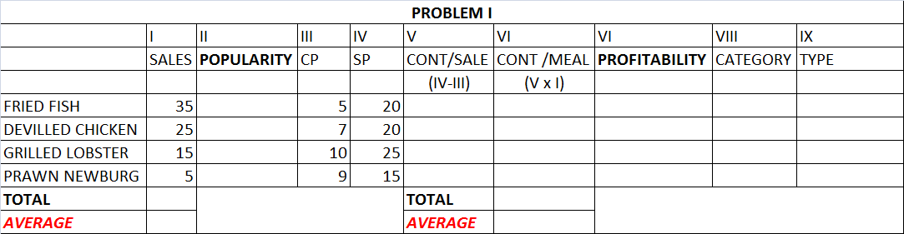

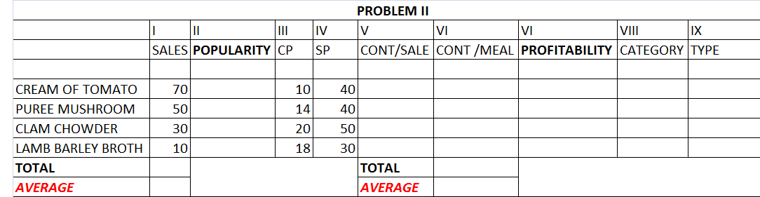

PREVIOUS YEARS’QUESTION PAPERS

- Define menu engineering. How are menu items categorized on the basis of menu engineering? (2017-18)
- Write short notes on Sales mix (2017-18)
- Define Menu Engineering. Explain how it helps in deciding the suitability of
- menu item on the menu card (2013-14)
- With the help of flow chart, how menu items are grouped upon the popularity amongst guest
- Define menu engineering. Illustrate classification of dishes based on menu engineering (2014-15)

UNIT 11: MANAGEMENT INFORMATION SYSTEM

The Management Information System( M.I.S) is defined as a computer based information system based on the databases of the organization, evolved with the purpose of providing information for better efficiency of the organization.
MIS is a system to support the decision making function in the hotel / organization. MIS contains information and can be used by the executives of the organization in various ways they deem it fit and useful. In the modern days, most of the time is taken in collecting data processing it, documenting and communicating to the executives of the organization.
The following points should be considered while collecting information, processing and documenting it for the use of the executives of the organization
- To be able to handle and store a large volume of data.
- To ensure the validity of data and transaction.
- To be able to process complex data and multi-dimensional analysis
- To be able to retrieve the information quickly and as and when required.
- To be able to communicate the information system to the user on time
- Fulfilling the changing needs of the information.
The role of the Management Information System in an organization is comparable to the role of heart in the body. The information is the blood and MIS is the heart. The heart supplies blood to the whole body. The MIS collects data from various sources and transmits to all the needy outlets / destinations like individuals, group of persons, management, etc. The MIS helps the office staff in the transaction
processing and answers their queries on the data pertaining to the transaction, the status of a particular record and references on the numerous documents. The MIS helps the junior management by providing them operational data for planning scheduling and control and this subsequently helps them in decision taking. The MIS helps the top management in goal setting, strategic planning and evolving the business plans and their implementation. The MIS, therefore. plays a vital role in the management, administration and operations of an organization.
PREVIOUS YEARS’ QUESTIONS
- What is MIS? Explain the various reports generated through MIS in Food &Beverage business. (2013-14)
- Define MIS. Explain the various reports generated through MIS. (2017-18)
- Define MIS and explain its role for a restaurant (2016-17)
- How restaurant sale summary sheet helps in controlling and evaluating restaurant sale? Explain (2016-17)
- Write short notes (any two) :( 2014-15)
(a) MIS
(b) Material variance
(c) POS
(d) Sales summary sheet

OLD QUESTION PAPERS

