**STRATEGIC MANAGEMENT**

LIST OF CONTENTS

|  |  |  |
| --- | --- | --- |
| A. | STUDENT REQUIREMENT | 2 |
| C. | SYLLABUS + TRAINING PLAN | 6 |
| E. | STUDENT NOTES/POWER POINT NOTES: |  |
|  | 1. **ORGANISATIONAL STRATEGY.**  2 **.ENVIRONMENTAL AND INTERNAL RESOURCE ANALYSIS.**  3 **.STRATEGY FORMULATION.**  4 **.STRATEGIC ANALYSIS AND CHOICE (ALLOCATION OF RESOURCES)**  5 **.POLICIES IN FUNCTIONAL AREAS.**  6 **.STRATEGIC IMPLEMENTATION REVIEW AND EVALUATION.** | 25  35  42  47  66  69 |
| F. | QUESTION PAPERS | 77 |

**REQUIREMENTS**

**STRATEGIC MANAGEMENT**

*Bound study material*:

Students shall be provided with printed handouts, spirally bound.

Students are encouraged to read up the recommended books and make their own notes.

Bound study material will be evaluated on content, presentation and promptness.

*Assignments*:

Assignments must be submitted on the date specified. Late submissions will not be evaluated.

*Evaluation*:

Evaluation test to reviews will be conducted periodically.

|  |  |  |
| --- | --- | --- |
| Internal tests | T E E | Total |
| 30 marks | 70 marks | 100 |

* Minimum pass marks 40 %

*Recommended reading*:

* Strategic management *by* srinivasan.
* Strategic management *by* John A and Richard B.
* Introduction to Corporate Strategy *by* Richard Patting
* Harward Business Review Journals.

SYLLABUS

&

TRAINING PLAN

|  |  |  |  |  |
| --- | --- | --- | --- | --- |
| **S.No.** | **Topic** | **Hours** | **Weight age** | **Date of**  **Accord** |
| 1 | **ORGANISATIONAL STRATEGY**  A. MISSION  • Mission Statement Elements and its importance  B. OBJECTIVES  • Necessity of formal objectives  • Objective Vs Goal  C. STRATEGY  • DEVELOPING STRATEGIES  - Adaptive Search  - Intuition search  - Strategic factors  - Picking Niches  - Entrepreneurial Approach | 04 | 15% |  |
| 2 | **ENVIRONMENTAL AND INTERNAL RESOURCE ANALYSIS**  A. NEED FOR ENVIRONMENTAL ANALYSIS  B. KEY ENVIRONMENTAL VARIABLE FACTORS C. OPPORTUNITIES AND THREATS  • Internal resource analysis  D. FUNCTIONAL AREAS RESOURCE DEVELOPMENT MATRIX E. STRENGTHS AND WEAKNESSES  • Marketing  • Finance  • Production  • Personnel  • Organisation | 05 | 15% |  |
| 3 | **STRATEGY FORMULATION**  A. STRATEGY (GENERAL) ALTERNATIVES  • Stability Strategies  • Expansion Strategies  • Retrench Strategies  • Combination Strategies  B. COMBINATION STRATEGIES  • Forward integration  • Backward integration  • Horizontal integration  • Market penetration  • Market development  • Product development  • Concentric diversification  • Conglomerate diversification  • Horizontal diversification  • Joint Venture | 08 | 25% |  |

|  |  |  |  |  |
| --- | --- | --- | --- | --- |
|  | • Retrenchment  • Divestitute  • Liquidation  • Combination |  |  |  |
| 4 | **STRATEGIC ANALYSIS AND CHOICE (ALLOCATION OF RESOURCES)**  A. FACTORS INFLUENCING CHOICE  • Strategy formulation  B. INPUT STAGE  • Internal factor evaluation matrix  • External factor evaluation matrix  • Competitive profile matrix  C. MATCHING STAGE  • Threats opportunities – weaknesses – strengths matrix (TOWS)  • Strategic position and action evaluation matrix (SPACE)  • Boston consulting group matrix (BCGM)  • Internal – External matrix  • Grand Strategy matrix  D. DECISION STAGE  • Quantitative Strategic Planning matrix (QSPM) | 06 | 20% |  |
| 5 | **POLICIES IN FUNCTIONAL AREAS**  A. POLICY  B. PRODUCT POLICIES  C. PERSONNEL POLICIES D. FINANCIAL POLICIES  E. MARKETING POLICIES  F. PUBLIC RELATION POLICIES | 03 | 10% |  |
| 6 | **STRATEGIC IMPLEMENTATION REVIEW AND EVALUATION**  A. MCKINSEY 7-S FRAMEWORK  B. LEADERSHIP AND MANAGEMENT STYLE  **C.** STRATEGY REVIEW AND EVALUATION  • Review underlying bases of Strategy  • Measure Organisational Performance  • Take corrective actions | 04 | 15% |  |
| **TOTAL** | | 30 | 100% |  |

STUDENT NOTES



**TOPIC 1: ORGANISATIONAL STRATEGY**

Strategic Management

The word strategy is derived from the Greek word “STRATEGIA” which means the art and science of directing the military forces.

Strategy is defined as a unified comprehensive and integrated plan of the firm to meet the challenges of the environment. The main challenges that the organizations face from the environment is competition. Competition is at the heart of strategy formulation and if competition is absent there would be no need for strategy. Hence strategy is a well thought out systematic plan of action to defend oneself or to defeat rivals. Strategy is formulated in anticipation of the possible positions, moves, actions and reactions of rivals.

What are strategies?

The typical business firm usually considers three types of strategy: Corporate, Business, and Functional.

1. Corporate strategy describes a company’s overall direction in terms of its general attitude toward growth and the management of its various businesses and product lines. Corporate strategy comprises of stability, growth, retrenchment.
2. Business strategy usually occurs at the business unit or product level, and it emphasizes improvement of the competitive position of a company’s products or services in the specific industry. Business strategies are composed of competitive and cooperative strategies. For E.g. Apple computer uses a differentiation competitive strategy that emphasizes innovative products with creative design. In contrast, British airways followed a cooperative strategy by forming an alliance with American Airlines in order to provide global service.
3. Functional strategy is the approach taken by a functional area, such as marketing or research and development, to achieve corporate and business unit objectives and strategies by maximizing resource productivity. It is concerned with a developing and nurturing a distinctive competence to provide a company or business unit with a competitive advantage. An E.g. of a functional strategy is America Online’s marketing strategy of saturating the entire market with a low priced product.

Hierarchy of strategy

Corporate Strategy

Business

(Division level)

Strategy



Business firms use all three types of strategy simultaneously. A hierarchy of strategy is the grouping of strategy types by level in the organization. This hierarchy of strategy shown in Figure is a nesting of one strategy within another so that they complement and support each other. Functional strategies support business strategies, which, inturn, support the corporate strategy.

What is strategic management?

It is that set of decisions and actions which leads to the development of an effective strategy or strategies to help achieve corporate objectives. The process of strategic management starts with the formulation of mission. Mission is the very purpose of the existence of the organization. The mission focuses on the purpose of the business and the employees should find it achievable and relatable. The mission of ISRO is to send Man to Moon and also Space Technology should benefit the society.

Therefore organizations today come out with mission statements.

MISSION STATEMENT

What is mission statement?

It is an enduring statement of purpose that distinguishes one business from other similar business of different firms. A mission statement reveals the long term vision of an organization of what it wants to be and whom it wants to serve in the distant future(A vision is a very long term imagined view of the organization as it might be in the future). The mission statement describes an organization’s purpose, customers, products or services, markets and the basic technology that is adopted by the organization. A mission statement is evolved through various meetings amongst the senior management team and after calling for suggestions from employees.

What are the elements of mission statements?

1. It must be clearly articulated: - It should be easy to understand so that the values and purpose of the organization are clear to everybody in the organization and will be a guide to them.
2. It must be relevant: - should be appropriate to the organization in terms of its history, culture, and shared values.
3. It must be current: - A mission statement may become obsolete after some time because of change in the environmental factors and organizational factors. Some companies have changed there mission statements several times. The factors which call for change in the mission statement are changes in the market, growth, diversification into new areas.
4. It must be written in a positive tone: - It must be capable of inspiring and encouraging commitment towards fulfilling the mission.
5. It must be unique: - It should establish the individuality if not the uniqueness of the company and its products of services.
6. It must be enduring: - It should continually guide and inspire and be challenging in the pursuit of its mission.
7. Adapted to the target audience: - The mission statement must be directed towards the consumers, general public, share holders, employees.

What is the importance of mission statement?

1. It provides a road to development and drive for growth.
2. It provides a clear sense of purpose , direction, and desired future state and when this image is widely shared individuals are able o find their own roles both in the organization and in the society.
3. Mission statement empowers individuals and confers status on employees because they see themselves as a apart of a worth while enterprise.
4. It results in a clear definition of the business of a company.
5. Mission statement helps in modifying, extending and developing the existing ongoing business.
6. A mission statement makes everybody imbibe the spirit and inspires employees.

Peter F Drucker: “without an effective statement there will be no performance it has to express the contribution the organization plans to make to the society, customer and to the economy.”

**Stakeholders and interested parties**

Stakeholders or interested parties of an organization are those affected by it and those who affect it . They hold varying types of degree of influence and interest in it, its product and services; it was of working, its standards and outcomes, its successes and its failures. They are as follows.

1. The staff: Everyone who works for and in the organisation and who is therefore dependent upon it for their income and spending power and , to a greater extent, for the standard and style of living.
2. The communities in which the staff lives and work and in which the organisation operates.
3. Social customers: for example, charities, schools and hospitality which may approach the organisation for sponsorship and support for social, educational, charitable or other worthy causes.
4. Shareholders: The investors of money in an organisation in the expectation and anticipation of returns.
5. Other financial interests including backers , contributors
6. Suppliers of components and raw materials: These have a vested interest in the success of the organisation in focus.

Customers and clients

The customers and clients of organizations are those who avail themselves of its product and services. A finer distinction may also be drawn as follows:

The customers are the one who pays for the offering; the clients are the one who uses it. The two may be the same (the driver who both pays for and uses the petrol for the car), or they may not be (the parent buys toys, the child uses them).

This also applies to public services and the not – for profit sector. In each case, continual focus on the client groups in question is critical to their effective operation, maximization and optimization of what are invariably scarce resources.

**OBJECTIVES**

What are objectives?

Objectives may be defined as those ends which the organization seeks to achieve by its existence and operations. What the organization seeks to achieved must be quantified and specific so that there is no confusion when one reaches there. The changes in the market environment, changes in the organizational factors like strength, weakness may call for modification of objectives.

What are the factors that affect objective?

1. Forces in the environment
2. Internal forces
3. The value system of top executives

Forces in the environment like the politics of the government, competition, and change in customer preference of products / services affect objectives.

Internal forces like employer – employee relation, technology adopted by the organization, commitment of the top management and its employees.

The value system of the top Executives like there social and moral responsibilities to the customer, shareholders, societies etc.

Necessity of formal objectives( remember acronym: SMS CODE)

1. Strategy Plans: Objectives help strategy planning and thus help effective functioning of the organizations in a given environment
2. Management by objective: Clearly formulated objectives form the basis for the management to manage the organization by objectives so that the desired objectives are achieved.
3. Standards for assessments and control: By making clear the objectives what the results should be provided the basis for control and assessment of organizational performance.
4. Coordination: Objectives help coordinate decision and decision makers. It reduces conflict in decision making.
5. Organization: Objectives indicate the purpose and aim of the organization there by justifying its existence.
6. Decentralization: Objectives help decentralization, i.e., objectives when assigned to lower level employees in the organization it helps faster decision making.
7. Efficiency: Objectives help in the overall efficiency of the organization thereby helping the organization for the achievement of the strategies or strategic plans.

*Examples of objectives:*Objectives must be achievable and materially quantifiable.

Profit objective: To increase profits from Rs.10.00 lakh today to 80.00 lakhs ten years hence.

Marketing objective: To increase total company sales by 10% annually to reach Rs. 22.00 lakhs 10 years from now.

Hierarchy of objectives

Corporate Level objectives

Unit Level objectives

Department objectives

Individual objectives

Corporate level objective form the overall objectives of the organization which are long range. It is formulated and pursued by the top management, Board of Directors and the top most managers.

Unit level objectives: - These objectives of the strategic business unit (SBU) form the next level.

Department level objective: - These are the objectives of the different departments like production, marketing, finance, personal, research and development which will help the unit level objective which in turn would help the corporate objective.

Individual objectives: - A department may have several sections under it. Each section has several personnel responsible for the achievement of the department objectives. E.g.: A salesman in a marketing division will have to achieve specific objectives like sales targets.

**GOALS**

***CASE FOR STUDENTS: Objectives and goal setting at Canara Bank***

*B. Ratnakar, ex-chairman of Canara Bank, on being interviewed by Business World just before completing his six-year term, expressed the purpose of his organisation as: “Our mission is to be the most competitive and progressive institution in our(i.e.banking) industry.” The bank’s stated objectives are: “growth, innovativeness, high profits as a barometer of efficiency, highly involved employees distinctively charged with pride…”*

*During his six-year successful tenure, Ratnakar has attempted to achieve the above objectives in a number of ways.*

* *Growth has been achieved in terms of customers (20.4million), reserves (Rs 200 crore), average business per employee (Rs 21.78lakh), deposits per branch (Rs3.4 crore) and priority sector lending (47 per cent of net credit against an industry norm of only 40 per cent). All figures relate to 1987.*
* *Innovativeness is reflected in a number of new schemes like mutual funds such as Canstock and Canshare, and setting up of Canbank Financial Services Ltd, for merchant banking and portfolio management.*
* *High profits of Rs 45 crore in 1987; the highest among all public sector banks and nearly equal to that of the industry leader, State Bank of India.*
* *Employee involvement has been sought through delegation of authority and devolution of power to grassroot levels through a change in administrative structure and the creation of circle and branch management boards.*

*Observe from the above that bank’s purpose is supported by objectives, which in turn are achieved through goals that are measurable.*

DIFFERENTIATE BETWEEN OBJECTIVES AND GOALS:

|  |  |
| --- | --- |
|  |  |
|  |  |
|  |  |
|  |  |
|  |  |
|  |  |
|  |  |
|  |  |

AN ILLUSTRATION OF OBJECTIVES AND GOALS:

|  |  |
| --- | --- |
| EXAMPLE OF OBJECTIVES | EXAMPLE OF OBJECTIVE CONVERTED TO GOALS |
| To improve efficiency of factory | Reduce shut down 10% monthly |
| To improve the profitability of the outlet | Improve nteprofit to 12 % from current 10% |
| To promote growth of the chain of hotels | Add 250 keys this year to the chain |
| To contribute to the wealth of shareholders | Pay ---% of dividend |
| To ensure optimal use of resources | Improve return on investment by 5% this financial year |
| To contribute to employee welfare | Annual increment ,P L I,etc |
| To promote towards welfare of society | Construction of bus stands,wells,etc. this budgeted year |
| To be leaders in technology and knowhow | Innovative technologies the operational year. |

**STRATEGIES: DEVELOPING STRATEGIES**

Many strategies are developed for the long run future of the organization. Strategic decision is made by the CEO who has a brilliant insight and is quickly able to convince others in the organization to follow the idea. Some typical approaches are the following.

*Adaptive search*: As per this approach an appropriate solution to a problem is formulated by moving in incremental steps for many years. Eureka Forbes door to door selling of its water purifier to the customer to sell its products in the market is an example of adaptive search. This product will not sell unless there is door to door selling.

*Intuition search:* As per this approach the executive uses his institution for strategy development. It comes out of his instinct. He thinks without any data available but his experience in the field matters. He is very keen and ha quick insight.

*Strategic factors:* Under this approach the CEO looks out for various critical factors in the organization – like the various SBUs and its business in terms of its strengths and weakness that would determine the success or future of the organization.

*Picking niches:*

A Niche is a product / service suitable for a segment of customers. For e.g. A company manufactured a machine for smoothing ice for ice skating which earlier was done manually. No company has found a substitute. This company has found a niche in the business world. The customers are clearly defined and the products are unique.

*Entrepreneurial approach*: In this approach the strategy is developed by one powerful individual. The focus is on opportunity and the problems are secondary. The strategy is pushed ahead and the power rests with one man who is capable of taking bold decision.

* * *

**MAIN QUESTIONS:**

1. Define strategic management. State the elements involved.

|  |
| --- |
|  |
|  |
|  |
|  |
|  |

1. Explain the various approaches to developing strategies.

|  |
| --- |
|  |
|  |
|  |
|  |
|  |

1. What is the importance of setting strategic objectives?

|  |
| --- |
|  |
|  |
|  |
|  |
|  |

1. Distinguish between
   1. vision and mission
   2. objectives and goals

|  |
| --- |
|  |
|  |
|  |
|  |
|  |

1. What are characteristics of mission statement?

Or

What is the scope of a mission statement?

|  |
| --- |
|  |
|  |
|  |
|  |
|  |
|  |

**CHAPTER 2.ENVIRONMENTAL AND INTERNAL RESOURCE ANALYSIS**

Business decisions are influences by two sets of factors viz internal factors (the internal environment) and external factors (external environment).

*The methods and techniques employed by an organization to monitor the environment and to gather data to decisive information about the opportunities and threats that affect their business and the process by which organizations monitor their environment is known as environmental analysis.*

Environmental analysis is defined as the process by which strategic managers monitor economic, governmental, legal, market, technological, demographic and social settings to determine opportunities and threats to their firms.

***PESTLE ANALYSIS:Key external Variable factors***

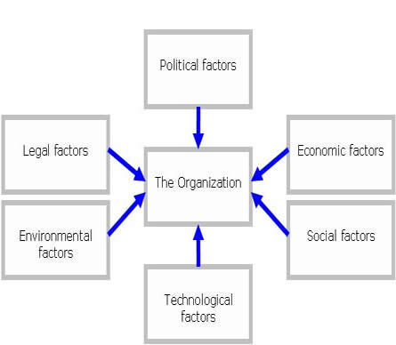

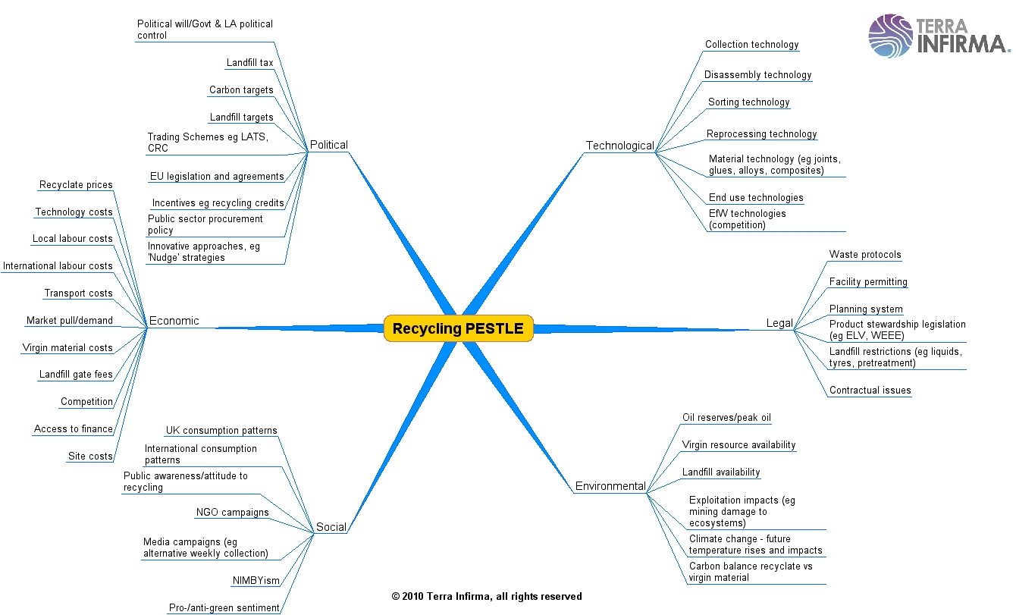

*Political Environment*:

Government policies also impact the business climate of a country. The recent policy of Globalization of the Indian economy, liberalization etc has created a good climate for private sector investment in the country several laws are enacted to protect companies from each other by preventing unfair competition. Some laws are intended to protect workers, consumers and communities from business firms.

The political atmosphere of the country is significantly relevant to business organizations. No business can think of expanding a diversifying its activity if the political atmosphere is unstable and in turmoil.

*Economic Environment:*

In recent years, the degree of competition in the world has increased tremendously. Costs controlled are profits earned. Market share of the competitors, pricing of product general level of profits are factors that affect a company’s product / service. In analyzing the competitive environment, it should be the prime concern of the management to find out if there is a minimum market share of its product in relation to its competitors.

*Social environment*:

Demographic factors like the size of the population, age composition, sex composition, educational levels, language, caste, and religion etc are all factors which are relevant to business. E.g., a rapidly increasing population indicates a growing demand for many products.

The social changes occur gradually. The social environment consists for factors related to the consumption habits of the people, customs and traditions, tastes, preferences. People of varied culture use products in different ways. E.g.: Rice, wheat, etc are consumed by people by cooking it in different methods etc. Hence the buying and consumption habits differ from culture to culture.

*Natural Environment:*

Geographical and ecological factors such as natural resources weather and climatic location are all relevant to business. Climate and weather conditions affect the location of certain industries.

**“PESTLE ANALYSIS”**

|  |  |
| --- | --- |
| POLITICAL   * Regulatory bodies and processes * Government policies * Government term and change * Trading policies * Funding, grants and initiatives * Home market lobbying/pressure groups * International pressure groups * Wars and conflicts/terrorism. | ECONOMIC   * Home economy situation/Growth * Home economy trends * Overseas economies and trends * General taxation issues * Level of savings * Industry properties * Taxation specific to product/services * Market and trade cycles * Specific industry factors * Market routes and distribution trends * Customer/end-user drivers * Interest and exchange rates |
| SOCIAL   * Lifestyle trends * Demographics * Consumer attitudes and opinions * Media views * Brand, company, technology image * Consumer buying patterns * Fashion and role models * Major events and influences * Buying access and trends * Ethnic/religious factors * Advertising and publicity | TECHNOLOGICAL   * Competing technology development * Research funding * Associated/dependent technologies * Replacement technology/solutions * Maturity of technology * Manufacturing maturity and capacity * Information and communications * Consumer buying mechanisms/technology * Innovation potential * Global communications |
| LEGAL   * Current legislation home market * Future legislation * International legislation * Law changes affecting social factors * Technology legislation * Technology access, licensing, patents * Intellectual property issues | ECOLOGICAL   * Weather/climate * Sustainability? * Ecological/environmental issues * Ethical issues |

**“SWOT ANALYSIS”**

SWOT is an acronym for the internal ***strengths*** and ***weaknesses*** of business and environmental ***opportunities*** and ***threats*** facing that business. SWOT analysis is a systematic identification of the factors and the strategy that reflects the best match between them. It is based on the logic that an effective strategy maximizes the business’s strengths and opportunities but at the same time minimizes its weaknesses threats.

Strengths Strength is a resource, skill or other advantage relative to competitor’s and the needs of the markets and organization serves or anticipates serving. Strength is a distinctive competence that gives leadership, and buyer-supplier relations are examples.

Weaknesses A weakness is a limitation or deficiency in resources, skills, and capabilities that serious impedes effective performance. Facilities, financial resources, management capabilities, marketing skills and brand image could be sources of weaknesses. Understanding the key strengths and weaknesses of an organization in narrowing the choice of alternatives and selective a strategy. Distinct competence and critical weakness are identified in relation to key determinants of successes for different market segments; this provides a useful framework for making the best strategic choice.

Opportunities An opportunity is a major favorable situation in an organization’s environment. Identification of a previously over looked marketing segment, changes in competitive or regulatory circumstances, technological changes, and improved buyer or supplies relationships could represent major opportunities

Threats A threat is a major unfavorable situation in an organization’s environment. The entrance of a new competitor, slow market, growth, increased bargaining power of key buyers or suppliers, major technological change, and changing regulations could represent major threats to an organization’s success.

|  |  |
| --- | --- |
| **STRENGTHS** | **WEAKNESS** |
| * Strong brand image | * Poor brand image |
| * Strong distribution network | * Weak distribution network |
| * Deep product mix | * Narrow product mix |
| * High quality product | * Low product quality |
| **OPPORTUNITIES** | **THREATS** |
| * Large and growing market | * Fierce international competition |
| * Delicensing and import liberalization | * Prices down, cost of production up |
| * Advantage of a good product range | * High job attrition(employees leaving) rates |
| * Economic boom | * Political instability |
| * Fast increase in income of people | * Economic recession |

**S W O T** **analysis** studies important factor that affects the performance of the company is the forces that constitute the company’s immediate environment. They include some factors like:

Physical assets and facilities: Like capital equipment production capacity, technology, logistics etc

R & D and technological capabilities: Like ability to innovate and compete.

Marketing Resources: like brand, image, good distribution network etc.

Financial factors: like financial policies, financial position, capital structure etc.

Human Resources: like skill, morale, attitude, commitment etc.

Finance:

|  |  |
| --- | --- |
| 1.High credit rating | 1. Low credit rating |
| Large amount of internally accrued money | 2. Poor receivables management |

Production:

|  |  |
| --- | --- |
| 1.State of the art of technology | 1. Obsolete technology |
| 2. Strong R & D support | 2.No R & D support |
| 3.Efficient inventory management | 3. Poor inventory management |

Personnel:

|  |  |
| --- | --- |
| 1.Qualified and experienced human resource | 1.Unqualified & inexperienced work force |
| 2. Good industrial relations | 2. Poor industrial relations |
| 3. Motivated Human resources. | 3. Low morale work force. |

Organization:

|  |  |
| --- | --- |
| 1. Efficient Board of directors | 1. Inefficient board of directors |
| 2. Efficient and motivated managers | 2. Conflict between managers. |

* * *

**MAIN QUESTIONS:**

1. Define Environment. State the types.

Or

What is Environment Scanning?

|  |
| --- |
|  |
|  |
|  |
|  |
|  |
|  |
|  |

1. Explain the components of External Environment.

|  |
| --- |
|  |
|  |
|  |
|  |
|  |
|  |
|  |
|  |

1. Throw light on SWOT analysis.

Or

What are the factors that affect the dynamics of Internal Environment?

|  |
| --- |
|  |
|  |
|  |
|  |
|  |
|  |

**CHAPTER 3. STRATEGY FORMULATION**

Strategic alternatives evolve and revolve around the question of whether a company must continue or change the business which it is currently doing or improve the efficiency and effectiveness with which the firm achieves its corporate objectives in its chosen business sector……

According to GLUECK, there are four grand strategic alternatives which are *stability, expansion, retrenchment* and any *combination* of these three. These strategic alternatives are termed as *grand strategies* or *basic strategies* or *generic strategies.*

**GRAND STRATEGIES OF GLUECK**

1. *Stability strategy*

It involves incremental improvement in functional performance in terms of customer groups in order to remain successful in business.

E.g. A photocopier machine company provides better after sales service to its existing customer groups to improve its company and product image and increase sales of accessories and consumables.

2. *Expansion strategy*

When a company substantially broadens the scope of its customer groups in order to improve its performance either singly or jointly with another firm. E.g. A printing firm changes from the traditional letter press printing to desktop publishing in order to increase its production and efficiency.

3. *Retrenchment strategy*

When a company substantially reduces the scope of its customer groups in order to improve its performance either singly or jointly.

E.g. A corporate hospital decides to focus only on specialty treatment and realize higher revenues by reducing its commitment to general cases which are typically less profitable to deal with.

4. *Combination strategy*

When a company adopts a mixture of stability, expansion and retrenchment either at the same time in its different business or at different times in the same business with the aim of improving its performance.

E.g. a paint company continues to offer decorative paints to provide a wider variety to its customers (stability) and expands its product range to include industrial and automotive paints (expansion) simultaneously it decides to close down the division which undertakes large scale painting jobs (retrenchment).

**COMBINATION STRATEGIES**

***Horizontal integration***

In order to eliminate or reduce competition some companies acquire one or more competitors which is known as horizontal integration.

E.g. a) Hindustan lever acquires Tata oil mills company “TOMCO”

b) Jet airways acquires SAHARA AIR

c) VIP acquires ARISTOCRAT LUGGAGE.

***Backward integration***

Some companies acquire / purchase business that supplies them with raw materials or inputs.

E.g. a) A restaurant purchasing a bakery

b) A detergent manufacturer taking up the manufacturer of LAB which is a raw material for the manufacture of detergents. This is being done by NIRMA.

***Forward integration***

When a company involves taking up of activities that will bring the company nearer to the ultimate customer.

E.g. a) The manufacturer of the raw material (LAB) for detergents takes up the manufacture of the finished products.

b) A hotel acquiring a chain of travel agents.

***Market penetration***

Market penetration strategy strives to increase the sale of the current products in the current market. Company follows the methods given below.

1. Increase sales to the current customers. E.g. If customers of tooth paste who brush once a day now, habituate to brush twice a day, the sale of the product to the current customers would almost double.
2. Pull customers from the competitor’s products. E.g. a) if the customers switch from the competitors brands to the company’s brand while maintaining its existing customers intact there will be an increase in the company’s sales. b) a television company offering additional guarantee for two years

c) Convert non users into users

If there is a significant no of non users of a product who could be made users of the product, that provides a potential opportunity or increasing the sales. E.g. In India there are a large no of people in the rural areas who do not use tooth paste these people could be encouraged to start using the product. Babool toothpaste mainly targeted the first time users of toothpaste.

***Market development strategy***

A company broadening the market for a product by entering into anew geographical areas i.e., Regional Expansion, Natural Expansion and Industrial Expansion. Some companies add new channels of distribution and there by expanding the consumer reach of the product.

E.g. Hindustan Lever has entered new geographical markets, added new channels of distribution and also entered new market segments.

***Product development strategy***

A company may be able to increase its current business by product improvement or introducing products with new features.

E.g. Japan Company SONY keeps up the sale of their consumer goods through continuous feature improvements.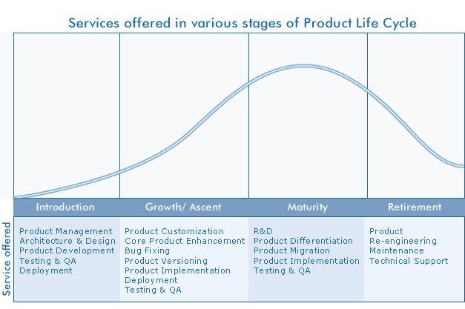

***concentric diversifiction***

When a company takes up an activity in such a manner that it is related to its existing business then it is called concentric diversification

E.g. Rain coat manufacturer makes other rubber based products like water proof shoes. Rubber gloves and selling the same through the same retail outlets.

***Conglomerate diversification***

When a company adopts a strategy by taking up those activities which are unrelated to its existing business then it’s called as conglomerate diversification.

E.g. ITC a cigarette company diversifying into a hotel industry.

***Horizontal diversification***

When a company introduces a new product which is technologically unrelated to the current product line but which has appeal to its current customers then it’s called horizontal diversification.

E.g. Camlin which is famous for stationary products has come out with stitching and fabric painting materials.

***Joint venture***

When two or more independent firms mutually decide to participate in a business in a venture contribute to total equity capital and establish a new organization. It’s known as a joint venture.

E.g. a) Haldia petrochemicals (West Bengal govt and R.P. Goenka group)

b) Nagarjuna fertilizers (AP GOVT & Nagarjuna group)

***Divestiture***

When a company sells or divests itself of a business or a part of a business because of lose, less target rate of return urgency to mobilize funds, managerial problems etc it takes up the divestiture strategy.

***Liquidation***

When an entire company is sold or dissolves of loss or other problems like the case of divestiture then it is called as liquidation.

* * *

**MAIN QUESTIONS:**

1. List *GLUECKS* four grand strategies and explain in detail.

|  |
| --- |
|  |
|  |
|  |
|  |
|  |
|  |
|  |

1. Distinguish between
2. Forward and Backward Integration.
3. Market Development and Product Development.
4. Liquidation and Divestiture.
5. Joint Venture and Merger.

|  |
| --- |
|  |
|  |
|  |
|  |
|  |
|  |
|  |
|  |

1. Define combination strategy. List examples.

|  |
| --- |
|  |
|  |
|  |
|  |
|  |
|  |
|  |

1. Diversification is a popular strategy. Throw light on the types of diversification.

|  |
| --- |
|  |
|  |
|  |
|  |
|  |
|  |
|  |
|  |

1. Define joint venture. What are the gains of joint venture?

|  |
| --- |
|  |
|  |
|  |
|  |
|  |
|  |
|  |

1. What is Modernization strategy?

|  |
| --- |
|  |
|  |
|  |
|  |
|  |
|  |
|  |

**CHAPTER 3. STRATEGIC ANALYSIS AND CHOICE**

**(ALLOCATION OF RESOURCES)**

Strategy Analysis and Choice is a process that reconciles strategic actions, market opportunities, corporate strengths and resources, values of managers, and legal requirements and social responsibilities to select a "best" mission, strategic thrust, and set of strategic actions.

Strategy formulating techniques can be integrated into a three-stage decision making frame work.

MATCH STAGE

INPUT STAGE

DECISIVE STAGE

**INTERNAL FACTOR EVALUATION MATRIX (IFE)**

**Internal Factor Evaluation (IFE) matrix** is a strategic management tool for auditing or evaluating major strengths and weaknesses in functional areas of a business.

The **IFE Matrix** together with the [EFE matrix](http://www.maxi-pedia.com/EFE+matrix+external) is a strategy-formulation tool that can be utilized to evaluate how a company is performing in regards to identified internal strengths and weaknesses of a company. The IFE matrix method conceptually relates to the [Balanced Scorecard](http://www.maxi-pedia.com/balanced+scorecard+method+what+is) method.

#### How to create the IFE matrix?

The IFE matrix can be created using the following five steps:

1. *Key internal factors...*

Conduct internal audit and identify both strengths and weaknesses in all your business areas. Identify 10 to 20 internal factors, but the more you can provide for the IFE matrix, the better. It is wise to be as specific and objective as possible. (You can for example, express in percentages, ratios, and comparative numbers.)

1. *Weights...*

 Having identified strengths and weaknesses, the core of the IFE matrix, assign a weight that ranges from 0 to 100 scale .After you assign weight to individual factors, make sure the sum of all weights equals 100.

The weight assigned to a given factor indicates the relative importance of the factor to being successful in the firm's industry. *Weights are industry based.*

1. *Rating...*

Assign a 1 to 4 rating to each factor. Your rating scale can be per your preference. If you use the rating scale 1 to 4, then strengths must receive a 4 or 3 rating and weaknesses must receive a 1 or 2 rating.

Rating 1=a major weakness.

Rating 2 = a minor weakness.

Rating 3=a minor strength.

Rating 4= a major strength.

*Note: the weights determined in the previous step are industry based. Ratings are company based.*

1. *Multiply...*

Now we can get to the IFE matrix math. Multiply each factor's weight by its rating. This will give you a weighted score for each factor.

1. *Sum...*

The last step in constructing the IFE matrix is to sum the weighted scores for each factor. This provides the total weighted score for your business.

#### **Example of IFE matrix**

The following table provides an example of an **IFE matrix**.

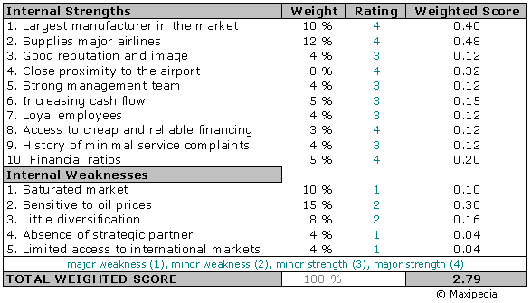

Weights times ratings equal weighted score.

#### What values does the IFE matrix take?

Regardless of how many factors are included in an IFE Matrix, the total weighted score can range from a low of 1.0 to a high of 4.0 (assuming you used the 1 to 4 rating scale). The average score you can possibly get is 2.5.Total weighted scores well below 2.5 point to internally weak business. Scores significantly above 2.5 indicate a strong internal position.

It is important to note that a thorough understanding of individual factors included in the IFE matrix is still more important than the actual numbers.

**EXTERNAL FACTOR EVALUATION MATRIX (EFE)**

**External Factor Evaluation (EFE) matrix** method is a strategic-management tool often used for assessment of current business conditions. *The EFE matrix is a good tool to visualize and prioritize the opportunities and threats that a business is facing.*

The EFE matrix is very similar to the [IFE matrix](http://www.maxi-pedia.com/IFE+EFE+matrix+internal+factor+evaluation). The major difference between the EFE matrix and the IFE matrix is the type of factors that are included in the model. While the IFE matrix deals with internal factors, the EFE matrix is concerned solely with external factors.

External factors assessed in the EFE matrix are the ones that are subjected to the will of social, economic, political, legal, and other external forces.

#### How to create the EFE matrix?

1. ***List factors…..***

The first step is to gather a list of external factors. Divide factors into two groups: opportunities and threats.

1. ***Assign weights………***

Assign a weight to each factor. The value of each weight should be between 0 and 100. The total value of all weights together should equal 1 or 100.

1. ***Rate factors…..***

Assign a rating to each factor. Rating should be between 1 and 4. Rating indicates how effective the firm’s current strategies respond to the factor. 1 = the response is poor.

2 = the response is below average.

3 = above average.

4 = superior.

*Note: the weights determined in the previous step are industry based. Ratings are company based.*

1. ***Multiply weights by ratings…..***

Multiply each factor weight with its rating. This will calculate the weighted score for each factor.

1. ***Total all weighted scores….***

Add all weighted scores for each factor. This will calculate the **total weighted score** for the company.

#### **EFE matrix example**

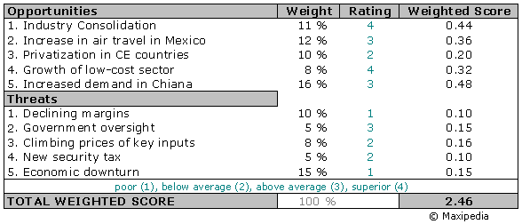

Total weighted score of 2.46 indicates that the business has slightly less than average ability to respond to external factors.

#### What should I include in the EFE matrix?

Now that we know how to construct or create the EFE matrix, let's focus on factors. External factors can be grouped into the following groups:

* Social, cultural, demographic, and environmental variables:
* Economic variables
* Political, government, business trends, and legal variables

Below you can find examples of some factors that capture aspects external to your business. (Not all apply to a business, but one can use this listing as a starting point...)

- Aging population, Per-capita income, Education  
- Trends in housing, shopping, careers, business  
- Number of births and/or deaths  
- Immigration & emigration rates

Economic factors...

- Growth of the economy  
- Level of savings, investments, and capital spending  
- Inflation  
- Foreign exchange rates  
- Stock market trends  
- - Product life cycle ………..etc

# COMPETITIVE MATRIX

**Definition: A chart that compares your product or service to your competitor(s)**

A competitive matrix is an analysis tool that helps you establish your company's competitive advantage. It provides an easy-to-read portrait of your competitive landscape and your position in the marketplace. The matrix can be just a simple chart. In the left column, you list the main features and benefits of your product or service. On the top row, you list your company and the names of your competitors. Then fill in the chart with the appropriate information for each company. For example, if you own a dry cleaning service, you might list the different services you offer or the quick turnaround you provide on items (24 hours), and then note how your competitors fail at these features.

The matrix can be shared with customers as a sales tool, or you can develop the matrix solely for in-house purposes to keep abreast of the competition.

**Internal-External (IE) matrix**

The **Internal-External (IE) matrix** is another strategic management tool used to analyze working conditions and strategic position of a business. The Internal External Matrix or short IE matrix is based on an analysis of internal and external business factors which are combined into one suggestive model.

The IE matrix is a continuation of the [EFE matrix](http://www.maxi-pedia.com/EFE+matrix+external) and [IFE matrix](http://www.maxi-pedia.com/IFE+EFE+matrix+internal+factor+evaluation) models.

How does the Internal-External IE matrix work?

The IE matrix belongs to the group of strategic portfolio management tools. In a similar manner like the [BCG matrix](http://www.maxi-pedia.com/BCG+matrix+model), the IE matrix positions an organization into a nine cell matrix.

The IE matrix is based on the following two criteria:

1. Score from the **EFE matrix** -- this score is plotted on the y-axis
2. Score from the **IFE matrix** -- plotted on the x-axis

The IE matrix works in a way that you plot the **total weighted score** from the EFE matrix on the y axis and draw a horizontal line across the plane. Then you take the score calculated in the IFE matrix, plot it on the x axis, and draw a vertical line across the plane. The point where your horizontal line meets your vertical line is the determinant of your strategy. This point shows the strategy that your company should follow.

On the x axis of the IE Matrix, an IFE total weighted score of 1.0 to 1.99 represents a weak internal position. A score of 2.0 to 2.99 is considered average. A score of 3.0 to 4.0 is strong.

On the y axis, an EFE total weighted score of 1.0 to 1.99 is considered low. A score of 2.0 to 2.99 is medium. A score of 3.0 to 4.0 is high.

IE matrix example...

Let us take a look at an example. We calculated IFE matrix for an anonymous company on the [IFE matrix](http://www.maxi-pedia.com/IFE+EFE+matrix+internal+factor+evaluation) page. The total weighted score calculated on this page is 2.79 which points at a company with an above-average internal strength.

We also calculated the EFE matrix for the same company on the [EFE matrix](http://www.maxi-pedia.com/EFE+matrix+external) page. The total weighted score calculated for the EFE matrix is 2.46 which suggests a slightly less than average ability to respond to external factors.

Now we plot these values on axes in the IE matrix.

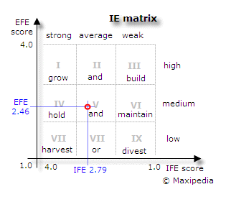

This IE matrix tells us that our company should *hold and maintain* its position. The company should pursue strategies focused on increasing market penetration and product development

What does the IE matrix tell me?

Your horizontal and vertical lines meet in one of the nine cells in the IE matrix. You should follow a strategy depending on in which cell those lines intersect.

The IE matrix can be divided into **three** major regions that have different strategy implications.

Cells I, II, and III suggest the **grow and build strategy**. This means intensive and aggressive tactical strategies. Your strategies should focus on market penetration, market development, and product development. From the operational perspective, a backward integration, forward integration, and horizontal integration should also be considered.

Cells IV, V, and VI suggest the **hold and maintain strategy**. In this case, your tactical strategies should focus on market penetration and product development.

Cells VII, VIII, and IX are characterized with the **harvest or exit strategy**. If costs for rejuvenating the business are low, then it should be attempted to revitalize the business. In other cases, aggressive cost management is a way to play the end game.

**“TOWS” matrix**

A TOW is inverted SWOT …… An acronym for the internal ***strengths*** and ***weaknesses*** of business and environmental ***opportunities*** and ***threats*** facing that business. TOWS or SWOT analysis is a systematic identification of the factors and the strategy that reflects the best match between them. It is based on the logic that an effective strategy maximizes the business’s strengths and opportunities but at the same time minimizes its weaknesses threats.

|  |  |  |
| --- | --- | --- |
|  | Internal strengths(S)  ………………………………  ………………………………  ……………………………… | Internal weakness (W)  …………………………….  …………………………….  ……………………………. |
| Externalopportunities(O)  ……………………………  ……………………………  …………………………… | SO (Maxi- Maxi) Strategy  (maximize strengths and opportunities) | WO(Mini-Mini) Strategy  (minimize weakness and maximize opportunities) |
| External Threats(T)  ……………………………  ……………………………  …………………………… | ST (Maxi- Maxi) Strategy  (maximize strengths and opportunities) | WT (Mini – Mini) Strategy  (minimize weakness and threats) |

**SPACE MATRIX**

The **SPACE matrix** is a management tool used to analyze a company. It is used to determine what type of a strategy a company should undertake.

The **Strategic Position & ACtion Evaluation matrix** or short a *SPACE matrix* is a strategic management tool that focuses on strategy formulation especially as related to the competitive position of an organization.

What is the SPACE matrix strategic management method?

To explain how the SPACE matrix works, it is best to reverse-engineer it. First, let's take a look at what the outcome of a SPACE matrix analysis can be, take a look at the picture below. The SPACE matrix is broken down to four quadrants where each quadrant suggests a different type or a nature of a strategy:

* Aggressive
* Conservative
* Defensive
* Competitive

This is what a completed SPACE matrix looks like:

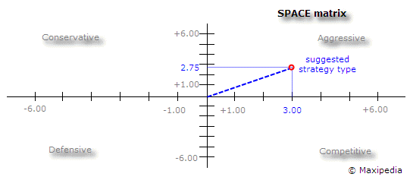

This particular SPACE matrix tells us that our company should pursue an *aggressive strategy*. Our company has a strong competitive position it the market with rapid growth. It needs to use its internal strengths to develop a market penetration and market development strategy. This can include product development, integration with other companies, acquisition of competitors, and so on.

Now, how do we get to the possible outcomes shown in the SPACE matrix? The SPACE Matrix analysis functions upon two internal and two external strategic dimensions in order to determine the organization's strategic posture in the industry. The SPACE matrix is based on four areas of analysis.

Internal strategic dimensions:

          Financial strength (FS)

          Competitive advantage (CA)

External strategic dimensions:

          Environmental stability (ES)

          Industry strength (IS)

There are many SPACE matrix factors under the **internal strategic dimension**. These factors analyze a business internal strategic position. The financial strength factors often come from company accounting. These SPACE matrix factors can include for example return on investment, leverage, turnover, liquidity, working capital, cash flow, and others. Competitive advantage factors include for example the speed of innovation by the company, market niche position, customer loyalty, product quality, market share, [product life cycle](http://www.maxi-pedia.com/product+life+cycle+plc), and others.

Every business is also affected by the environment in which it operates. SPACE matrix factors related to business **external strategic dimension** are for example overall economic condition, GDP growth, inflation, price elasticity, technology, barriers to entry, competitive pressures, industry growth potential, and others.

The SPACE matrix calculates the importance of each of these dimensions and places them on a Cartesian graph with X and Y coordinates.

The following are a few model technical assumptions:

* By definition,CA and IS values in SPACE matrix are plotted on X axis.
* CA values can range from -1 to -6.
* IS values can take +1 to +6.
* The FS and ES dimensions of the model are plotted on the Y axis.
* ES values can be between -1 and -6.
* FS values range from +1 to +6.

How do I construct a SPACE matrix?

The SPACE matrix is constructed by plotting calculated values for the competitive advantage (CA) and industry strength (IS) dimensions on the X axis. The Y axis is based on the environmental stability (ES) and financial strength (FS) dimensions. The SPACE matrix can be created using the following seven steps:

Step 1: Choose a set of variables to be used to gauge the competitive advantage (CA), industry strength (IS), environmental stability (ES), and financial strength (FS).

Step 2: Rate individual factors using rating system specific to each dimension. Rate competitive advantage (CA) and environmental stability (ES) using rating scale from -6 (worst) to -1 (best). Rate industry strength (IS) and financial strength (FS) using rating scale from +1 (worst) to +6 (best).

Step 3: Find the *average scores* for competitive advantage (CA), industry strength (IS), environmental stability (ES), and financial strength (FS).

Step 4: Plot values from step 3 for each dimension on the SPACE matrix on the appropriate axis.

Step 5: Add the average score for the competitive advantage (CA) and industry strength (IS) dimensions. This will be your final point on axis X on the SPACE matrix.

Step 6: Add the average score for the SPACE matrix environmental stability (ES) and financial strength (FS) dimensions to find your final point on the axis Y.

Step 7: Find intersection of your X and Y points. Draw a line from the center of the SPACE matrix to your point. This line reveals the *type of strategy the company should pursue*.

SPACE matrix example

The following table shows what values were used to create the SPACE matrix displayed above.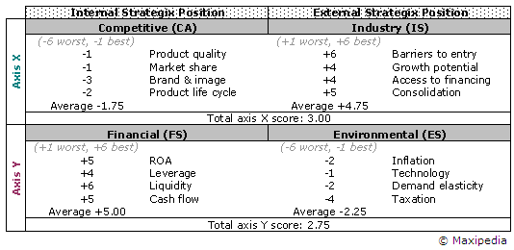

Each factor within each strategic dimension is rated using appropriate rating scale. Then averages are calculated. Adding individual strategic dimension averages provides values that are plotted on the axis X and Y.

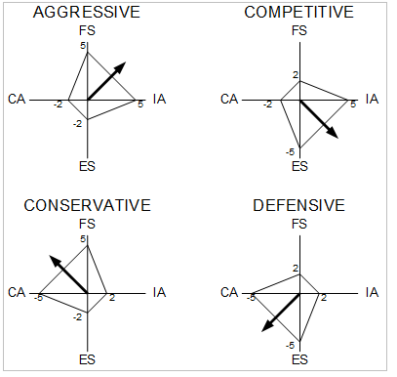

|  |
| --- |
| **BOSTON CONSULTING GROUP (BCG) MATRIX**  **Boston Consulting Group (BCG) Matrix** is a four celled matrix (a 2 * 2 matrix) developed by BCG, USA. It is the most renowned corporate portfolio analysis tool. It provides a graphic representation for an organization to examine different businesses in its portfolio on the basis of their related market share and industry growth rates. It is a two dimensional analysis on management of SBU’s (Strategic Business Units). In other words, it is a comparative analysis of business potential and the evaluation of environment.  According to this matrix, business could be classified as high or low according to their industry growth rate and relative market share.  **Relative Market Share** = SBU Sales this year-leading competitors sales.  **Market Growth Rate** = Industry sales this year - Industry Sales last year. |

BCG matrix has four cells, with the horizontal axis representing relative market share and the vertical axis denoting market growth rate. using the Boston Consulting Group approach, a company classifies all its SBUs according to the growth-share matrix. By dividing the growth-share matrix as indicated, four types of SBUs can be distinguished:

1. **Stars-** Stars represent business units having large market share in a fast growing industry. They may generate cash but because of fast growing market, stars require huge investments to maintain their lead. Net cash flow is usually modest. SBU’s located in this cell are attractive as they are located in a robust industry and these business units are highly competitive in the industry. If successful, a star will become a cash cow when the industry matures.
2. **Cash Cows-** Cash Cows represents business units having a large market share in a mature, slow growing industry. Cash cows require little investment and generate cash that can be utilized for investment in other business units. These SBU’s are the corporation’s key source of cash, and are specifically the core business. They are the base of an organization. These businesses usually follow stability strategies. When cash cows lose their appeal and move towards deterioration, then a retrenchment policy may be pursued.
3. **Question Marks-** Question marks represent business units having low relative market share and located in a high growth industry. They require huge amount of cash to maintain or gain market share. They require attention to determine if the venture can be viable. Question marks are generally new goods and services which have a good commercial prospective. There is no specific strategy which can be adopted. If the firm thinks it has dominant market share, then it can adopt expansion strategy, else retrenchment strategy can be adopted. Most businesses start as question marks as the company tries to enter a high growth market in which there is already a market-share. If ignored, then question marks may become dogs, while if huge investment is made, and then they have potential of becoming stars.
4. **Dogs-** Dogs represent businesses having weak market shares in low-growth markets. They neither generate cash nor require huge amount of cash. Due to low market share, these business units face cost disadvantages. Generally retrenchment strategies are adopted because these firms can gain market share only at the expense of competitor’s/rival firms. These business firms have weak market share because of high costs, poor quality, ineffective marketing, etc. Unless a dog has some other strategic aim, it should be liquidated if there is fewer prospects for it to gain market share. Number of dogs should be avoided and minimized in an organization.

##### Limitations of BCG Matrix

The BCG Matrix produces a framework for allocating resources among different business units and makes it possible to compare many business units at a glance. But BCG Matrix is not free from limitations, such as-

1. BCG matrix classifies businesses as low and high, but generally businesses can be medium also. Thus, the true nature of business may not be reflected.
2. Market is not clearly defined in this model.
3. High market share does not always leads to high profits. There are high costs also involved with high market share.
4. Growth rate and relative market share are not the only indicators of profitability. This model ignores and overlooks other indicators of profitability.
5. At times, dogs may help other businesses in gaining competitive advantage. They can earn even more than cash cows sometimes.

This four-celled approach is considered as to be too simplistic.

As time passes, SBUs change their positions in the growth-share matrix. Each SBU has a life cycle. Many SBUs start out as question marks and move into the star category if they succeed. They later become cash rows as market growth falls, then finally die off or turn into dogs toward the end of their life cycle. The company needs to add new products and units continuously so that some of them will become stars and, eventually, cash cows that will help finance other SBUs.

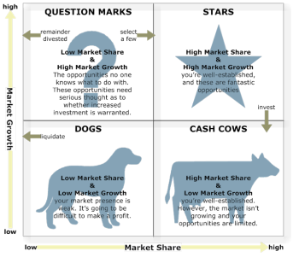

|  |  |  |  |
| --- | --- | --- | --- |
| |  |  |  | | --- | --- | --- | | |  |  | | --- | --- | | **GRAND STRATEGY MATRIX (GSM)**  Grand strategies, often called master or business strategies provide basic direction for strategic actions. They are the basis of coordinated and sustained efforts directed toward achieving long-term business objectives. Grand strategies indicate the time period over which long-range objectives are to be achieved. Thus, a grand strategy can be defined as a comprehensive general approach that guides a firm’s major actions. Grand Strategy Matrix has become an effective tool in devising alternative strategies. The matrix is based on the following four important elements.   * Rapid market growth * Slow market growth * Strong competitive position * Weak competitive position.   The above four elements form a***four quadrant matrix*** wherein every organization can be placed in a way the identification and selection of appropriate strategy becomes an easy task.  With the result, the matrix can be adapted to choose the best strategy based on the current growth and competitive state of the company.  A huge company with many divisions can also plot its divisions in these four quadrants Grand Strategy Matrix by formulating the best strategy for each division.  The management must select the strategy that is cohesive with the market and competitive position.  Broadly speaking the four elements of GSSM can be described as two evaluative dimensions of**market growth and competitive position.**  **Quadrant 1:** This quadrant is meant for companies that are in **strong competitive position and flourishing with market growth**.  The companies have an excellent strategic position and should focus on current markets and product and its development strategy.  With resources they can also expand in backward, forward, or horizontal integration.  A single product company here should diversify to avert risks with the slender product line.  Companies in this quadrant can afford to exploit external opportunities and enhance their financial muscle.  **Quadrant II:** Companies in this quadrant of the GSSM have **weak competitive position in a fast growing market.** Companies here are in growing market but they are competing ineffectively.  An intensive and effective strategy must be adopted.  Companies can adapt to horizontal integration.  If they cannot have a suitable strategy, then divestiture of some divisions can be considered.  As a last resort, liquidation can be considered and another business can be acquired.  **Quadrant III:**Here companies are in a **slow growth industry with weak competition**.  Drastic changes are required.  The management must change its philosophy and new approaches to governance are the need.  Overall revamping at a cost may be warranted. Strategic asset reduction, retrenchment may be the best option.  Diversifying by shifting the resources may be another option.   Final option could be divestiture or liquidation.  **Quadrant IV:**  The companies are in **strong competitive position, but in a slow growth industry.** Companies must look for promising growth areas and to exploit opportunities in the growing markets as they have the strength.  These companies have limited requirement of funds for internal growth and enjoy high cash flow due to a strong competitive position.  They can look for related or unrelated diversification with cash flow and funds; they can also look for joint ventures.  **Description: http://yousigma.com/tools/grandorbusinessstrategies2.jpg** |  | | |

**QUANTITATIVE STRATEGIC PLANNING MATRIX (QSPM)**

**Quantitative Strategic Planning Matrix** (**QSPM**) is a high-level strategic management approach for evaluating possible strategies. Quantitative Strategic Planning Matrix or a QSPM provides an *analytical method* for comparing feasible alternative actions. The QSPM method falls within so-called stage 3 of the strategy formulation analytical framework.

When company executives think about what to do, and which way to go, they usually have a *prioritized list* of strategies. If they like one strategy over another one, they move it up on the list. This process is very much intuitive and subjective. The **QSPM method** introduces some numbers into this approach making it a little more "*expert*" technique.

What is a Quantitative Strategic Planning Matrix or a QSPM?

The *Quantitative Strategic Planning Matrix* or a *QSPM* approach attempts to objectively select the best strategy using input from other management techniques and some easy computations. In other words, the QSPM method uses inputs from stage 1 analyses, matches them with results from stage 2 analyses, and then decides objectively among alternative strategies.

What does a QSPM look like and what does it tell me?

First, let us take a look at a sample Quantitative Strategic Planning Matrix QSPM, see the picture below. This QSPM compares two alternatives. Based on strategies in the stage 1 (IFE, EFE) and stage 2 (BCG, SPACE, IE), company executives determined that this company XYZ needs to pursue an ***aggressive strategy*** aimed at development of new products and further penetration of the market.

They also identified that this strategy can be executed in two ways. One strategy is *acquiring a competing company*. The other strategy is to *expand internally*. They are now asking which option is the better one.

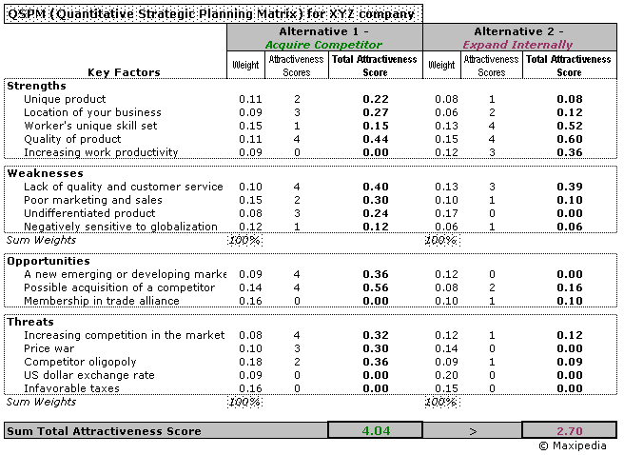

(Attractiveness Score: 1 = not acceptable; 2 = possibly acceptable; 3 = probably acceptable; 4 = most acceptable; 0 = not relevant)

Doing some easy calculations in the Quantitative Strategic Planning Matrix QSPM, we came to a conclusion that acquiring a competing company is a better option. This is given by the *Sum Total Attractiveness Score* figure. The acquisition strategy yields higher score than the internal expansion strategy. The acquisition strategy has a score of 4.04 in the QSPM shown above whereas the internal expansion strategy has a smaller score of 2.70.

How do I construct a QSPM?

You can see a sample Quantitative Strategic Planning Matrix QSPM above. The left column of a QSPM consists of key external and internal factors (identified in stage 1). The left column of a QSPM lists factors obtained directly from the EFE matrix and IFE matrix. The top row consists of feasible alternative strategies (provided in stage 2) derived from the SWOT analysis, SPACE matrix, BCG matrix, and IE matrix. The first column with numbers includes weights assigned to factors. Now let us take a look at detailed steps needed to construct a QSPM.

STEP 1...

Provide a list of internal factors -- *strengths* and *weaknesses*. Then generate a list of the firm's key external **factors** -- *opportunities* and *threats*. These will be included in the left column of the QSPM. You can take these factors from the EFE matrix and the IFE matrix.

STEP 2… strategic management tools...

After we identify and analyze key strategic factors as inputs for QSPM, we can formulate the type of the strategy we would like to pursue. This can be done using the stage 2 strategic management tools, for example the [SWOT analysis](http://www.maxi-pedia.com/SWOT+analysis+matrix+method+model) (or TOWS), [SPACE matrix](http://www.maxi-pedia.com/SPACE+matrix+model+strategic+management+method) analysis, [BCG matrix](http://www.maxi-pedia.com/BCG+matrix+model) model, or the [IE matrix](http://www.maxi-pedia.com/internal+external+IE+matrix) model.

STEP 3...

Having the factors ready, identify **strategy alternatives** that will be further evaluated. These strategies are displayed at the top of the table. Strategies evaluated in the QSPM should be mutually exclusive if possible.

STEP 4...

Each key external and internal factor should have some **weight** in the overall scheme. You can take these weights from the IFE and EFE matrices again. You can find these numbers in our example in the column following the column with factors.

STEP 5...

**Attractiveness Scores** (AS) in the QSPM indicate how each factor is important or attractive to each alternative strategy. Attractiveness Scores are determined by examining each key external and internal factor separately, one at a time, and asking the following question:

*Does this factor make a difference in our decision about which strategy to pursue?*

If the answer to this question is yes, then the strategies should be compared relative to that key factor. The range for Attractiveness Scores is *1 = not attractive, 2 = somewhat attractive, 3 = reasonably attractive,* and *4 = highly attractive*. If the answer to the above question is no, then the respective key factor has no effect on our decision. If the key factor does not affect the choice being made at all, then the Attractiveness Score would be 0.

STEP 6...

Calculate the **Total Attractiveness Scores** (TAS) in the QSPM. Total Attractiveness Scores are defined as the product of multiplying the weights (step 3) by the Attractiveness Scores (step 4) in each row.

The Total Attractiveness Scores indicate the relative attractiveness of each key factor and related individual strategy. The higher the Total Attractiveness Score, the more attractive the strategic alternative or critical factor.

STEP 7...

Calculate the **Sum Total Attractiveness Score** by adding all Total Attractiveness Scores in each strategy column of the QSPM.

The QSPM Sum Total Attractiveness Scores reveal which strategy is most attractive. Higher scores point at a more attractive strategy, considering all the relevant external and internal critical factors that could affect the strategic decision.

* * *

**MAIN QUESTIONS:**

1. Throw light on BCG matrix on portfolio management.

|  |
| --- |
|  |
|  |
|  |
|  |
|  |
|  |
|  |

1. Explain the factors in the process of making a strategic choice.

|  |
| --- |
|  |
|  |
|  |
|  |
|  |
|  |
|  |
|  |

1. Explain TOWS Matrix –a tool for situational analysis.

|  |
| --- |
|  |
|  |
|  |
|  |
|  |
|  |
|  |

**CHAPTER 5. POLICIES IN FUNCTIONAL AREAS**

Policies are guidelines designed to guide the thinking, decisions and actions of managers and their subordinates in implementing an organization’s strategy. Policies help manager for establishing and controlling ongoing operations in manner consistent with the firm’s of strategic objectives.

*Purpose of policies:*

1. Policies provide a statement about how things are to be done in an organization. They help controlling decisions and the conduct of activities without direct intervention by top management.
2. Policies promote uniform handling of similar activities in an organization.
3. Since policies are written statements which ensure quicker decisions and helps reduce uncertainty in repetitive and day to day decision making.
4. Policies offer a predetermined answer to routine problems.
5. Policies give managers a mechanism for avoiding hasty decisions.

*Policies in functional areas*

1. Product Policy: In a product policy, the statements that are included are the products which the company should emphasize, the products that contribute most to the profitability, the image of the product which has to be given importance and also continuous improvement of the product.
2. Personal Policy: Personal policy guides the effective utilization of human resources to achieve both the annual objectives of the firm and the satisfaction and development of employees. The various statements in the personal policy include employee recruitment, selection, orientation, career development, counseling, performance evaluation, training and development, salary and compensation etc.
3. Financial Policies: Financial policy of an organization is related to the availability, usage and management of funds. Statements in the financial policy include capital investment, fixed asset acquisition, dividend decisions, usage of funds. If there is no financial policy, the wage of funds would be inefficient, leading to less than optimum utilization of resources. Some of the other statements in the financial policy include as to how final selections of projects are to be made, to obtain approval from top management regarding capital allocation, what portion of earnings should be paid not as dividend?, etc.
4. Marketing Policy: Marketing policy deals with the 4 “P”s of the marketing mix: Product, Price, place and promotion. Product policy is already mentioned. In the price policy, the various approaches to the pricing of the product are mentioned. How the product should be priced like cost oriented, market oriented, competition oriented etc are mentioned in the marketing policy of which price is component. In the promotion policy, various statements that guide the use of advertising budget, media selection are mentioned. These statements help manager to take decisions which are cost effective and beneficial to the company. The place component is concerned with as to how manager should appoint dealer, distributors, wholesalers etc. it also gives guidelines to managers regarding the selection of channel of distribution and how the goods / services should reach the final customer.
5. Public Relations Policy: public relations is the art of creating mutual understanding between an organization and the various group or groups of people whose opinion has a direct bearing in the functioning of an organization. In a public relation policy, the various statements that are mentioned are how to generate goodwill, understanding and image building of the organization through varied communication strategies, the various ways the media should be used for publicity, the importance of press. Audio- visual channels, radio etc the kind of audience to be reached, aim of public relations etc are mentioned in the policy. How to use the Public Relations Budget by the PR manager is mentioned in a statement form in the Public Relations Policy

* * *

**MAIN QUESTIONS:**

1. Mention the financial policies to facilitate strategic decision making.

|  |
| --- |
|  |
|  |
|  |
|  |
|  |

1. Explain the objectives and characteristics of policy.

|  |
| --- |
|  |
|  |
|  |
|  |
|  |

1. What is the importance of setting production policies and objectives?

|  |
| --- |
|  |
|  |
|  |
|  |
|  |

1. Give a brief on marketing plans and policies of and organization.

|  |
| --- |
|  |
|  |
|  |
|  |
|  |

1. What factors need to be considered while framing operational and marketing policies of a catering unit?

|  |
| --- |
|  |
|  |
|  |
|  |
|  |
|  |

**CHAPTER 6.**

**STRATEGIC IMPLEMENTATION REVIEW AND EVALUATION**

*MCKINSEY 7-S FRAMEWORK*

This model was developed in the 1980's by Robert Waterman, Tom Peters and Julian Philips whilst working for McKinsey and originally presented in their article “Structure is not Organisation". To quote them:

"Intellectually all managers and consultants know that much more goes on in the process of organizing than the charts, boxes, dotted lines, position descriptions, and matrices can possibly depict. But all too often we behave as though we didn’t know it - if we want change we change the structure.

Diagnosing and solving organizational problems means looking not merely to structural reorganization for answers but to a framework that includes structure and several related factors."

The 7S Model which they developed and presented became extensively used by managers and consultants and is one of the cornerstones of organisational analysis.

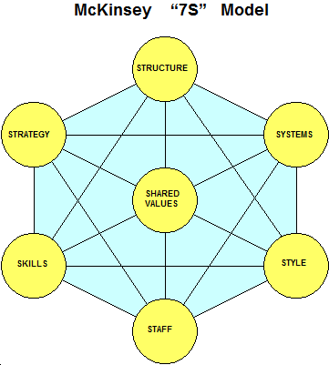

Essentially the model says that any organisation can be best described by the seven interrelated elements shown above:

McKinsey Company developed the 7-S framework. This frame work helps in strategic planning and help to determine the future impact of change and take decisions to reach a designed future.

7-S frame work also provides insight into an organizations working and help in formulating plans for improvement. The seven levers of the organization help achieve the desired results. The complex relationship is diagrammatically presented below:

Structure: The structure of the organization is designed in accordance with the strategy involved. If the structure of the organization is already in place, it is advisable that it is flexible enough to accommodate changes for implementing the strategy. The way the organization's units relate to each other: centralized, functional divisions (top-down); decentralized (the trend in larger organizations); matrix, network, holding, etc. The design of the structure involves allocation of responsibilities, relationship between various departments of the organizations, and the ways in which the organization’s tasks are integrated and coordinated. The structure of the organization is depicted by the organizational chart.

System: It refers to the rules and procedures that support the structure of the organization. Systems include production planning and control system, recruitment, selection, training and development strategy changes than the organization structure.

Style: Top managers in organization use style to implement strategies. The style of the working of the organization becomes evident through the patterns of actions taken by the top management over a period of time. These styles of managers are likely to influence the people in the lower levels of the organization. The style of the managers must be in such a way that it should be adaptable to the changing internal and external environment. The managerial style must be to teach the employees the correct way to think, take correct decisions etc.

Staff: Staff refers to the way organizations introduce young recruits into the mainstream of their activities and the manner in which they manage their careers as the new entrants develop into future manager.

Skills: It refers to the crucial attributes or capabilities of an organization. The dominant skills are those characteristics which most people use to describe an organization. E.g. Hindustan Lever is characteristic with distribution, Reliance is known for their marketing skills.

Strategy: It is the determination of basic long term goals and objectives of an enterprise and the adoption of courses of action and the allocation of resources for carrying out of goals like organization. Strategy comprises of four components Product-market scope, growth, competitive advantage and return on investment.

Super- Ordinate goals: Super ordinate goals refer to the fundamental ideas around which a business in built. They are its main values. They are the broad notions of future direction e.g. of super ordinate goals include strong drive to “customer service”, “innovation throughout the organization”.

The 7-S frame work highlights important organizational interconnections and their role in effecting strategic change. It produces a checklist for the organization to judge whether it is time for implementing a strategy. It helps in environment scanning and also to find out the organizations strength and weakness.

However the model is more than simply a list. Key Points are:

1. The top 3, strategy, structure and systems are the hard elements. The bottom 4, skills, staff, style, and shared values are the soft elements.Previously, any organizational study focused on the top "hard" elements and ignored the bottom "soft" elements.
2. The current view is to focus on all 7, accepting that for each business or enterprise, two or three will be the VITAL ones.
3. The key point is that all the elements are all inter-dependant. Changes in one will have repercussions on the others. Thus introduction of new systems will certainly affect skills, and may well effect structure, style and staff. It could even have an impact on strategy. Similar repercussions occur with decentralisation.
4. If you just try to change one element on its own, the other element may well resist the change and try to maintain the status quo.
5. In this sense, any change in organisation is best seen as a shift in the whole picture.

The model is based on the theory that, for an organization to perform well, these seven elements need to be aligned and mutually reinforcing. So, the model can be used to help identify what needs to be realigned to improve performance, or to maintain alignment (and performance) during other types of change.

Whatever the type of change – restructuring, new processes, organizational merger, new systems, change of leadership, and so on – the model can be used to understand how the organizational elements are interrelated, and so ensure that the wider impact of changes made in one area is taken into consideration.

OBJECTIVE OF THE MODEL

* Improve the performance of a company
* Examine the likely effects of future changes within a company
* Align departments and processes during a merger or acquisition
* Determine how best to implement a proposed strategy

* * *

*LEADERSHIP AND MANAGEMENT STYLE*

Leadership: The chairman, President, Managing Director, CEO of organizations involve getting things accomplished through and with others in others in order to meet the corporate objectives. The top man in the organization must successfully handle two responsibilities which is very important to effective strategic management of the organization.

1. Leadership

2. Manage strategic plans.

Leadership is the directing of activities towards the accomplishment of the organization’s objective. It sets the time for the entire organization. Good leaders create a vision, articulate the vision, passionately own the vision and relentlessly drive it to completion.

Leaders with a clear strategic vision are often perceived as dynamic and charismatic leaders. They are able to command respect and to influence strategy formulation and implementation. Leader should have three key characteristics.

1. Leader articulates a strategic vision. He envisions the organizations not as it currently is but as it can become…..
2. Leader presents a role for others to identity with and to follow. The leader sets an example in terms of behavior and dress
3. Leader not only communicates high performance standards but also shows confidence in the follower’s abilities to meet these standards.

Management style: this is also known as the entrepreneurial style. Management style in strategic management includes risk taking, proactivity and innovation.

Risk taking: the manager is willing to pursue opportunities boldly and aggressively. He prefers for high-risk projects with chances of very high returns over low risk projects with lower and more predictable rates of return.

Pro- activity: the manager’s style is his willingness to initiate actions to which competitors then respond. The proactive manager attempts to be first in the introduction of new products, services rather than merely responding to competitors.

Innovation: the manager’s style is to place strong emphasis on R&D, new products, new services, improved product lines, technological improvements etc

Innovative products are being introduced into the market which is the unique feature of management of strategies.

* * *

STRATEGY REVIEW AND EVALUATION:

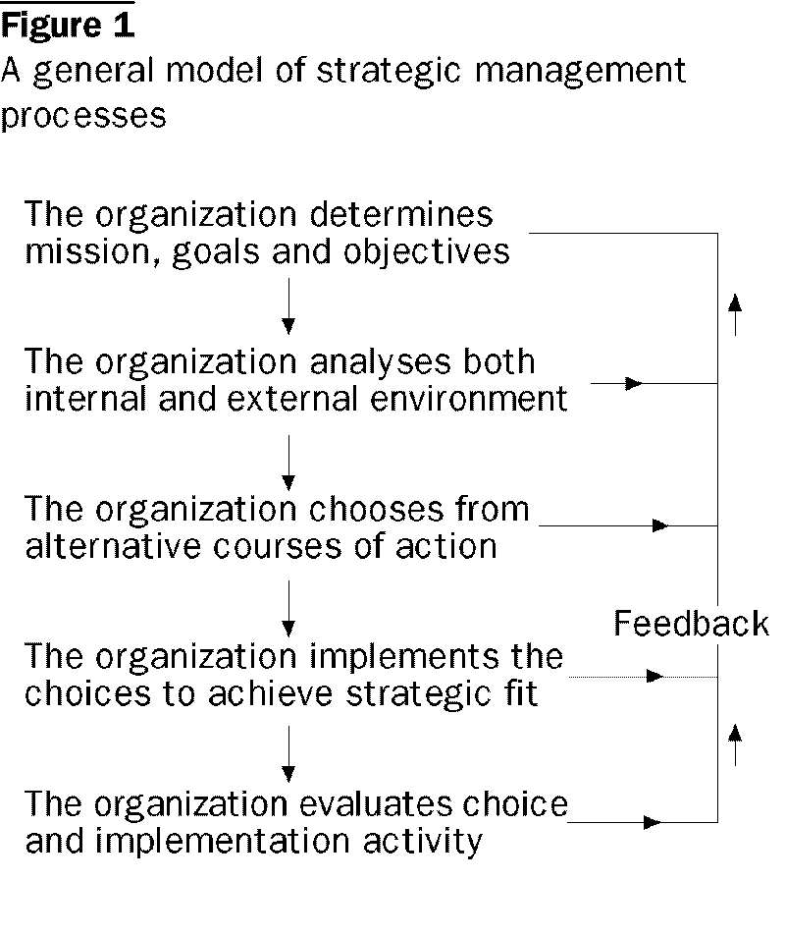

Effective strategy evaluation allows an organization to capitalize on internal strengths as they develop to immediately exploit external opportunities as they emerge, to recognize and defend against environmental threats and to improve internal weakness before they become bad for the organization. Top managers deliberately and systematically formulate, implement and evaluate strategies.

Strategy evaluation consists of three activities:

1. Review underlying bases of strategy
2. Measuring organizational performance
3. Taking corrective actions

*Review underlying bases of strategy*: To begin with, a review of the existing bases of an organization’s current strategy out because internal and external factors do change. Prepare a revised internal and external factor for strategy implementation.

*Measuring organizational performance*: Organizational objectives and goals are the key components of an effective strategic management system. Strategy evaluation is based on objective factors. e.g.

a. Growth as measured in total sales, unit sales, total assets.

b. Efficiency as measured in gross margin, net profits.

c. Asset utilization as measured by return on equity, earnings per share etc

*Take Corrective Actions:* If the organizational performance does not match the standards set corrective actions should be taken which should place an organization in a better position to capitalize on internal strength, to take advantage of key extend opportunities.

**Critical information Needs (for achieving strategic goals)**

The life blood of any organization is information. Thus it is important that the right information is available at the right time and in the right place. The integration of internally and externally focused information systems i.e., Management Information System developed by an organization serves the above purpose.

The schematic diagram is given on the next page.

MANAGEMENT DECISION MAKING

Strategic Planning Model

(SWOT Analysis Model)

Critical Success Factors

Internal

Critical Information Needs

External

Environmental Sub-Domains

Political

Economic

Social

Technology

Industry Analysis

Functional sub- domains

Marketing

Finance

Production

Personnel

Research & development

Environmental

Scanning System

**MANAGEMENT**

**INFORMATION**

**SYSTEMS**

* * *

**MAIN QUESTIONS:**

1. Discuss McKinsey’s 7-S framework in the context of hospitality industry.

|  |
| --- |
|  |
|  |
|  |
|  |
|  |

1. Explain the process of strategic evaluation and control with a neat flowchart.

|  |
| --- |
|  |
|  |
|  |
|  |
|  |

1. What is the importance of setting strategic objectives?

|  |
| --- |
|  |
|  |
|  |
|  |
|  |

1. Write short notes on:
   1. Leadership styles.
   2. GAP analysis.

|  |
| --- |
|  |
|  |
|  |
|  |
|  |

1. What are Likert’s leadership styles? Explain pictographically.

|  |
| --- |
|  |
|  |
|  |
|  |
|  |
|  |

OLD QUESTION PAPERS

|  |
| --- |
|  |
|  |
|  |